PPS NLCTA Laser Initial Acceptance Test Procedure

This document has been approved by:

________________________________________________ __________________
J. W. Humphrey, Date
Electronics & Software Engineering Dept. Head

________________________________________________ __________________
T. G. Porter, Date
I & C System Engineering Section Leader

________________________________________________ __________________
W. Kroutil, Safety Systems Review Officer Date

________________________________________________ __________________
P. Bong, PPS Group Leader Date

________________________________________________ __________________
E. Colby, E163 Laser Safety Officer Date

________________________________________________ __________________
K. Jobe, NLCTA Safety Officer Date

________________________________________________ __________________
M. Saleski, Accelerator Dept. Safety Officer (ADSO) Date

________________________________________________ __________________
T. Fieguth, SLAC Laser Safety Officer Date
Table of Contents

1 Revision History ii
2 Introduction 1
2.1 Purpose 1
2.2 Applicability 1
3 Limits and Precautions 2
4 Prerequisite Actions 3
5 Initial Setup 4
6 Laser Room Checks 6
6.1 Outer Doors 6
6.2 Inner Doors 8
6.3 Laser Room Shutters Check 9
6.4 Laser Room Emergency Off Check 20
6.5 Laser Room Annunciator Check 28
7. NLCTA Accelerator Enclosure / Laser Room Checks 31
7.2 NLCTA CONTROLLED ACCESS 41
7.3 NLCTA PERMITTED ACCESS 58
8 Experimental Hall Checks (Future) 74
9 Experimental Hall Checks / Laser Room Checks (Future) 74
10 Records and Reports 75
10.1 Tester 75
10.2 CONTROLS TEST Review 76
Appendix A – ESB Laser Facility Setup 77
Appendix B – E163 Laser Room Setup 77
Appendix B – E163 Laser Room Setup 78
Appendix D – Laser Room Outer Door 80
Appendix E – Inner Door Control Box – Outside 81
Appendix F – Inner Door 82
Appendix G – Inner Door Control Box – Inside 83
Appendix H – PPS Laser Safety System Box 83
Appendix H – PPS Laser Safety System Box 84
Appendix I – Laser System Emergency Off Power Contactor 85
Appendix J – NLCTA Transport Stopper Box inside 86
Appendix K – NLCTA PPS Panel Test Mode Box 87

1 Revision History

Rev # | Date | Changes
0 | 07/20/05 | Initial Issue
1 | 08/03/05 | - Step 5.22 – delete step – Verify the ALL TABLE SHUTTERS toggle switch is in the CLOSED position.  - Various steps - substitute - Toggle the ALL TABLE SHUTTERS switch – with - Push the ALL TABLE SHUTTERS CLOSE/OPEN push button as applicable  - Various steps – substitute – toggle switch with push button  - Step 6.5.1 – add – verify shutters open and LEDs display correctly
2 | 8/19/05 | - Step 5.23, added QLO verifies no laser during hazard test.  - Added section 7 tests.

2 Introduction

2.1 Purpose
To verify the correct function of the hardware associated with the ESB NLCTA Laser Room, NLCTA Accelerator Enclosure, and Experimental Hall. The procedure requires monitoring the Building 225 Laser Control panel, while executions occur in the ESB NLCTA Laser Room, Experimental Hall (future), and the NLCTA Accelerator Enclosure (future). This procedure tests the laser interlocks within and between all areas mentioned above.

2.2 Applicability
2.2.1 This certification shall be completed prior to facility startup.
2.2.2 The Controls and Power Electronics Department – Personnel Protection Systems Group is responsible for completion of this certification. Only qualified personnel trained by this Group are permitted to perform these tests.

3 Limits and Precautions
WARNING: The following tests may pose laser light and electrical hazards.

I have read the above warning and understand the risks involved and have reviewed my JHAM, the local AHA, and have the appropriate PPE required to safely perform this certification :
Test Persons signature: __________________________________ Date: _____________
Test Persons signature: __________________________________ Date: _____________
Test Persons signature: __________________________________ Date: _____________
Test Persons signature: __________________________________ Date: _____________

4 Prerequisite Actions | Initial Your  Verification
  - Record the following data:
Experiment # 1 ________________ Laser Mfg. _____________________
Power Supply I ___________________,
Experiment # 2 ________________ Laser Mfg. _____________________
Power Supply Section II ___________________,
Experiment # 3 ________________ Laser Mfg. _____________________
Power Supply Section III ___________________,
Experiment # 4 ________________ Laser Mfg. _____________________
Power Supply Section IV ___________________,

4.2 Place 4 people with the following tools at these locations:
[a] One PPS tester in Building 225 with PPS keys, all Laser power supply safety keys, LSS K2 test key, and NLCTA Stopper Enable Key.
[b] One PPS tester in field at testing area.
[c] Laser Expert present.
[d] NLCTA operator to guard the Experimental Hall and/or NLCTA enclosure entrance. | N/A
4.3 Useful phone numbers:
- NLCTA Safety Officer: 2084 (Keith Jobe)
- Laser Room PPS Gate: 2888
- Laser Room next to computer: 5060
- Experimental Hall – West: 3344
- Laser Expert pager: 650-849-9674 (Eric Colby, (E163))
- Building 225: 650-926-5491

5 Initial Setup | Initial Your  Verification
Note: Check off lines refer to E163 Laser Safety System panel (292-259-07) in rack B225-0230 (see Appendix C), unless otherwise indicated.
5.1 Close outer and inner doors in ESB Laser Room.
5.2 Laser covers are in place for the four lasers in ESB Laser Room and all laser power supplies are OFF. Laser expert to verify and communicate to test leader.
5.3 Laser shutters are in place and connected to laser safety system: six for ESB Laser Room are IN.
5.4 120 Volts A.C. for Racks B225-01 and B225-02 is ON.
5.5 120 Volts A.C. for the Annunciator Panel above the Outer Door from ESB Laser Room is ON.
5.6 Verify the +24 Volt D.C. Power Supply is ON.
5.7 Verify the Laser Room Emergency Off buttons are reset.
5.8 Verify the Laser Room Doors Closed LEDs are lit.
5.9 Verify the Laser Room Inner Door Closed Bypassed LED is not lit.
5.10 Verify the Laser Room Emergency Off OK LED is lit.
5.11 Verify the Laser Room Emergency Off FAULT LED is not lit.
5.12 Verify the Laser Room Laser Imminent LED is not lit.
5.13 Verify the Laser Room Any Shutter Open LED is not lit.
5.14 Verify the Laser Room SA Open LED is not lit.
5.15 Verify the Laser Room SB Open LED is not lit.
5.16 Verify the Laser Room SC Open LED is not lit.
5.17 Verify the Laser Room SD Open LED is not lit.
Initial Your
Verification

5.18 Verify the Laser Room SE Open LED is not lit.
5.19 Verify the Laser Room SF Open LED is not lit.
5.20 Transport Stoppers to Experimental Hall is either locked closed or the pipes are tagged “DO NOT USE”.
5.21 Transport Stoppers to NLCTA are closed.
5.22 Verify the LSS E/O OK LED is lit on the PPS LASER SAFETY SYSTEM (292-259) box.
5.23 Set the NLCTA to NO ACCESS with a NLCTA Search Reset if doing Section 7.
5.24 Verify the Laser Test Mode switch is NOT SET on the NLCTA PPS Control Panel.
5.25 QLO verifies that no laser hazards are available during the test.

6 Laser Room Checks
6.1 Outer Doors |  | Initial Your  Verification
    - Position the tester outside the Outer Door.
    - Verify the Outer Doors are closed, locked, and bolted.
    - Attempt to open the large Outer Door without the K1 Laser key and verify the following:
[a] Doors Closed Outer LED is lit on the Laser Control panel.
[b] Outer door will not open.
    - Position the tester between the Outer Doors and the Inner Doors.
    - Unbolt and open the small Outer Door.
    - Close the large and small Outer Door switches and verify the following:
[a] Doors Closed Outer LED is lit on the Laser Control panel.
    - Open the large Outer Door switch leaving the small Outer Door switch closed and verify the following:
[a] Doors Closed Outer LED is not lit on the Laser Control panel.
    - Close the large Outer Door switch leaving the small Outer Door switch closed and verify the following:
[a] Doors Closed Outer LED is lit on the Laser Control panel.
    - Open the small Outer Door switch leaving the large Outer Door switch closed and verify the following:
[a] Doors Closed Outer LED is not lit on the Laser Control panel.
    - Close and bolt the small Outer Door.
Initial Your
Verification

    - Close the large Outer Door and verify the following:
[a] Doors Closed Outer LED is lit on the Laser Control panel.
[b] Doors Closed Inner LED is lit on the Laser Control panel.
6.2 Inner Doors |  | Initial Your  Verification
    - Verify one tester is positioned between the Outer Door and the Inner door and another tester inside the Laser Room.
    - Verify the Inner Doors are closed and bolted.
    - Verify Doors Closed Inner LED is lit on the Laser Control panel.
    - Unbolt and open the small Inner Door.
    - Close the large and small Inner Door switches and verify the following:
[a] Doors Closed Inner LED is lit on the Laser Control panel.
    - Open the large Inner Door switch leaving the small Inner Door switch closed and verify the following:
[a] Doors Closed Inner LED is not lit on the Laser Control panel.
    - Close the large Inner Door switch leaving the small Inner Door switch closed and verify the following:
[a] Doors Closed Outer LED is lit on the Laser Control panel.
    - Open the small Inner Door switch leaving the large Inner Door switch closed and verify the following:
[a] Doors Closed Inner LED is not lit on the Laser Control panel.
    - Close the small Inner Door switch leaving the large Inner Door switch closed and verify the following:
[a] Doors Closed Outer LED is lit on the Laser Control panel.
    - Close and latch the small Inner Door.
    - Close the large Inner Door and verify the following:
[a] Doors Closed Outer LED is lit on the Laser Control panel.
[b] Doors Closed Inner LED is lit on the Laser Control panel.
6.3 Laser Room Shutters Check |  | Initial Your  Verification
    - Verify the Laser Room Inner Door Closed Bypassed LED is not lit.
    - Verify the Laser Room Emergency Off OK LED is lit.
    - Verify the Laser Room Laser Imminent LED is not lit.
    - Verify the Laser Room Any Shutter Open LED is not lit.
    - Disconnect all laser shutter plugs J2– J7 on the side of the PPS LASER SAFETY SYSTEM box.
    - Connect the Laser Room SA plug into J2.
    - Push the ALL TABLE SHUTTERS OPEN push button to and wait 20 seconds.
    - Verify the Laser Room Any Shutter Open LED is lit.
    - Verify that only the Laser Room SA Open LED is lit.
    - Visually verify the Laser SA shutter is Open.
    - Push the ALL TABLE SHUTTERS CLOSE push button to CLOSE shutters.
    - Verify the Laser Room Any Shutter Open LED is not lit.
    - Verify the Laser Room SA Open LED is not lit.
    - Visually verify the Laser SA shutter is Closed.
    - Disconnect the Laser Room SA plug into J2.
Initial Your
Verification

    - Connect the Laser Room SB plug into J3
    - Push the ALL TABLE SHUTTERS OPEN push button to OPEN shutters and wait 20 seconds.
    - Verify the Laser Room Any Shutter Open LED is lit.
    - Verify the that only Laser Room SB Open LED is lit.
    - Visually verify the Laser SB shutter is Open.
    - Push the ALL TABLE SHUTTERS CLOSED push button to CLOSE shutters.
    - Verify the Laser Room Any Shutter Open LED is not lit.
    - Verify the Laser Room SB Open LED is not lit.
    - Visually verify the Laser SB shutter is Closed.
    - Disconnect the Laser Room SB plug into J3.
    - Connect the Laser Room SC plug into J4.
    - Push the ALL TABLE SHUTTERS OPEN push button to OPEN shutters and wait 20 seconds.
    - Verify the Laser Room Any Shutter Open LED is lit.
    - Verify that only the Laser Room SC Open LED is lit.
    - Visually verify the Laser SC shutter is Open.
    - Push the ALL TABLE SHUTTERS CLOSE push button to CLOSE shutters.
    - Verify the Laser Room Any Shutter Open LED is not lit.
    - Verify the Laser Room SC Open LED is not lit.
    - Visually verify the Laser SC shutter is Closed.
    - Disconnect the Laser Room SC plug into J4.
Initial Your
Verification

    - Connect the Laser Room SD plug into J5.
    - Push the ALL TABLE SHUTTERS OPEN push button to OPEN shutters and wait 20 seconds.
    - Verify the Laser Room Any Shutter Open LED is lit.
    - Verify that only the Laser Room SD Open LED is lit.
    - Visually verify the Laser SD shutter is Open.
    - Push the ALL TABLE SHUTTERS CLOSE push button to CLOSE shutters.
    - Verify the Laser Room Any Shutter Open LED is not lit.
    - Verify the Laser Room SD Open LED is not lit.
    - Visually verify the Laser SD shutter is Closed.
    - Disconnect the Laser Room SD plug into J5
    - Connect the Laser Room SE plug into J6.
    - Push the ALL TABLE SHUTTERS OPEN push button to OPEN shutters and wait 20 seconds.
    - Verify the Laser Room Any Shutter Open LED is lit.
    - Verify that only the Laser Room SE Open LED is lit.
    - Visually verify the Laser SE shutter is Open.
    - Push the ALL TABLE SHUTTERS CLOSE push button to CLOSE shutters.
    - Verify the Laser Room Any Shutter Open LED is not lit.
    - Verify the Laser Room SE Open LED is not lit.
    - Visually verify the Laser SE shutter is Closed.
    - Disconnect the Laser Room SE plug into J6.
Initial Your
Verification

    - Connect the Laser Room SF plug into J7.
    - Push the ALL TABLE SHUTTERS OPEN push button to OPEN shutters and wait 20 seconds.
    - Verify the Laser Room Any Shutter Open LED is lit.
    - Verify that only the Laser Room SF Open LED is lit.
    - Visually verify the Laser SF shutter is Open.
    - Push the ALL TABLE SHUTTERS CLOSE push button to CLOSE shutters.
    - Verify the Laser Room Any Shutter Open LED is not lit.
    - Verify the Laser Room SF Open LED is not lit.
    - Visually verify the Laser SF shutter is Closed.
    - Connect all remaining laser shutter plugs to the PPS Laser Safety System box.
Initial Your
Verification

    - Push ALL TABLE SHUTTERS OPEN push button to OPEN shutters and verify the following before 20 seconds lapses:
[a] Any Shutter Open LED is not lit.
[b] All Laser Room shutter LEDs are not lit.
[c] Laser warning audible sounds and the visual lights are activated.
    - Before 20 seconds lapses from the previous step, push ALL TABLE SHUTTERS CLOSE push button to keep shutters CLOSED and verify the following:
[a] Any Shutter Open LED is not lit.
[b] All Laser Room shutter LEDs are not lit.
[c] Laser warning audible sounds and the visual lights are stopped.
    - Push ALL TABLE SHUTTERS OPEN push button to OPEN shutters and after 20 seconds verify the following:
- Any Shutter Open LED is lit.
- All Laser Room shutter LEDs are lit.
[c] Laser warning audible sounds and the visual lights ran for 20 seconds.
Initial Your
Verification

    - Open and hold the large Inner Door and verify the following:
- Doors Closed Inner LED is not lit on the Laser Control panel.
- Any Shutter Open LED is not lit.
- All Laser Room shutter LEDs are not lit.
    - Push the ALL TABLE SHUTTERS OPEN push button, wait 20 seconds and verify the following:
- Doors Closed Inner LED is not lit on the Laser Control panel.
- Any Shutter Open LED is not lit.
- All Laser Room shutter LEDs are not lit.
    - Close the large Inner Door.
Initial Your
Verification

    - Push the ALL SHUTTER OPEN push button , in 20 Seconds or less, Open and hold the Inner Door by turning the K1 Laser key to the START TIMED ENTRY position on the Outer Door Control box.
- Doors Closed Inner LED is not lit.
- Any Shutter Open LED is not lit.
- All Laser Room shutter LEDs are not lit.
- Door bypass audio is started.
- Door bypass CLOSED/BYPASSES LED is lit.
- 24 V LED is lit.
    - Close the Inner Door before 20 seconds or less and verify the following:
- Doors Closed Inner LED is lit.
- Any Shutter Open LED is not lit.
- All Laser Room shutter LEDs are lit.
- Door bypass audio continues to play.
- Door bypass CLOSED/BYPASSES LED is not lit.
- 24 V LED is lit.
    - Push the ALL SHUTTER OPEN push button and wait 20 Seconds.
- Doors Closed Inner LED is lit.
- Any Shutter Open LED is lit.
- All Laser Room shutter LEDs are lit.
Initial Your
Verification

    - Open the Inner Door by turning the K1 Laser key to the START TIMED ENTRY position on the Outer Door Control box and hold the door open and wait more then 20 Seconds to verify the following:
- Doors Closed Inner LED is not lit.
- Any Shutter Open LED is not lit.
- All Laser Room shutter LEDs are not lit.
    - Close the Inner Door
- Doors Closed Inner LED is lit.
- Any Shutter Open LED is not lit.
- All Laser Room shutter LEDs are not lit.
    - Push the ALL TABLE SHUTTERS OPEN push button, wait 20 seconds and verify the following:
- Doors Closed Inner LED is lit on the Laser Control panel.
- Any Shutter Open LED is lit.
- All Laser Room shutter LEDs are lit.
Initial Your
Verification

    - In 20 Seconds or less, Open the Inner Door by pushing the START DOOR BYPASS TIMER button and verity the DOOR ENABLED LED is lit on the Inner Door Control box and verify the following:
- Doors Closed Inner LED is not lit.
- Any Shutter Open LED is lit.
- All Laser Room shutter LEDs are lit.
- Door bypass audio starts.
- Door bypass CLOSED/BYPASSES LED is lit.
- DOOR ENABLED LED is lit
    - Close the Inner Door within 20 seconds and verify the following:
- Doors Closed Inner LED is lit.
- Any Shutter Open LED is lit.
- All Laser Room shutter LEDs are lit.
- Door bypass audio continues to play.
- Door bypass CLOSED/BYPASSES LED is lit.
- DOOR ENABLED LED is lit
Initial Your
Verification

    - Open the Inner Door by pushing the START DOOR BYPASS TIMER button, hold the door open and wait more then 20 Seconds to verify the following:
- Doors Closed Inner LED is not lit.
- Any Shutter Open LED is not lit.
- All Laser Room shutter LEDs are not lit.
- Laser Room shutter audio and visual 20 second warning is not playing.
- Inner door BYPASS audio and visual 20 second warning stops.
    - Close the Inner Door and verify the following:
- Doors Closed Inner LED is lit.
- Doors Closed Outer LED is lit.
- Any Shutter Open LED is not lit.
- All Laser Room shutter LEDs are not lit.
- Laser Room shutter audio and visual 20 second warning does not start.
    - Push the ALL TABLE SHUTTERS OPEN push button, wait 20 seconds.
Initial Your
Verification

    - Open the Inner Door using the BYPASS and before 20 seconds or less open the Outer door and verify the following:
- Doors Closed Inner LED is not lit.
- Doors Closed Outer LED is not lit.
- Any Shutter Open LED is not lit.
- All Laser Room shutter LEDs are not lit.
- Inner Door BYPASS audio and visual 20 second warning stops when Outer door is opened.
    - Close the Inner and Outer Doors, push ALL TABLE SHUTTERS OPEN push button, and wait 20 seconds.
6.4 Laser Room Emergency Off Check |  | Initial Your  Verification
    - Verify the Inner and Outer Doors are CLOSED.
    - Verify LSS EO OK LED is lit on the PPS LASER SAFETY SYSTEM box.
    - Verify LSS EO OK LED is lit on the LASER SAFETY SYSTEM panel.
    - Verify LSS EO FAULT LED is not lit on the LASER SAFETY SYSTEM panel.
    - Request Laser Expert to disconnect cables from the power contactor J3 (SA), J4 (SB) and J5 (SC) connections.
    - Verify Laser System Emergency Off Power Contactors chassis power from 2PCC3A73A CB 14-16-18 is closed.
    - Verify the following at the Laser System Emergency Off Power Contactors chassis (235-984) in a rack under the optical table.
- E/O OK led is lit
- E/O NOT OK led is not lit
- Laser #1 (SA) test lamp is ON.
- Laser #2 (SB) test lamp is ON.
- Laser #3 (SC) test lamp is ON.
Initial Your
Verification

    - Push the EO Reset button on the PPS Laser Safety System box and verify the following:
- Laser #1 (SA) test lamp is ON.
- Laser #2 (SB) test lamp is ON.
- Laser #3 (SC) test lamp is ON.
- Any Shutter Open LED is lit.
- All Laser Room shutter LEDs are lit.
- LSS EO OK LED is lit on the PPS LASER SAFETY SYSTEM box.
- LSS EO OK LED is lit on the LASER SAFETY SYSTEM panel.
- LSS EO FAULT LED is not lit on the LASER SAFETY SYSTEM panel.
Initial Your
Verification

    - Push the East EO button and verify the following:
- Laser #1 (SA) test lamp is OFF.
- Laser #2 (SB) test lamp is OFF.
- Laser #3 (SC) test lamp is OFF.
- Any Shutter Open LED is not lit.
- All Laser Room shutter LEDs are not lit.
- LSS EO OK LED is not lit on the PPS LASER SAFETY SYSTEM box.
- LSS EO OK LED is not lit on the LASER SAFETY SYSTEM panel.
- LSS EO FAULT LED is lit on the LASER SAFETY SYSTEM panel.
    - Push the ALL TABLE SHUTTERS OPEN push button and verify the following:
- Laser #1 (SA) test lamp is OFF.
- Laser #2 (SB) test lamp is OFF.
- Laser #3 (SC) test lamp is OFF.
- Any Shutter Open LED is not lit.
- All Laser Room shutter LEDs are not lit.
- LSS EO OK LED is not lit on the PPS LASER SAFETY SYSTEM box.
- LSS EO OK LED is not lit on the LASER SAFETY SYSTEM panel.
- LSS EO FAULT LED is lit on the LASER SAFETY SYSTEM panel.
- LSS audio and visual warnings do not start.
Initial Your
Verification

    - Reset the EO button by pushing the EMERGENCY OFF RESET button on the PPS LASER SAFETY SYSTEM box and within 20 seconds verify the following:
- Laser #1 (SA) test lamp is ON.
- Laser #2 (SB) test lamp is ON.
- Laser #3 (SC) test lamp is ON.
- Any Shutter Open LED is not lit.
- All Laser Room shutter LEDs are not lit.
- LSS EO OK LED is lit on the PPS LASER SAFETY SYSTEM box.
- LSS EO OK LED is lit on the LASER SAFETY SYSTEM panel.
- LSS EO FAULT LED is not lit on the LASER SAFETY SYSTEM panel.
    - Push the ALL TABLE SHUTTERS OPEN push button and wait 20 seconds and verify the following:
- Any Shutter Open LED is lit.
- All Laser Room shutter LEDs are lit.
Initial Your
Verification

    - Push the South EO button and verify the following:
- Laser #1 (SA) test lamp is OFF.
- Laser #2 (SB) test lamp is OFF.
- Laser #3 (SC) test lamp is OFF.
- Any Shutter Open LED is not lit.
- All Laser Room shutter LEDs are not lit.
- LSS EO OK LED is not lit on the PPS LASER SAFETY SYSTEM box.
- LSS EO OK LED is not lit on the LASER SAFETY SYSTEM panel.
- LSS EO FAULT LED is lit on the LASER SAFETY SYSTEM panel.
    - Push the ALL TABLE SHUTTERS OPEN push button and verify the following:
- Laser #1 (SA) test lamp is OFF.
- Laser #2 (SB) test lamp is OFF.
- Laser #3 (SC) test lamp is OFF.
- Any Shutter Open LED is not lit.
- All Laser Room shutter LEDs are not lit.
- LSS EO OK LED is not lit on the PPS LASER SAFETY SYSTEM box.
- LSS EO OK LED is not lit on the LASER SAFETY SYSTEM panel.
- LSS EO FAULT LED is lit on the LASER SAFETY SYSTEM panel.
- LSS audio and visual warnings do not start.
Initial Your
Verification

    - Reset the EO button by pushing the EMERGENCY OFF RESET button on the PPS LASER SAFETY SYSTEM box and within 20 seconds verify the following:
- Laser #1 (SA) test lamp is ON.
- Laser #2 (SB) test lamp is ON.
- Laser #3 (SC) test lamp is ON.
- Any Shutter Open LED is not lit.
- All Laser Room shutter LEDs are not lit.
- LSS EO OK LED is lit on the PPS LASER SAFETY SYSTEM box.
- LSS EO OK LED is lit on the LASER SAFETY SYSTEM panel.
- LSS EO FAULT LED is not lit on the LASER SAFETY SYSTEM panel.
    - Push the ALL TABLE SHUTTERS OPEN push button and wait 20 seconds and verify the following:
- Any Shutter Open LED is lit.
- All Laser Room shutter LEDs are lit.
Initial Your
Verification

    - Push the West EO button and verify the following:
- Laser #1 (SA) test lamp is OFF.
- Laser #2 (SB) test lamp is OFF.
- Laser #3 (SC) test lamp is OFF.
- Any Shutter Open LED is not lit.
- All Laser Room shutter LEDs are not lit.
- LSS EO OK LED is not lit on the PPS LASER SAFETY SYSTEM box.
- LSS EO OK LED is not lit on the LASER SAFETY SYSTEM panel.
- LSS EO FAULT LED is lit on the LASER SAFETY SYSTEM panel.
    - Push the ALL TABLE SHUTTERS OPEN push button and verify the following:
- Laser #1 (SA) test lamp is OFF.
- Laser #2 (SB) test lamp is OFF.
- Laser #3 (SC) test lamp is OFF.
- Any Shutter Open LED is not lit.
- All Laser Room shutter LEDs are not lit.
- LSS EO OK LED is not lit on the PPS LASER SAFETY SYSTEM box.
- LSS EO OK LED is not lit on the LASER SAFETY SYSTEM panel.
- LSS EO FAULT LED is lit on the LASER SAFETY SYSTEM panel.
- LSS audio and visual warnings do not start.
Initial Your
Verification

    - Reset the EO button by pushing the EMERGENCY OFF RESET button on the PPS LASER SAFETY SYSTEM box and within 20 seconds verify the following:
- Laser #1 (SA) test lamp is ON.
- Laser #2 (SB) test lamp is ON.
- Laser #3 (SC) test lamp is ON.
- Any Shutter Open LED is not lit.
- All Laser Room shutter LEDs are not lit.
- LSS EO OK LED is lit on the PPS LASER SAFETY SYSTEM box.
- LSS EO OK LED is lit on the LASER SAFETY SYSTEM panel.
- LSS EO FAULT LED is not lit on the LASER SAFETY SYSTEM panel.
    - Push the ALL TABLE SHUTTERS OPEN push button and wait 20 seconds and verify the following:
- Any Shutter Open LED is lit.
- All Laser Room shutter LEDs are lit.
    - Disconnect the test lamps from each of the power contactor connections of J3 (SA), J4 (SB) and J5 (SC).
    - Request the Laser Expert to connect the laser power supplies to J3 (SA), J4 (SB) and J5 (SC).
    - Request the Laser Expert to turn ON laser power supply 1.
6.5 Laser Room Annunciator Check |  | Initial Your  Verification
    - Push the ALL SHUTTER OPEN push button and verify the following:
- Laser Room Laser Annunciator displays a steady red - Laser ON.
- Laser Room Laser Imminent LED is not lit Laser Safety System panel.
    - Request the Laser Expert to turn ON laser power supply #1 and verify the following:
- Laser Room Laser Annunciator displays a steady red - Laser On
- Laser Room Laser Imminent LED is lit Laser Safety System panel.
    - Push the ALL SHUTTER CLOSE push button and verify the following:
- Laser Room Laser Annunciator displays a steady red - Laser On.
- Laser Room Laser Imminent LED is lit Laser Safety System panel.
    - Request the laser expert to turn OFF laser power supply #1 and verify the following:
- Laser Room Laser Annunciator displays a steady green – Laser Off
- Laser Room Laser Imminent LED is not lit Laser Safety System panel.
Initial Your
Verification

    - Push the ALL SHUTTER OPEN push button and verify the following:
- Laser Room Laser Annunciator displays a steady red - Laser ON.
- Laser Room Laser Imminent LED is not lit Laser Safety System panel.
    - Request the Laser Expert to turn ON laser power supply #2 and verify the following:
- Laser Room Laser Annunciator displays a steady red - Laser On
- Laser Room Laser Imminent LED is lit Laser Safety System panel.
    - Push the ALL SHUTTER CLOSE push button and verify the following:
- Laser Room Laser Annunciator displays a steady red - Laser On.
- Laser Room Laser Imminent LED is lit Laser Safety System panel.
    - Request the laser expert to turn OFF laser power supply #2 and verify the following:
- Laser Room Laser Annunciator displays a steady green - Laser Off
- Laser Room Laser Imminent LED is not lit Laser Safety System panel.
Initial Your
Verification

    - Push the ALL SHUTTER OPEN push button and verify the following:
- Laser Room Laser Annunciator displays a steady red - Laser ON.
- Laser Room Laser Imminent LED is not lit Laser Safety System panel.
    - Request the Laser Expert to turn ON laser power supply #3 and verify the following:
- Laser Room Laser Annunciator displays a steady red - Laser On
- Laser Room Laser Imminent LED is lit Laser Safety System panel.
    - Push the ALL SHUTTER CLOSE push button and verify the following:
- Laser Room Laser Annunciator displays a steady red - Laser On.
- Laser Room Laser Imminent LED is lit Laser Safety System panel.
    - Request the laser expert to turn OFF laser power supply #3 and verify the following:
- Laser Room Laser Annunciator displays a steady green - Laser Off
- Laser Room Laser Imminent LED is not lit Laser Safety System panel.

- NLCTA Accelerator Enclosure / Laser Room Checks
- NLCTA Accelerator Enclosure No Access | Initial Your  Verification
Note: An NLCTA Operator search is required for the NLCTA accelerator enclosure if the Search Reset is not complete. Give the NLCTA Stopper Enable key to a PPS tester.
    - Verify the following:
- NLCTA EO OK LED is lit on the NLCTA PPS panel.
- NLCTA EE OK LED is lit on the NLCTA PPS panel.
- NLCTA Search Reset is set.
- NLCTA is in CONTROLLED ACCESS.
- NLCTA N/A (SR)(TIMER CMPLT) LED is not lit on the LASER SAFETY SYSTEM panel.
- NLCTA C/A LED is lit on the LASER SAFETY SYSTEM panel.
- NLCTA P/A LED is not lit on the LASER SAFETY SYSTEM panel.
- NLCTA EE OK WEST LED is lit on the LASER SAFETY SYSTEM panel.
- NLCTA EE OK EAST LED is lit on the LASER SAFETY SYSTEM panel.
- NLCTA Transport Stopper Status STN1 IN is lit on the LASER SAFETY SYSTEM panel.
- NLCTA Transport Stopper Status STN1 OUT is not lit on the LASER SAFETY SYSTEM panel.
Initial Your
Verification

- NLCTA Transport Stopper Status STN2 IN is lit on the LASER SAFETY SYSTEM panel. | N/A
- NLCTA Transport Stopper Status STN2 OUT is not lit on the LASER SAFETY SYSTEM panel. | N/A
- NLCTA VACUUM OK is lit on the LASER SAFETY SYSTEM panel.
- NLCTA REMOTE keyswitch is in the LOCAL position on the PPS LASER SAFETY SYSTEM box.
    - Turn the NLCTA REMOTE keyswitch to the REMOTE position.
    - Transfer the NLCTA accelerator enclosure to NO ACCESS, wait for the timeout, and open the transport stoppers using the SCP and verify the following:
- NLCTA N/A (SR)(TIMER CMPLT) LED is lit on the LASER SAFETY SYSTEM panel.
- NLCTA C/A LED is not lit on the LASER SAFETY SYSTEM panel.
- NLCTA P/A LED is not lit on the LASER SAFETY SYSTEM panel.
- NLCTA Transport Stopper Status STN1 IN is not lit on the LASER SAFETY SYSTEM panel.
- NLCTA Transport Stopper Status STN1 OUT is lit on the LASER SAFETY SYSTEM panel.
- NLCTA Transport Stopper Status STN2 IN is not lit on the LASER SAFETY SYSTEM panel. | N/A
- NLCTA Transport Stopper Status STN2 OUT is lit on the LASER SAFETY SYSTEM panel. | N/A
- NLCTA VACUUM OK is lit on the LASER SAFETY SYSTEM panel.
- NLCTA REMOTE keyswitch is in the REMOTE position on the PPS LASER SAFETY SYSTEM box.
- Visually verify the laser stopper S1N is open.
Initial Your
Verification

    - Vent the NLCTA Laser Transport vacuum and verify the following:
- NLCTA N/A (SR)(TIMER CMPLT) LED is lit on the LASER SAFETY SYSTEM panel.
- NLCTA C/A LED is not lit on the LASER SAFETY SYSTEM panel.
- NLCTA P/A LED is not lit on the LASER SAFETY SYSTEM panel.
- NLCTA Transport Stopper Status STN1 IN is lit on the LASER SAFETY SYSTEM panel.
- NLCTA Transport Stopper Status STN1 OUT is not lit on the LASER SAFETY SYSTEM panel.
- NLCTA Transport Stopper Status STN2 IN is lit on the LASER SAFETY SYSTEM panel. | N/A
- NLCTA Transport Stopper Status STN2 OUT is not lit on the LASER SAFETY SYSTEM panel. | N/A
- NLCTA VACUUM OK is not lit on the LASER SAFETY SYSTEM panel.
- Visually verify the laser stopper S1N is closed.
    - Attempt to open the transport stoppers using the SCP and verify the following:
- NLCTA N/A (SR)(TIMER CMPLT) LED is lit on the LASER SAFETY SYSTEM panel.
- NLCTA C/A LED is not lit on the LASER SAFETY SYSTEM panel.
- NLCTA P/A LED is not lit on the LASER SAFETY SYSTEM panel.
- NLCTA Transport Stopper Status STN1 IN is lit on the LASER SAFETY SYSTEM panel.
- NLCTA Transport Stopper Status STN1 OUT is not lit on the LASER SAFETY SYSTEM panel.
Initial Your
Verification

- NLCTA Transport Stopper Status STN2 IN is lit on the LASER SAFETY SYSTEM panel. | N/A
- NLCTA Transport Stopper Status STN2 OUT is not lit on the LASER SAFETY SYSTEM panel. | N/A
- NLCTA VACUUM OK is not lit on the LASER SAFETY SYSTEM panel.
- NLCTA REMOTE keyswitch is in the REMOTE position on the PPS LASER SAFETY SYSTEM box.
    - Restore the NLCTA Laser Transport vacuum and verify the following:
- NLCTA N/A (SR)(TIMER CMPLT) LED is lit on the LASER SAFETY SYSTEM panel.
- NLCTA C/A LED is not lit on the LASER SAFETY SYSTEM panel.
- NLCTA P/A LED is not lit on the LASER SAFETY SYSTEM panel.
- NLCTA Transport Stopper Status STN1 IN is lit on the LASER SAFETY SYSTEM panel.
- NLCTA Transport Stopper Status STN1 OUT is not lit on the LASER SAFETY SYSTEM panel.
- NLCTA Transport Stopper Status STN2 IN is lit on the LASER SAFETY SYSTEM panel. | N/A
- NLCTA Transport Stopper Status STN2 OUT is not lit on the LASER SAFETY SYSTEM panel. | N/A
- NLCTA VACUUM OK is lit on the LASER SAFETY SYSTEM panel.
Initial Your
Verification

    - Have the PPS enclosure tester walk to the West Door.
    - Open the transport stoppers using the SCP and verify the following:
- NLCTA N/A (SR)(TIMER CMPLT) LED is lit on the LASER SAFETY SYSTEM panel.
- NLCTA C/A LED is not lit on the LASER SAFETY SYSTEM panel.
- NLCTA P/A LED is not lit on the LASER SAFETY SYSTEM panel.
- NLCTA Transport Stopper Status STN1 IN is not lit on the LASER SAFETY SYSTEM panel.
- NLCTA Transport Stopper Status STN1 OUT is lit on the LASER SAFETY SYSTEM panel.
- NLCTA Transport Stopper Status STN2 IN is not lit on the LASER SAFETY SYSTEM panel. | N/A
- NLCTA Transport Stopper Status STN2 OUT is lit on the LASER SAFETY SYSTEM panel. | N/A
- NLCTA REMOTE keyswitch is in the REMOTE position on the PPS LASER SAFETY SYSTEM box.
    - Have PPS tester outside the NLCTA Accelerator Enclosure activate the West Door EE and verify the following:
- NLCTA N/A (SR)(TIMER CMPLT) LED is not lit on the LASER SAFETY SYSTEM panel.
- NLCTA C/A LED is not lit on the LASER SAFETY SYSTEM panel.
- NLCTA P/A LED is not lit on the LASER SAFETY SYSTEM panel.
- NLCTA EE OK WEST LED is not lit on the LASER SAFETY SYSTEM panel.
- NLCTA EE OK EAST LED is lit on the LASER SAFETY SYSTEM panel.
Initial Your
Verification

- NLCTA Transport Stopper Status STN1 IN is lit on the LASER SAFETY SYSTEM panel.
- NLCTA Transport Stopper Status STN1 OUT is not lit on the LASER SAFETY SYSTEM panel.
- NLCTA Transport Stopper Status STN2 IN is lit on the LASER SAFETY SYSTEM panel. | N/A
- NLCTA Transport Stopper Status STN2 OUT is not lit on the LASER SAFETY SYSTEM panel. | N/A
    - Transfer the NLCTA accelerator enclosure to CONTROLLED ACCESS and obtain a Search Reset.
    - Reset the NLCTA West Door EE and verify the following:
- NLCTA N/A (SR)(TIMER CMPLT) LED is not lit on the LASER SAFETY SYSTEM panel.
- NLCTA C/A LED is lit on the LASER SAFETY SYSTEM panel.
- NLCTA P/A LED is not lit on the LASER SAFETY SYSTEM panel.
- NLCTA EE OK WEST LED is lit on the LASER SAFETY SYSTEM panel.
- NLCTA EE OK EAST LED is lit on the LASER SAFETY SYSTEM panel.
- NLCTA Transport Stopper Status STN1 IN is lit on the LASER SAFETY SYSTEM panel.
- NLCTA Transport Stopper Status STN1 OUT is not lit on the LASER SAFETY SYSTEM panel.
- NLCTA Transport Stopper Status STN2 IN is lit on the LASER SAFETY SYSTEM panel. | N/A
- NLCTA Transport Stopper Status STN2 OUT is not lit on the LASER SAFETY SYSTEM panel. | N/A
Initial Your
Verification

    - Transfer the NLCTA accelerator enclosure to NO ACCESS, wait for the timeout, and open the transport stoppers using the SCP and verify the following:
- NLCTA N/A (SR)(TIMER CMPLT) LED is lit on the LASER SAFETY SYSTEM panel.
- NLCTA C/A LED is not lit on the LASER SAFETY SYSTEM panel.
- NLCTA P/A LED is not lit on the LASER SAFETY SYSTEM panel.
- NLCTA EE OK WEST LED is lit on the LASER SAFETY SYSTEM panel.
- NLCTA EE OK EAST LED is lit on the LASER SAFETY SYSTEM panel.
- NLCTA Transport Stopper Status STN1 IN is not lit on the LASER SAFETY SYSTEM panel.
- NLCTA Transport Stopper Status STN1 OUT is lit on the LASER SAFETY SYSTEM panel.
- NLCTA Transport Stopper Status STN2 IN is not lit on the LASER SAFETY SYSTEM panel. |  | N/A
- NLCTA Transport Stopper Status STN2 OUT is lit on the LASER SAFETY SYSTEM panel. |  | N/A
    - Have the PPS enclosure tester walk to the East Door.
Initial Your
Verification

    - Have PPS tester outside the NLCTA Accelerator Enclosure activate the East Door EE and verify the following:
- NLCTA N/A (SR)(TIMER CMPLT) LED is not lit on the LASER SAFETY SYSTEM panel.
- NLCTA C/A LED is not lit on the LASER SAFETY SYSTEM panel.
- NLCTA P/A LED is not lit on the LASER SAFETY SYSTEM panel.
- NLCTA EE OK WEST LED is lit on the LASER SAFETY SYSTEM panel.
- NLCTA EE OK EAST LED is not lit on the LASER SAFETY SYSTEM panel.
- NLCTA Transport Stopper Status STN1 IN is lit on the LASER SAFETY SYSTEM panel.
- NLCTA Transport Stopper Status STN1 OUT is not lit on the LASER SAFETY SYSTEM panel.
- NLCTA Transport Stopper Status STN2 IN is lit on the LASER SAFETY SYSTEM panel. | N/A
- NLCTA Transport Stopper Status STN2 OUT is not lit on the LASER SAFETY SYSTEM panel. | N/A
    - Transfer the NLCTA accelerator enclosure to CONTROLLED ACCESS and obtain a Search Reset.
    - Reset the NLCTA East Door EE and verify the following:
- NLCTA N/A (SR)(TIMER CMPLT) LED is not lit on the LASER SAFETY SYSTEM panel.
- NLCTA C/A LED is lit on the LASER SAFETY SYSTEM panel.
- NLCTA P/A LED is not lit on the LASER SAFETY SYSTEM panel.
- NLCTA EE OK WEST LED is lit on the LASER SAFETY SYSTEM panel.
Initial Your
Verification

- NLCTA EE OK EAST LED is lit on the LASER SAFETY SYSTEM panel.
- NLCTA Transport Stopper Status STN1 IN is lit on the LASER SAFETY SYSTEM panel.
- NLCTA Transport Stopper Status STN1 OUT is not lit on the LASER SAFETY SYSTEM panel.
- NLCTA Transport Stopper Status STN2 IN is lit on the LASER SAFETY SYSTEM panel. | N/A
- NLCTA Transport Stopper Status STN2 OUT is not lit on the LASER SAFETY SYSTEM panel. | N/A
    - Transfer the NLCTA accelerator enclosure to NO ACCESS, wait for the timeout, and open the transport stoppers using the SCP and verify the following:
- NLCTA N/A (SR)(TIMER CMPLT) LED is lit on the LASER SAFETY SYSTEM panel.
- NLCTA C/A LED is not lit on the LASER SAFETY SYSTEM panel.
- NLCTA P/A LED is not lit on the LASER SAFETY SYSTEM panel.
- NLCTA EE OK WEST LED is lit on the LASER SAFETY SYSTEM panel.
- NLCTA EE OK EAST LED is lit on the LASER SAFETY SYSTEM panel.
- NLCTA Transport Stopper Status STN1 IN is not lit on the LASER SAFETY SYSTEM panel.
- NLCTA Transport Stopper Status STN1 OUT is lit on the LASER SAFETY SYSTEM panel.
- NLCTA Transport Stopper Status STN2 IN is not lit on the LASER SAFETY SYSTEM panel. | N/A
- NLCTA Transport Stopper Status STN2 OUT is lit on the LASER SAFETY SYSTEM panel. | N/A
Initial Your
Verification

    - Transfer the NLCTA accelerator enclosure to CONTROLLED ACCESS and verify the following:
- NLCTA N/A (SR)(TIMER CMPLT) LED is not lit on the LASER SAFETY SYSTEM panel.
- NLCTA C/A LED is lit on the LASER SAFETY SYSTEM panel.
- NLCTA P/A LED is not lit on the LASER SAFETY SYSTEM panel.
- NLCTA EE OK WEST LED is lit on the LASER SAFETY SYSTEM panel.
- NLCTA EE OK EAST LED is lit on the LASER SAFETY SYSTEM panel.
- NLCTA Transport Stopper Status STN1 IN is lit on the LASER SAFETY SYSTEM panel.
- NLCTA Transport Stopper Status STN1 OUT is not lit on the LASER SAFETY SYSTEM panel.
- NLCTA Transport Stopper Status STN2 IN is lit on the LASER SAFETY SYSTEM panel. | N/A
- NLCTA Transport Stopper Status STN2 OUT is not lit on the LASER SAFETY SYSTEM panel. | N/A
7.2 NLCTA CONTROLLED ACCESS | Initial Your  Verification
    - Verify the NLCTA accelerator enclosure is in CONTROLLED ACCESS, with the PPS tester at the East Door and verify the following:
- NLCTA N/A (SR)(TIMER CMPLT) LED is not lit on the LASER SAFETY SYSTEM panel.
- NLCTA C/A LED is lit on the LASER SAFETY SYSTEM panel.
- NLCTA P/A LED is not lit on the LASER SAFETY SYSTEM panel.
- NLCTA EE OK WEST LED is lit on the LASER SAFETY SYSTEM panel.
- NLCTA EE OK EAST LED is lit on the LASER SAFETY SYSTEM panel.
- NLCTA Transport Stopper Status STN1 IN is lit on the LASER SAFETY SYSTEM panel.
- NLCTA Transport Stopper Status STN1 OUT is not lit on the LASER SAFETY SYSTEM panel.
- NLCTA Transport Stopper Status STN2 IN is lit on the LASER SAFETY SYSTEM panel. | N/A
- NLCTA Transport Stopper Status STN2 OUT is not lit on the LASER SAFETY SYSTEM panel. | N/A
    - Turn the NLCTA REMOTE keyswitch to the LOCAL position on the PPS LASER SAFETY SYSTEM box and remove the K2 key.
    - Verify the QLO has the K1 key and the Transport Line Stopper key in hand and not in the NLCTA Stopper Control box.
Initial Your
Verification

    - Attempt to open the Transport stoppers using the SCP and verify the following:
- The Transport Stopper warning does not sound at the NLCTA Stopper Control box.
- STN1 OPEN is not lit on the NLCTA Stopper Control box.
- STN2 OPEN is not lit on the NLCTA Stopper Control box. | N/A
- BOUNDARY EO SUM OK is lit on the NLCTA Stopper Control box.
- NLCTA Transport Stopper Status STN1 IN is lit on the LASER SAFETY SYSTEM panel.
- NLCTA Transport Stopper Status STN1 OUT is not lit on the LASER SAFETY SYSTEM panel.
- NLCTA Transport Stopper Status STN2 IN is lit on the LASER SAFETY SYSTEM panel. | N/A
- NLCTA Transport Stopper Status STN2 OUT is not lit on the LASER SAFETY SYSTEM panel. | N/A
    - Push the ALL TABLE SHUTTERS OPEN push button on the PPS Laser Safety System box, wait 20 seconds and verify the following:
- The Transport Stopper warning does not sound at the NLCTA Stopper Control box.
- STN1 OPEN is not lit on the NLCTA Stopper Control box.
- STN2 OPEN is not lit on the NLCTA Stopper Control box. |  | N/A
- Any Shutter Open LED is lit on the NLCTA Stopper Control box.
Initial Your
Verification

    - Push the ALL TABLE SHUTTERS CLOSE push button on the PPS Laser Safety System box and verify the following:
- STN1 OPEN is not lit on the NLCTA Stopper Control box.
- STN2 OPEN is not lit on the NLCTA Stopper Control box. |  | N/A
- Any Shutter Open LED is not lit on the NLCTA Stopper Control box.
    - Request the QLO to push the Reset button on the Stopper control box and verify that RESET is lit.
    - Request the QLO to put the Transport Line Stopper key in the Stopper control box and switch to the STOPPERS OUT COMMAND position.
- The Transport Stopper warning sounds for 20 seconds at the NLCTA Stopper Control box.
- STN1 OPEN is lit on the NLCTA Stopper Control box.
- STN2 OPEN is lit on the NLCTA Stopper Control box. | N/A
- BOUNDARY EO SUM OK is lit on the NLCTA Stopper Control box.
- NLCTA Transport Stopper Status STN1 IN is not lit on the LASER SAFETY SYSTEM panel.
- NLCTA Transport Stopper Status STN1 OUT is lit on the LASER SAFETY SYSTEM panel.
- NLCTA Transport Stopper Status STN2 IN is not lit on the LASER SAFETY SYSTEM panel. | N/A
- NLCTA Transport Stopper Status STN2 OUT is lit on the LASER SAFETY SYSTEM panel. | N/A
Initial Your
Verification

    - Request the QLO to turn the Transport Line Stopper key in the Stopper control box to the OFF position and verify the following:
- STN1 OPEN is not lit on the NLCTA Stopper Control box.
- STN2 OPEN is not lit on the NLCTA Stopper Control box. | N/A
- BOUNDARY EO SUM OK is lit on the NLCTA Stopper Control box.
- NLCTA Transport Stopper Status STN1 IN is lit on the LASER SAFETY SYSTEM panel.
- NLCTA Transport Stopper Status STN1 OUT is not lit on the LASER SAFETY SYSTEM panel.
- NLCTA Transport Stopper Status STN2 IN is lit on the LASER SAFETY SYSTEM panel. | N/A
- NLCTA Transport Stopper Status STN2 OUT is not lit on the LASER SAFETY SYSTEM panel. | N/A
    - Request the QLO to turn the Transport Line Stopper key in the Stopper control box to the STOPPERS OUT COMMAND position and verify the following:
- The Transport Stopper warning sounds for 20 seconds at the NLCTA Stopper Control box.
- STN1 OPEN is lit on the NLCTA Stopper Control box.
- STN2 OPEN is lit on the NLCTA Stopper Control box. | N/A
- BOUNDARY EO SUM OK is lit on the NLCTA Stopper Control box.
- NLCTA Transport Stopper Status STN1 IN is not lit on the LASER SAFETY SYSTEM panel.
- NLCTA Transport Stopper Status STN1 OUT is lit on the LASER SAFETY SYSTEM panel.
Initial Your
Verification

- NLCTA Transport Stopper Status STN2 IN is not lit on the LASER SAFETY SYSTEM panel. | N/A
- NLCTA Transport Stopper Status STN2 OUT is lit on the LASER SAFETY SYSTEM panel. |  | N/A
    - Push the nearest EO button and verify the following:
- STN1 OPEN is not lit on the NLCTA Stopper Control box.
- STN2 OPEN is not lit on the NLCTA Stopper Control box. |  | N/A
- BOUNDARY EO SUM OK is not lit on the NLCTA Stopper Control box.
- NLCTA Transport Stopper Status STN1 IN is lit on the LASER SAFETY SYSTEM panel.
- NLCTA Transport Stopper Status STN1 OUT is not lit on the LASER SAFETY SYSTEM panel.
- NLCTA Transport Stopper Status STN2 IN is lit on the LASER SAFETY SYSTEM panel. |  | N/A
- NLCTA Transport Stopper Status STN2 OUT is not lit on the LASER SAFETY SYSTEM panel. |  | N/A
    - Request the QLO to turn the Transport Line Stopper key in the Stopper control box to the OFF position.
    - Reset the NLCTA EO fault and verify the following:
- STN1 OPEN is not lit on the NLCTA Stopper Control box.
- STN2 OPEN is not lit on the NLCTA Stopper Control box. |  | N/A
- BOUNDARY EO SUM OK is lit on the NLCTA Stopper Control box.
Initial Your
Verification

    - Request the QLO to turn the Transport Line Stopper key in the Stopper control box to the STOPPERS OUT COMMAND position and verify the following:
- NLCTA N/A (SR)(TIMER CMPLT) LED is not lit on the LASER SAFETY SYSTEM panel.
- NLCTA C/A LED is lit on the LASER SAFETY SYSTEM panel.
- NLCTA P/A LED is not lit on the LASER SAFETY SYSTEM panel.
- NLCTA EE OK WEST LED is lit on the LASER SAFETY SYSTEM panel.
- NLCTA EE OK EAST LED is lit on the LASER SAFETY SYSTEM panel.
- NLCTA Transport Stopper Status STN1 IN is lit on the LASER SAFETY SYSTEM panel.
- NLCTA Transport Stopper Status STN1 OUT is not lit on the LASER SAFETY SYSTEM panel.
- NLCTA Transport Stopper Status STN2 IN is lit on the LASER SAFETY SYSTEM panel. | N/A
- NLCTA Transport Stopper Status STN2 OUT is not lit on the LASER SAFETY SYSTEM panel. | N/A
- Laser stopper 20 second warning does not begin.
    - Request the QLO to turn the Transport Line Stopper key in the Stopper control box to the OFF position.
    - Request the QLO to push the Reset button on the Stopper control box and verify that RESET is lit.
Initial Your
Verification

    - Request the QLO to turn the Transport Line Stopper key in the Stopper control box to the STOPPERS OUT COMMAND position. Wait 20 seconds before verifying the following:
- NLCTA N/A (SR)(TIMER CMPLT) LED is not lit on the LASER SAFETY SYSTEM panel.
- NLCTA C/A LED is lit on the LASER SAFETY SYSTEM panel.
- NLCTA P/A LED is not lit on the LASER SAFETY SYSTEM panel.
- NLCTA EE OK WEST LED is lit on the LASER SAFETY SYSTEM panel.
- NLCTA EE OK EAST LED is lit on the LASER SAFETY SYSTEM panel.
- NLCTA Transport Stopper Status STN1 IN is not lit on the LASER SAFETY SYSTEM panel.
- NLCTA Transport Stopper Status STN1 OUT is lit on the LASER SAFETY SYSTEM panel.
- NLCTA Transport Stopper Status STN2 IN is not lit on the LASER SAFETY SYSTEM panel. | N/A
- NLCTA Transport Stopper Status STN2 OUT is lit on the LASER SAFETY SYSTEM panel. | N/A
- Laser stopper warning sounded for 20 seconds.
Initial Your
Verification

    - Have PPS tester inside the NLCTA Accelerator Enclosure activate the East Door EE and verify the following:
- NLCTA N/A (SR)(TIMER CMPLT) LED is not lit on the LASER SAFETY SYSTEM panel.
- NLCTA C/A LED is not lit on the LASER SAFETY SYSTEM panel.
- NLCTA P/A LED is not lit on the LASER SAFETY SYSTEM panel.
- NLCTA EE OK WEST LED is lit on the LASER SAFETY SYSTEM panel.
- NLCTA EE OK EAST LED is not lit on the LASER SAFETY SYSTEM panel.
- NLCTA Transport Stopper Status STN1 IN is lit on the LASER SAFETY SYSTEM panel.
- NLCTA Transport Stopper Status STN1 OUT is not lit on the LASER SAFETY SYSTEM panel.
- NLCTA Transport Stopper Status STN2 IN is lit on the LASER SAFETY SYSTEM panel. | N/A
- NLCTA Transport Stopper Status STN2 OUT is not lit on the LASER SAFETY SYSTEM panel. | N/A
Initial Your
Verification

    - Reset the NLCTA East Door EE and verify the following:
- NLCTA N/A (SR)(TIMER CMPLT) LED is not lit on the LASER SAFETY SYSTEM panel.
- NLCTA C/A LED is not lit on the LASER SAFETY SYSTEM panel.
- NLCTA P/A LED is not lit on the LASER SAFETY SYSTEM panel.
- NLCTA EE OK WEST LED is lit on the LASER SAFETY SYSTEM panel.
- NLCTA EE OK EAST LED is lit on the LASER SAFETY SYSTEM panel.
- NLCTA Transport Stopper Status STN1 IN is lit on the LASER SAFETY SYSTEM panel.
- NLCTA Transport Stopper Status STN1 OUT is not lit on the LASER SAFETY SYSTEM panel.
- NLCTA Transport Stopper Status STN2 IN is lit on the LASER SAFETY SYSTEM panel. | N/A
- NLCTA Transport Stopper Status STN2 OUT is not lit on the LASER SAFETY SYSTEM panel. | N/A
- Laser stopper 20 second warning does not begin.
    - Request the QLO to turn the Transport Line Stopper key in the Stopper control box to the OFF position.
    - Request the QLO to push the Reset button on the Stopper control box and verify that RESET is lit.
    - Reset the NLCTA Search Reset.
Initial Your
Verification

    - Request the QLO to turn the Transport Line Stopper key in the Stopper control box to the STOPPERS OUT COMMAND position. Wait 20 seconds before verifying the following:
- NLCTA N/A (SR)(TIMER CMPLT) LED is not lit on the LASER SAFETY SYSTEM panel.
- NLCTA C/A LED is lit on the LASER SAFETY SYSTEM panel.
- NLCTA P/A LED is not lit on the LASER SAFETY SYSTEM panel.
- NLCTA EE OK WEST LED is lit on the LASER SAFETY SYSTEM panel.
- NLCTA EE OK EAST LED is lit on the LASER SAFETY SYSTEM panel.
- NLCTA Transport Stopper Status STN1 IN is not lit on the LASER SAFETY SYSTEM panel.
- NLCTA Transport Stopper Status STN1 OUT is lit on the LASER SAFETY SYSTEM panel.
- NLCTA Transport Stopper Status STN2 IN is not lit on the LASER SAFETY SYSTEM panel. |  | N/A
- NLCTA Transport Stopper Status STN2 OUT is lit on the LASER SAFETY SYSTEM panel. |  | N/A
Initial Your
Verification

    - Request QLO to enter the East Door without using the K1 access key and verify the following:
- NLCTA Transport Stopper Status STN1 IN is lit on the LASER SAFETY SYSTEM panel.
- NLCTA Transport Stopper Status STN1 OUT is not lit on the LASER SAFETY SYSTEM panel.
- NLCTA Transport Stopper Status STN2 IN is lit on the LASER SAFETY SYSTEM panel. |  | N/A
- NLCTA Transport Stopper Status STN2 OUT is not lit on the LASER SAFETY SYSTEM panel. |  | N/A
    - Request the QLO to turn the Transport Line Stopper key in the Stopper control box to the OFF position.
    - Request the QLO to push the Reset button on the Stopper control box and verify that RESET is lit.
    - Request QLO to put the Transport Line Stopper key in the Stopper control box and switch to STOPPERS OUT COMMAND position.
- NLCTA Transport Stopper Status STN1 IN is not lit on the LASER SAFETY SYSTEM panel.
- NLCTA Transport Stopper Status STN1 OUT is lit on the LASER SAFETY SYSTEM panel.
- NLCTA Transport Stopper Status STN2 IN is not lit on the LASER SAFETY SYSTEM panel. |  | N/A
- NLCTA Transport Stopper Status STN2 OUT is lit on the LASER SAFETY SYSTEM panel. |  | N/A
Initial Your
Verification

    - Exit the East Door using the K1 timed bypass closing the door within 20 seconds and verify the following:
- NLCTA Transport Stopper Status STN1 IN is not lit on the LASER SAFETY SYSTEM panel.
- NLCTA Transport Stopper Status STN1 OUT is lit on the LASER SAFETY SYSTEM panel.
- NLCTA Transport Stopper Status STN2 IN is not lit on the LASER SAFETY SYSTEM panel. |  | N/A
- NLCTA Transport Stopper Status STN2 OUT is lit on the LASER SAFETY SYSTEM panel. |  | N/A
    - Enter the East Door using the K1 timed bypass leaving the East door open longer than 20 seconds and verify the following:
- NLCTA Transport Stopper Status STN1 IN is lit on the LASER SAFETY SYSTEM panel.
- NLCTA Transport Stopper Status STN1 OUT is not lit on the LASER SAFETY SYSTEM panel.
- NLCTA Transport Stopper Status STN2 IN is lit on the LASER SAFETY SYSTEM panel. |  | N/A
- NLCTA Transport Stopper Status STN2 OUT is not lit on the LASER SAFETY SYSTEM panel. |  | N/A
    - Request the QLO to turn the Transport Line Stopper key in the Stopper control box to the OFF position.
    - Request the QLO to push the Reset button on the Stopper control box and verify that RESET is lit.
    - Have the PPS enclosure tester walk to the West Door.
Initial Your
Verification

    - Have PPS tester inside the NLCTA Accelerator Enclosure activate the West Door EE and verify the following:
- NLCTA N/A (SR)(TIMER CMPLT) LED is not lit on the LASER SAFETY SYSTEM panel.
- NLCTA C/A LED is not lit on the LASER SAFETY SYSTEM panel.
- NLCTA P/A LED is not lit on the LASER SAFETY SYSTEM panel.
- NLCTA EE OK WEST LED is not lit on the LASER SAFETY SYSTEM panel.
- NLCTA EE OK EAST LED is lit on the LASER SAFETY SYSTEM panel.
- NLCTA Transport Stopper Status STN1 IN is lit on the LASER SAFETY SYSTEM panel.
- NLCTA Transport Stopper Status STN1 OUT is not lit on the LASER SAFETY SYSTEM panel.
- NLCTA Transport Stopper Status STN2 IN is lit on the LASER SAFETY SYSTEM panel. | N/A
- NLCTA Transport Stopper Status STN2 OUT is not lit on the LASER SAFETY SYSTEM panel. | N/A
Initial Your
Verification

    - Reset the NLCTA West Door EE and verify the following:
- NLCTA N/A (SR)(TIMER CMPLT) LED is not lit on the LASER SAFETY SYSTEM panel.
- NLCTA C/A LED is not lit on the LASER SAFETY SYSTEM panel.
- NLCTA P/A LED is not lit on the LASER SAFETY SYSTEM panel.
- NLCTA EE OK WEST LED is lit on the LASER SAFETY SYSTEM panel.
- NLCTA EE OK EAST LED is lit on the LASER SAFETY SYSTEM panel.
- NLCTA Transport Stopper Status STN1 IN is lit on the LASER SAFETY SYSTEM panel.
- NLCTA Transport Stopper Status STN1 OUT is not lit on the LASER SAFETY SYSTEM panel.
- NLCTA Transport Stopper Status STN2 IN is lit on the LASER SAFETY SYSTEM panel. | N/A
- NLCTA Transport Stopper Status STN2 OUT is not lit on the LASER SAFETY SYSTEM panel. | N/A
- Laser stopper 20 second warning does not begin.
    - Request the QLO to turn the Transport Line Stopper key in the Stopper control box to the OFF position.
    - Request the QLO to push the Reset button on the Stopper control box and verify that RESET is lit.
    - Reset the NLCTA Search Reset.
Initial Your
Verification

    - Request the QLO to turn the Transport Line Stopper key in the Stopper control box to the STOPPERS OUT COMMAND position. Wait 20 seconds before verifying the following:
- NLCTA N/A (SR)(TIMER CMPLT) LED is not lit on the LASER SAFETY SYSTEM panel.
- NLCTA C/A LED is lit on the LASER SAFETY SYSTEM panel.
- NLCTA P/A LED is not lit on the LASER SAFETY SYSTEM panel.
- NLCTA EE OK WEST LED is lit on the LASER SAFETY SYSTEM panel.
- NLCTA EE OK EAST LED is lit on the LASER SAFETY SYSTEM panel.
- NLCTA Transport Stopper Status STN1 IN is not lit on the LASER SAFETY SYSTEM panel.
- NLCTA Transport Stopper Status STN1 OUT is lit on the LASER SAFETY SYSTEM panel.
- NLCTA Transport Stopper Status STN2 IN is not lit on the LASER SAFETY SYSTEM panel. | N/A
- NLCTA Transport Stopper Status STN2 OUT is lit on the LASER SAFETY SYSTEM panel. | N/A
Initial Your
Verification

    - Request the QLO to enter the West Door without using the K1 access key and verify the following:
- NLCTA Transport Stopper Status STN1 IN is lit on the LASER SAFETY SYSTEM panel.
- NLCTA Transport Stopper Status STN1 OUT is not lit on the LASER SAFETY SYSTEM panel.
- NLCTA Transport Stopper Status STN2 IN is lit on the LASER SAFETY SYSTEM panel. |  | N/A
- NLCTA Transport Stopper Status STN2 OUT is not lit on the LASER SAFETY SYSTEM panel. | N/A
    - Request the QLO to turn the Transport Line Stopper key in the Stopper control box to the OFF position.
    - Request the QLO to push the Reset button on the Stopper control box and verify that RESET is lit.
    - Request the QLO to turn the Transport Line Stopper key in the Stopper control box to the STOPPERS OUT COMMAND position.
- NLCTA Transport Stopper Status STN1 IN is not lit on the LASER SAFETY SYSTEM panel.
- NLCTA Transport Stopper Status STN1 OUT is lit on the LASER SAFETY SYSTEM panel.
- NLCTA Transport Stopper Status STN2 IN is not lit on the LASER SAFETY SYSTEM panel. |  | N/A
- NLCTA Transport Stopper Status STN2 OUT is lit on the LASER SAFETY SYSTEM panel. |  | N/A
Initial Your
Verification

    - Exit the West Door using the K1 timed bypass closing the door within 20 seconds and verify the following:
- NLCTA Transport Stopper Status STN1 IN is not lit on the LASER SAFETY SYSTEM panel.
- NLCTA Transport Stopper Status STN1 OUT is lit on the LASER SAFETY SYSTEM panel.
- NLCTA Transport Stopper Status STN2 IN is not lit on the LASER SAFETY SYSTEM panel. |  | N/A
- NLCTA Transport Stopper Status STN2 OUT is lit on the LASER SAFETY SYSTEM panel. | N/A
    - Enter the West Door using the K1 timed bypass leaving the West door open longer than 20 seconds and verify the following:
- NLCTA Transport Stopper Status STN1 IN is lit on the LASER SAFETY SYSTEM panel.
- NLCTA Transport Stopper Status STN1 OUT is not lit on the LASER SAFETY SYSTEM panel.
- NLCTA Transport Stopper Status STN2 IN is lit on the LASER SAFETY SYSTEM panel. |  | N/A
- NLCTA Transport Stopper Status STN2 OUT is not lit on the LASER SAFETY SYSTEM panel. |  | N/A
    - Request the QLO to set the Transport Line Stopper key to the OFF position on the Stopper Control Box and remove the key.
7.3 NLCTA PERMITTED ACCESS | Initial Your  Verification
    - Set the NLCTA accelerator enclosure to PERMITTED ACCESS and verify the following:
- NLCTA N/A (SR)(TIMER CMPLT) LED is not lit on the LASER SAFETY SYSTEM panel.
- NLCTA C/A LED is not lit on the LASER SAFETY SYSTEM panel.
- NLCTA P/A LED is lit on the LASER SAFETY SYSTEM panel.
- NLCTA EE OK WEST LED is lit on the LASER SAFETY SYSTEM panel.
- NLCTA EE OK EAST LED is lit on the LASER SAFETY SYSTEM panel.
- NLCTA Transport Stopper Status STN1 IN is lit on the LASER SAFETY SYSTEM panel.
- NLCTA Transport Stopper Status STN1 OUT is not lit on the LASER SAFETY SYSTEM panel.
- NLCTA Transport Stopper Status STN2 IN is lit on the LASER SAFETY SYSTEM panel. | N/A
- NLCTA Transport Stopper Status STN2 OUT is not lit on the LASER SAFETY SYSTEM panel. | N/A
    - Verify the NLCTA doors and gates are CLOSED.
    - Turn the NLCTA REMOTE keyswitch to the REMOTE position on the PPS LASER SAFETY SYSTEM box.
    - Set the NLCTA housing to Laser Test Mode by pushing the Reset button while turning the Test key switch on the NLCTA Test Mode Switch box and verify the following;
- TEST MODE SET/LATCHED is lit.
Initial Your
Verification

    - Attempt to open the Transport stoppers using the SCP and verify the following:
- NLCTA Transport Stopper Status STN1 IN is lit on the LASER SAFETY SYSTEM panel.
- NLCTA Transport Stopper Status STN1 OUT is not lit on the LASER SAFETY SYSTEM panel.
- NLCTA Transport Stopper Status STN2 IN is lit on the LASER SAFETY SYSTEM panel. | N/A
- NLCTA Transport Stopper Status STN2 OUT is not lit on the LASER SAFETY SYSTEM panel. | N/A
    - Cancel Laser Test Mode by turning the Cancel key switch on the NLCTA Test Mode Switch box and verify the following;
- TEST MODE SET/LATCHED is not lit.
    - Request the QLO to push the Reset button on the Stopper control box and verify that RESET is lit.
    - Request the QLO to put the Transport Line Stopper key in the Stopper control box and switch to STOPPERS OUT COMMAND position and verify the following:
- NLCTA Transport Stopper Status STN1 IN is lit on the LASER SAFETY SYSTEM panel.
- NLCTA Transport Stopper Status STN1 OUT is not lit on the LASER SAFETY SYSTEM panel.
- NLCTA Transport Stopper Status STN2 IN is lit on the LASER SAFETY SYSTEM panel. |  | N/A
- NLCTA Transport Stopper Status STN2 OUT is not lit on the LASER SAFETY SYSTEM panel. | N/A
Initial Your
Verification

    - Request QLO to insert the Transport Line Stopper key into the Transport Line Stopper keyswitch in the PPS Laser Control Panel and rotate it momentarily to the INITIATE position then release it to the LOCAL position and remove it.
    - Attempt to open the Transport stoppers using the SCP and verify the following:
- NLCTA Transport Stopper Status STN1 IN is lit on the LASER SAFETY SYSTEM panel.
- NLCTA Transport Stopper Status STN1 OUT is not lit on the LASER SAFETY SYSTEM panel.
- NLCTA Transport Stopper Status STN2 IN is lit on the LASER SAFETY SYSTEM panel. | N/A
- NLCTA Transport Stopper Status STN2 OUT is not lit on the LASER SAFETY SYSTEM panel. | N/A
    - Set the NLCTA housing to Laser Test Mode by pushing the Reset button while turning the Test key switch on the NLCTA Test Mode Switch box and verify the following;
- TEST MODE SET/LATCHED is lit.
Initial Your
Verification

    - Request the QLO to set the Transport Line Stopper key to STOPPERS OUT COMMAND position on the Stopper Control Box, leave it captive and verify the following:
- NLCTA Transport Stopper Status STN1 IN is not lit on the LASER SAFETY SYSTEM panel.
- NLCTA Transport Stopper Status STN1 OUT is lit on the LASER SAFETY SYSTEM panel.
- NLCTA Transport Stopper Status STN2 IN is not lit on the LASER SAFETY SYSTEM panel. | N/A
- NLCTA Transport Stopper Status STN2 OUT is lit on the LASER SAFETY SYSTEM panel. | N/A
- The Laser Stopper Warning sounds for 20 seconds before the Transport Stoppers open.
    - Request the QLO to set the Transport Line Stopper key to the OFF position on the Stopper Control Box, remove the key and verify the following:
- NLCTA Transport Stopper Status STN1 IN is lit on the LASER SAFETY SYSTEM panel.
- NLCTA Transport Stopper Status STN1 OUT is not lit on the LASER SAFETY SYSTEM panel.
- NLCTA Transport Stopper Status STN2 IN is lit on the LASER SAFETY SYSTEM panel. |  | N/A
- NLCTA Transport Stopper Status STN2 OUT is not lit on the LASER SAFETY SYSTEM panel. |  | N/A
Initial Your
Verification

    - Request the QLO to put the Transport Line Stopper key in the Stopper control box and switch to STOPPERS OUT COMMAND position.
    - Attempt to open the NLCTA East Outer Door and verify the following:
- NLCTA Transport Stopper Status STN1 IN is not lit on the LASER SAFETY SYSTEM panel.
- NLCTA Transport Stopper Status STN1 OUT is lit on the LASER SAFETY SYSTEM panel.
- NLCTA Transport Stopper Status STN2 IN is not lit on the LASER SAFETY SYSTEM panel. | N/A
- NLCTA Transport Stopper Status STN2 OUT is lit on the LASER SAFETY SYSTEM panel. | N/A
- NLCTA East Outer Door cannot open.
    - Request PPS Tester to walk to the NLCTA West Outer Door.
    - Attempt to open the NLCTA West Outer Door and verify the following:
- NLCTA Transport Stopper Status STN1 IN is not lit on the LASER SAFETY SYSTEM panel.
- NLCTA Transport Stopper Status STN1 OUT is lit on the LASER SAFETY SYSTEM panel.
- NLCTA Transport Stopper Status STN2 IN is not lit on the LASER SAFETY SYSTEM panel. | N/A
- NLCTA Transport Stopper Status STN2 OUT is lit on the LASER SAFETY SYSTEM panel. |  | N/A
- NLCTA West Outer Door cannot open.
Initial Your
Verification

    - Push the nearest EO button and verify the following:
- NLCTA Transport Stopper Status STN1 IN is lit on the LASER SAFETY SYSTEM panel.
- NLCTA Transport Stopper Status STN1 OUT is not lit on the LASER SAFETY SYSTEM panel.
- NLCTA Transport Stopper Status STN2 IN is lit on the LASER SAFETY SYSTEM panel. | N/A
- NLCTA Transport Stopper Status STN2 OUT is not lit on the LASER SAFETY SYSTEM panel. | N/A
    - Transfer the NLCTA housing to Controlled Access
    - Reset the EO fault.
    - Transfer the NLCTA housing to Permitted Access
    - Request the QLO to turn the Transport Line Stopper key in the Stopper control box to the OFF position.
    - Request QLO to insert the Transport Line Stopper key into the Transport Line Stopper keyswitch in the PPS Laser Control Panel and rotate it momentarily to the INITIATE position then release it to the LOCAL position and remove it.
    - Request the QLO to push the Reset button on the Stopper control box and verify that RESET is lit.
    - Request the QLO to turn the Transport Line Stopper key in the Stopper control box to the STOPPERS OUT COMMAND position and verify the following:
- NLCTA Transport Stopper Status STN1 IN is not lit on the LASER SAFETY SYSTEM panel.
- NLCTA Transport Stopper Status STN1 OUT is lit on the LASER SAFETY SYSTEM panel.
Initial Your
Verification

- NLCTA Transport Stopper Status STN2 IN is not lit on the LASER SAFETY SYSTEM panel. | N/A
- NLCTA Transport Stopper Status STN2 OUT is lit on the LASER SAFETY SYSTEM panel. | N/A
    - Have PPS tester inside the NLCTA Accelerator Enclosure activate the East Door EE and verify the following:
- NLCTA N/A (SR)(TIMER CMPLT) LED is not lit on the LASER SAFETY SYSTEM panel.
- NLCTA C/A LED is not lit on the LASER SAFETY SYSTEM panel.
- NLCTA P/A LED is lit on the LASER SAFETY SYSTEM panel.
- NLCTA EE OK WEST LED is lit on the LASER SAFETY SYSTEM panel.
- NLCTA EE OK EAST LED is not lit on the LASER SAFETY SYSTEM panel.
- NLCTA Transport Stopper Status STN1 IN is lit on the LASER SAFETY SYSTEM panel.
- NLCTA Transport Stopper Status STN1 OUT is not lit on the LASER SAFETY SYSTEM panel.
- NLCTA Transport Stopper Status STN2 IN is lit on the LASER SAFETY SYSTEM panel. | N/A
- NLCTA Transport Stopper Status STN2 OUT is not lit on the LASER SAFETY SYSTEM panel. | N/A
Initial Your
Verification

    - Reset the NLCTA East Door EE and verify the following:
- NLCTA N/A (SR)(TIMER CMPLT) LED is not lit on the LASER SAFETY SYSTEM panel.
- NLCTA C/A LED is not lit on the LASER SAFETY SYSTEM panel.
- NLCTA P/A LED is lit on the LASER SAFETY SYSTEM panel.
- NLCTA EE OK WEST LED is lit on the LASER SAFETY SYSTEM panel.
- NLCTA EE OK EAST LED is lit on the LASER SAFETY SYSTEM panel.
- NLCTA Transport Stopper Status STN1 IN is lit on the LASER SAFETY SYSTEM panel.
- NLCTA Transport Stopper Status STN1 OUT is not lit on the LASER SAFETY SYSTEM panel.
- NLCTA Transport Stopper Status STN2 IN is lit on the LASER SAFETY SYSTEM panel. | N/A
- NLCTA Transport Stopper Status STN2 OUT is not lit on the LASER SAFETY SYSTEM panel. | N/A
Initial Your
Verification

    - Request the QLO to turn the Transport Line Stopper key in the Stopper control box to the OFF position.
    - Request QLO to insert the Transport Line Stopper key into the Transport Line Stopper keyswitch in the PPS Laser Control Panel and rotate it momentarily to the INITIATE position then release it to the LOCAL position and remove it.
    - Request the QLO to push the Reset button on the Stopper control box and verify that RESET is lit.
    - Request the QLO to put the Transport Line Stopper key in the Stopper control box and switch to STOPPERS OUT COMMAND position and verify the following:
- NLCTA Transport Stopper Status STN1 IN is not lit on the LASER SAFETY SYSTEM panel.
- NLCTA Transport Stopper Status STN1 OUT is lit on the LASER SAFETY SYSTEM panel.
- NLCTA Transport Stopper Status STN2 IN is not lit on the LASER SAFETY SYSTEM panel. | N/A
- NLCTA Transport Stopper Status STN2 OUT is lit on the LASER SAFETY SYSTEM panel. | N/A
    - Have the PPS enclosure tester walk to the West Door.
Initial Your
Verification

    - Have PPS tester inside the NLCTA Accelerator Enclosure activate the West Door EE and verify the following:
- NLCTA N/A (SR)(TIMER CMPLT) LED is not lit on the LASER SAFETY SYSTEM panel.
- NLCTA C/A LED is not lit on the LASER SAFETY SYSTEM panel.
- NLCTA P/A LED is lit on the LASER SAFETY SYSTEM panel.
- NLCTA EE OK WEST LED is not lit on the LASER SAFETY SYSTEM panel.
- NLCTA EE OK EAST LED is lit on the LASER SAFETY SYSTEM panel.
- NLCTA Transport Stopper Status STN1 IN is lit on the LASER SAFETY SYSTEM panel.
- NLCTA Transport Stopper Status STN1 OUT is not lit on the LASER SAFETY SYSTEM panel.
- NLCTA Transport Stopper Status STN2 IN is lit on the LASER SAFETY SYSTEM panel. | N/A
- NLCTA Transport Stopper Status STN2 OUT is not lit on the LASER SAFETY SYSTEM panel. | N/A
Initial Your
Verification

    - Reset the NLCTA West Door EE and verify the following:
- NLCTA N/A (SR)(TIMER CMPLT) LED is not lit on the LASER SAFETY SYSTEM panel.
- NLCTA C/A LED is not lit on the LASER SAFETY SYSTEM panel.
- NLCTA P/A LED is lit on the LASER SAFETY SYSTEM panel.
- NLCTA EE OK WEST LED is lit on the LASER SAFETY SYSTEM panel.
- NLCTA EE OK EAST LED is lit on the LASER SAFETY SYSTEM panel.
- NLCTA Transport Stopper Status STN1 IN is lit on the LASER SAFETY SYSTEM panel.
- NLCTA Transport Stopper Status STN1 OUT is not lit on the LASER SAFETY SYSTEM panel.
- NLCTA Transport Stopper Status STN2 IN is lit on the LASER SAFETY SYSTEM panel. | N/A
- NLCTA Transport Stopper Status STN2 OUT is not lit on the LASER SAFETY SYSTEM panel. | N/A
Initial Your
Verification

    - Request the QLO to turn the Transport Line Stopper key in the Stopper control box to the OFF position.
    - Request QLO to insert the Transport Line Stopper key into the Transport Line Stopper keyswitch in the PPS Laser Control Panel and rotate it momentarily to the INITIATE position then release it to the LOCAL position and remove it.
    - Request the QLO to push the Reset button on the Stopper control box and verify that RESET is lit.
    - Request the QLO to turn the Transport Line Stopper key in the Stopper control box to the STOPPERS OUT COMMAND position and verify the following:
- NLCTA N/A (SR)(TIMER CMPLT) LED is not lit on the LASER SAFETY SYSTEM panel.
- NLCTA C/A LED is not lit on the LASER SAFETY SYSTEM panel.
- NLCTA P/A LED is lit on the LASER SAFETY SYSTEM panel.
- NLCTA EE OK WEST LED is lit on the LASER SAFETY SYSTEM panel.
- NLCTA EE OK EAST LED is lit on the LASER SAFETY SYSTEM panel.
- NLCTA Transport Stopper Status STN1 IN is not lit on the LASER SAFETY SYSTEM panel.
- NLCTA Transport Stopper Status STN1 OUT is lit on the LASER SAFETY SYSTEM panel.
- NLCTA Transport Stopper Status STN2 IN is not lit on the LASER SAFETY SYSTEM panel. | N/A
- NLCTA Transport Stopper Status STN2 OUT is lit on the LASER SAFETY SYSTEM panel. | N/A
    - Have the PPS enclosure tester walk back to the East Door.
Initial Your
Verification

    - Exit the East Door using the K1 timed bypass closing the door within 20 seconds and verify the following:
- NLCTA Transport Stopper Status STN1 IN is not lit on the LASER SAFETY SYSTEM panel.
- NLCTA Transport Stopper Status STN1 OUT is lit on the LASER SAFETY SYSTEM panel.
- NLCTA Transport Stopper Status STN2 IN is not lit on the LASER SAFETY SYSTEM panel. |  | N/A
- NLCTA Transport Stopper Status STN2 OUT is lit on the LASER SAFETY SYSTEM panel. |  | N/A
    - Enter the East Door using the K1 timed bypass leaving the East door open longer than 20 seconds and verify the following:
- NLCTA Transport Stopper Status STN1 IN is lit on the LASER SAFETY SYSTEM panel.
- NLCTA Transport Stopper Status STN1 OUT is not lit on the LASER SAFETY SYSTEM panel.
- NLCTA Transport Stopper Status STN2 IN is lit on the LASER SAFETY SYSTEM panel. |  | N/A
- NLCTA Transport Stopper Status STN2 OUT is not lit on the LASER SAFETY SYSTEM panel. |  | N/A
    - Request the QLO to turn the Transport Line Stopper key in the Stopper control box to the OFF position.
    - Request QLO to insert the Transport Line Stopper key into the Transport Line Stopper keyswitch in the PPS Laser Control Panel and rotate it momentarily to the INITIATE position then release it to the LOCAL position and remove it.
Initial Your
Verification

    - Request the QLO to push the Reset button on the Stopper control box and verify that RESET is lit.
    - Request the QLO to put the Transport Line Stopper key in the Stopper control box and switch to STOPPERS OUT COMMAND position and verify the following:
- NLCTA Transport Stopper Status STN1 IN is not lit on the LASER SAFETY SYSTEM panel.
- NLCTA Transport Stopper Status STN1 OUT is lit on the LASER SAFETY SYSTEM panel.
- NLCTA Transport Stopper Status STN2 IN is not lit on the LASER SAFETY SYSTEM panel. |  | N/A
- NLCTA Transport Stopper Status STN2 OUT is lit on the LASER SAFETY SYSTEM panel. |  | N/A
    - Exit the West Door using the K1 timed bypass closing the door within 20 seconds and verify the following:
- NLCTA Transport Stopper Status STN1 IN is not lit on the LASER SAFETY SYSTEM panel.
- NLCTA Transport Stopper Status STN1 OUT is lit on the LASER SAFETY SYSTEM panel.
- NLCTA Transport Stopper Status STN2 IN is not lit on the LASER SAFETY SYSTEM panel. |  | N/A
- NLCTA Transport Stopper Status STN2 OUT is lit on the LASER SAFETY SYSTEM panel. |  | N/A
Initial Your
Verification

    - Enter the West Door using the K1 timed bypass leaving the West door open longer than 20 seconds and verify the following:
- NLCTA Transport Stopper Status STN1 IN is lit on the LASER SAFETY SYSTEM panel.
- NLCTA Transport Stopper Status STN1 OUT is not lit on the LASER SAFETY SYSTEM panel.
- NLCTA Transport Stopper Status STN2 IN is lit on the LASER SAFETY SYSTEM panel. |  | N/A
- NLCTA Transport Stopper Status STN2 OUT is not lit on the LASER SAFETY SYSTEM panel. |  | N/A
    - Request the QLO to turn the Transport Line Stopper key in the Stopper control box to the OFF position.
    - Request QLO to insert the Transport Line Stopper key into the Transport Line Stopper keyswitch in the PPS Laser Control Panel and rotate it momentarily to the INITIATE position then release it to the LOCAL position and remove it.
    - Request the QLO to push the Reset button on the Stopper control box and verify that RESET is lit.
    - Request QLO to open Transport Line Stoppers and exit the NLCTA leaving the Transport Line Stopper key in the Stopper control box switched to the STOPPERS OUT COMMAND position.
Initial Your
Verification

    - Request QLO to set the Laser Test Mode switch to CANCEL position the NLCTA PPS Control Panel, remove the key and verify the following:
- NLCTA Transport Stopper Status STN1 IN is lit on the LASER SAFETY SYSTEM panel.
- NLCTA Transport Stopper Status STN1 OUT is not lit on the LASER SAFETY SYSTEM panel.
- NLCTA Transport Stopper Status STN2 IN is lit on the LASER SAFETY SYSTEM panel. |  | N/A
- NLCTA Transport Stopper Status STN2 OUT is not lit on the LASER SAFETY SYSTEM panel. | N/A
    - Attempt to open the Transport stoppers using the SCP and verify the following:
- NLCTA Transport Stopper Status STN1 IN is lit on the LASER SAFETY SYSTEM panel.
- NLCTA Transport Stopper Status STN1 OUT is not lit on the LASER SAFETY SYSTEM panel.
- NLCTA Transport Stopper Status STN2 IN is lit on the LASER SAFETY SYSTEM panel. | N/A
- NLCTA Transport Stopper Status STN2 OUT is not lit on the LASER SAFETY SYSTEM panel. | N/A
    - Request QLO to switch the Transport Line Stopper key to the OFF position and remove the key.
Initial Your
Verification

8 Experimental Hall Checks (Future) |  | N/A
9 Experimental Hall Checks / Laser Room Checks (Future) |  | N/A

10 Records and Reports
10.1 Tester
10.2.1 Completed by:

Signature _____________________________________________

Name and title (print)_____________________________________

Date/Time _____________________________________________

10.2.2 Comments and Issues:
_____________________________________________________________________________________________________________________________________________________________________________________________________________________________________________________________________________________________________________________________________________________________________________________________________________________________________________________________________________________________________________________________________________________________________________________________________________________________

10.2 CONTROLS TEST Review

10.3.1 PPS Group Leader Test Approval

Signature _____________________________________________
Name and title (print) ____________________________________
Date __________________________________________________

10.3.2 Safety System Review Officer Test Approval

Signature _____________________________________________
Name and title (print)_____________________________________
Date __________________________________________________

Are there any Outstanding Issues required before final signoff?
YES_______ NO______

If YES, enter items in table 1.

Table 1
Line Item # | CATER # | RSWCF # | Reconciled by | Date

Appendix A – ESB Laser Facility Setup
Appendix B – E163 Laser Room Setup
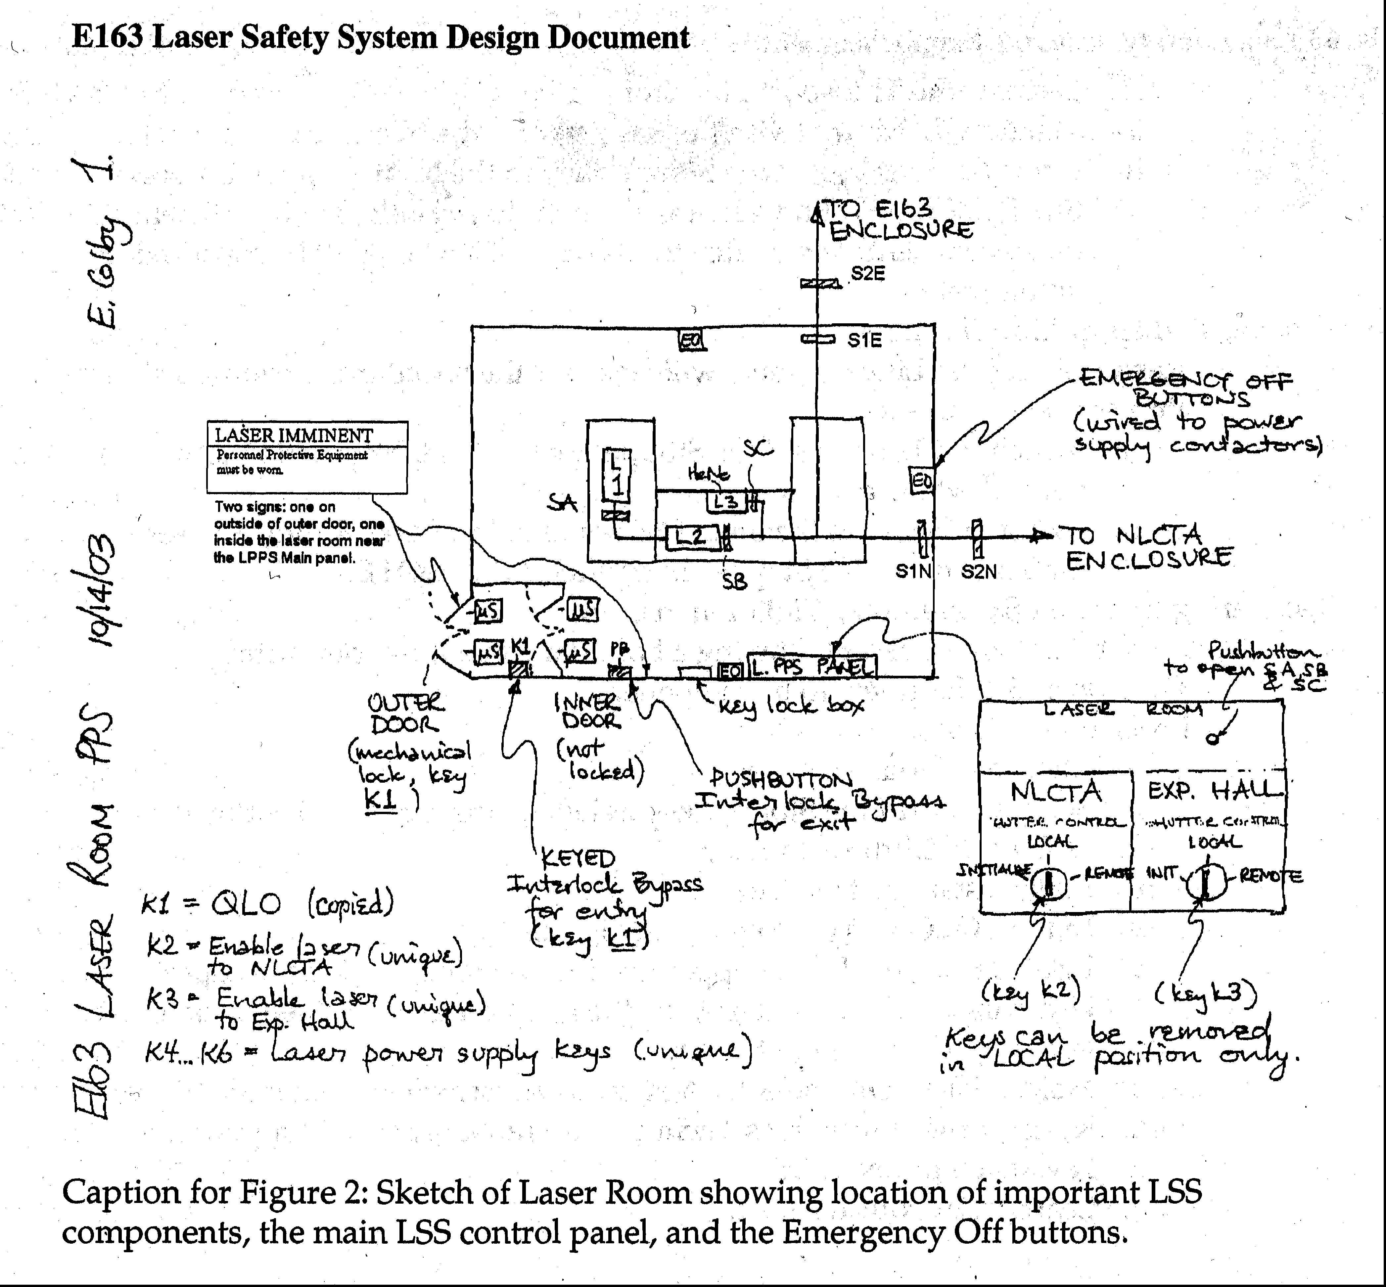

[

Note: figure is outdated and inaccurate. The changes made include adding three table shutters and putting the Wes t EO button on the PPS Laser Safety System box.]
Appendix C – Laser Safety System Panel
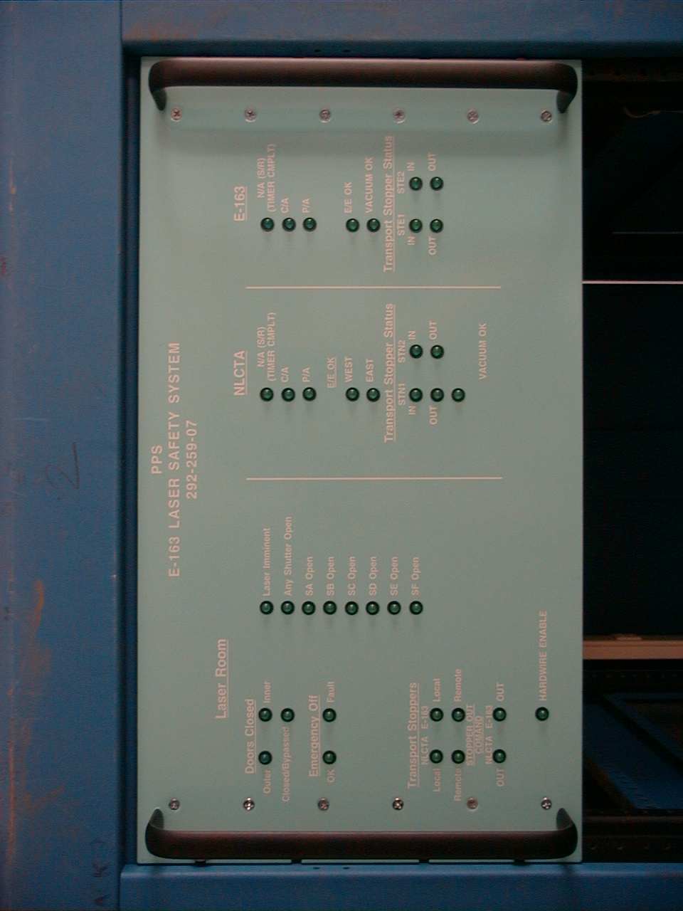

Appendix D – Laser Room Outer Door

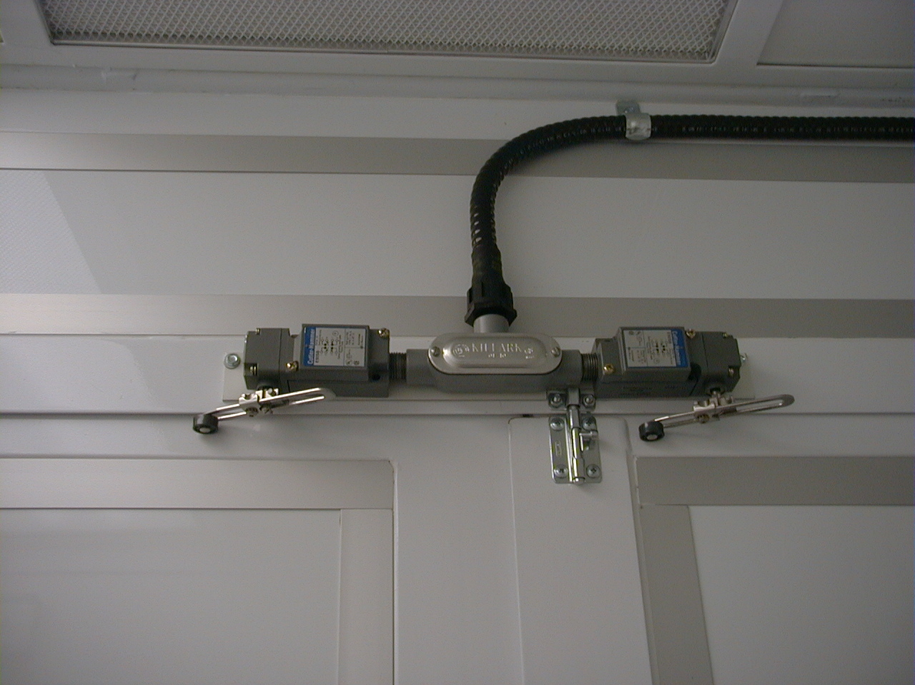
Appendix E – Inner Door Control Box – Outside
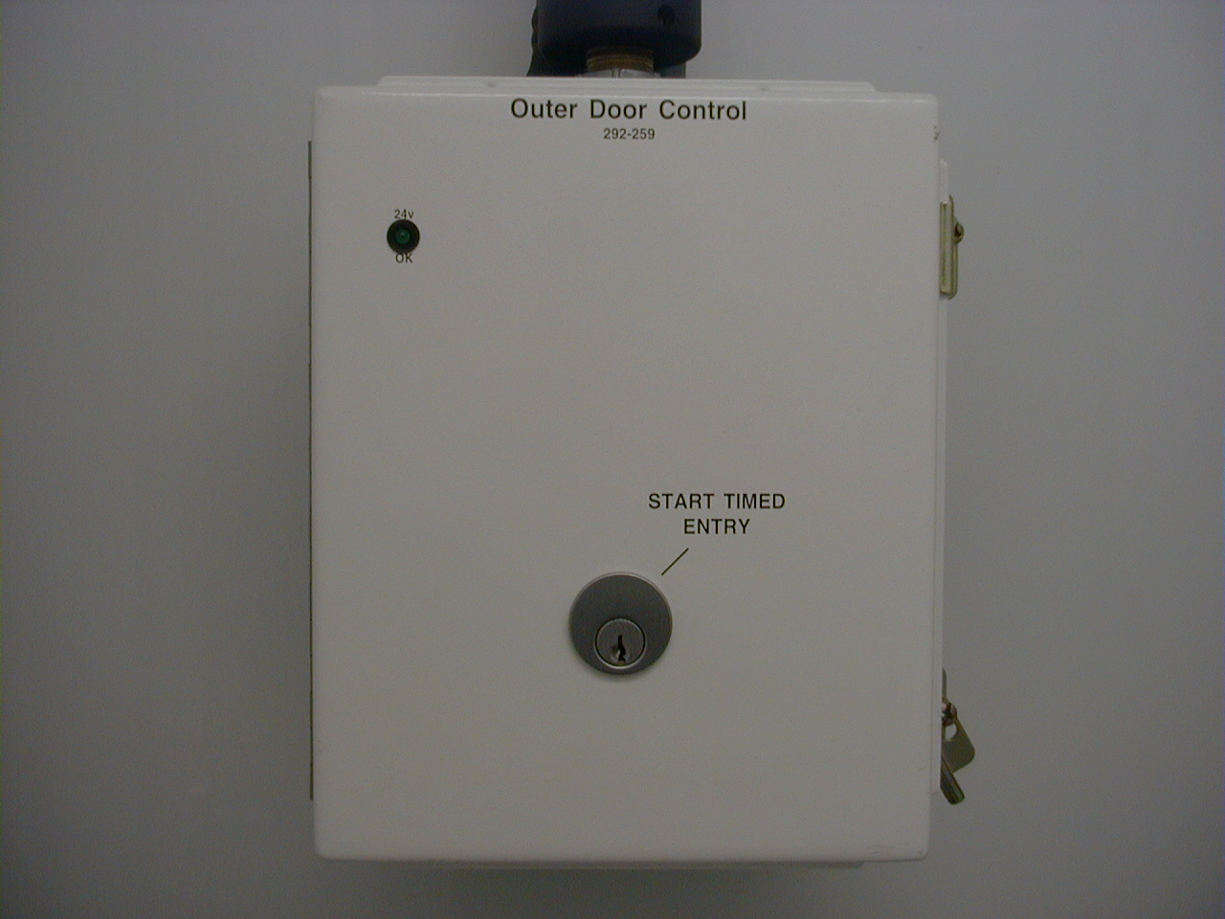
Appendix F – Inner Door

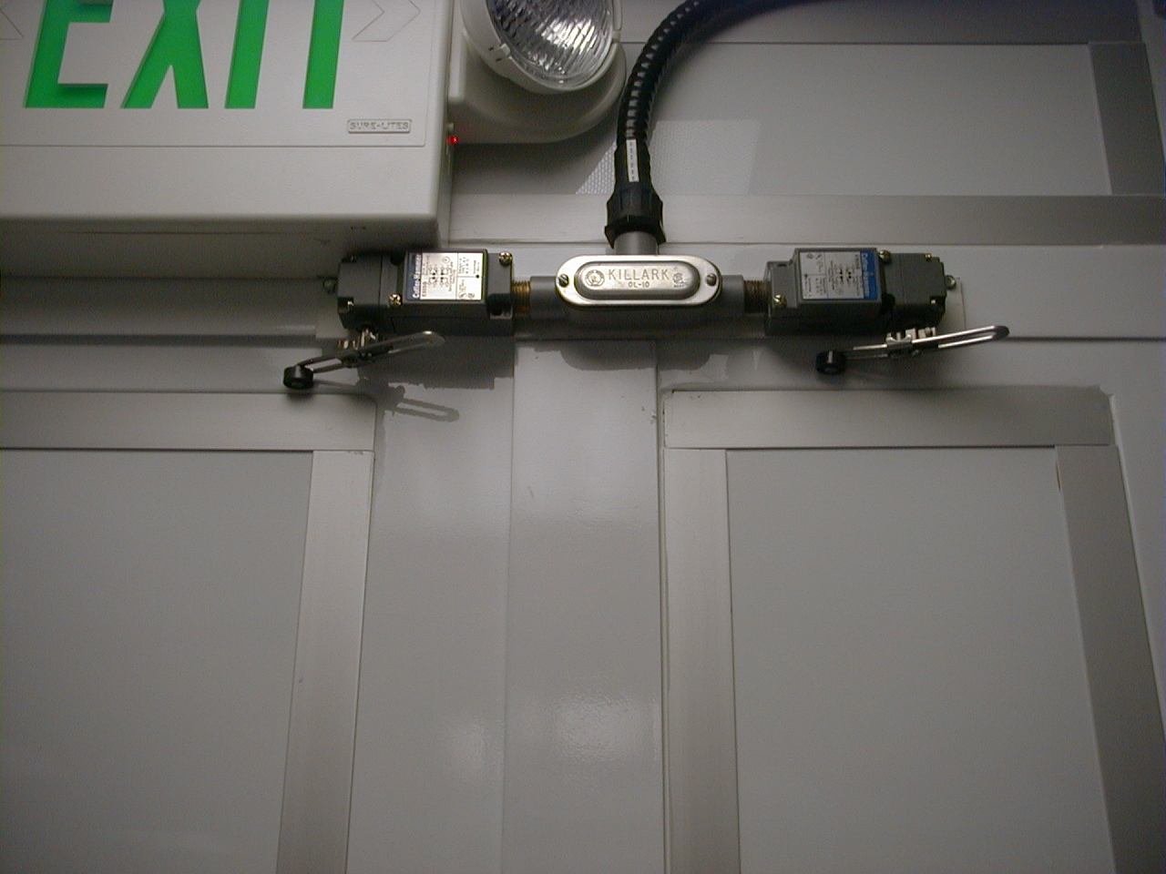
Appendix G – Inner Door Control Box – Inside

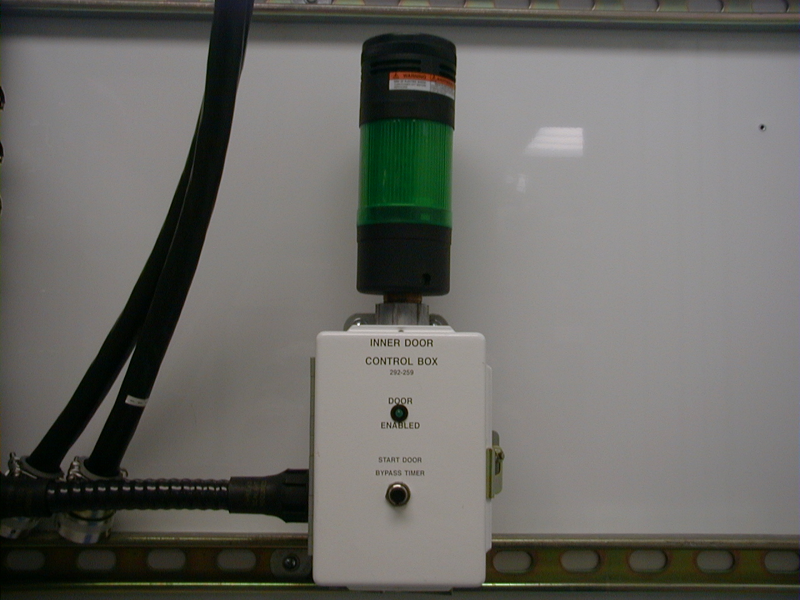
Appendix H – PPS Laser Safety System Box
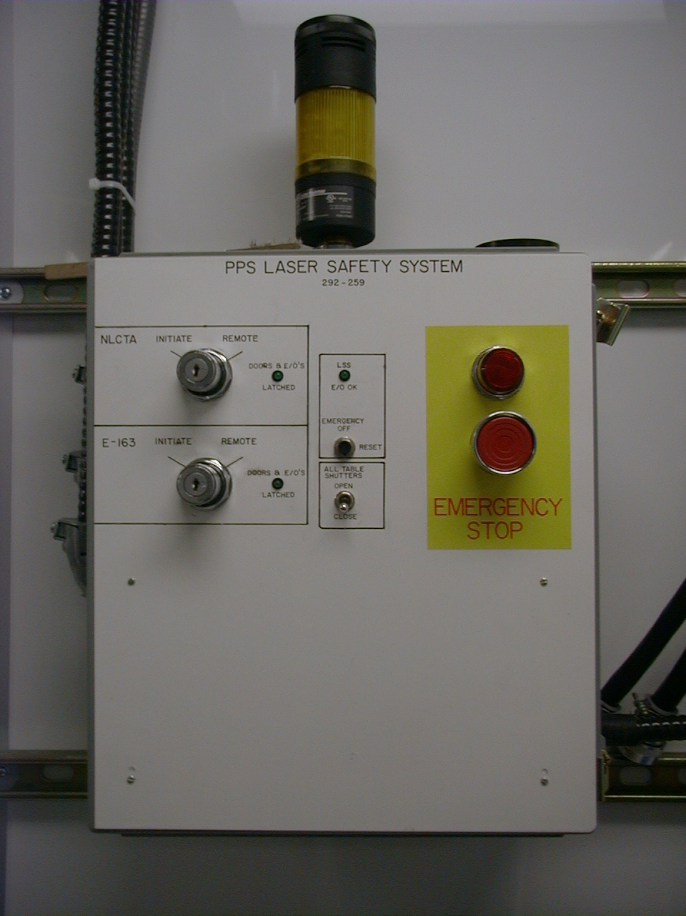

Appendix I – Laser System Emergency Off Power Contactor
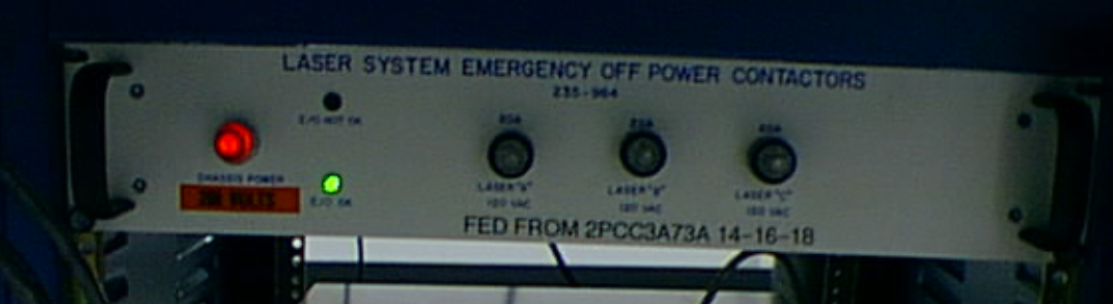
Figure 1. Front of Laser System Emergency Off Power Contactors chassis (235-984). Indicators that are visible: “Chassis Power” (large red indicator, at left), “E/O NOT OK” (top LED, red, not lit), and “E/O OK” (bottom LED, green, lit). Circuit fuses are visible as well.

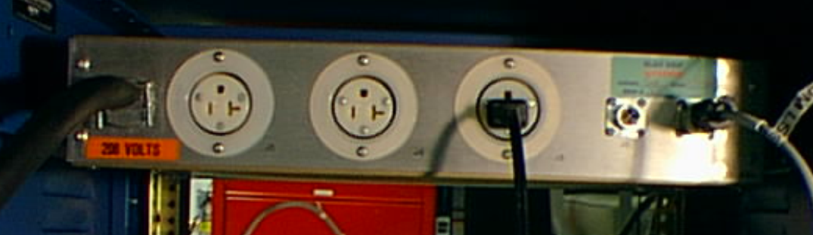

Figure 2. Rear of Laser System Emergency Off Power Contactors chassis (235-984). Connectors are J5 (leftmost) – 110V power for laser SA, J4 (middle) – 110V power for laser SB, J3 (right socket)—110 V power for laser SC. Also visible: J4 (E/O signal passthru to future contactors) and J5 (E/O signal input from Laser Safety System Box J1).

Appendix J – NLCTA Transport Stopper Box inside

Appendix K – NLCTA PPS Panel Test Mode Box

