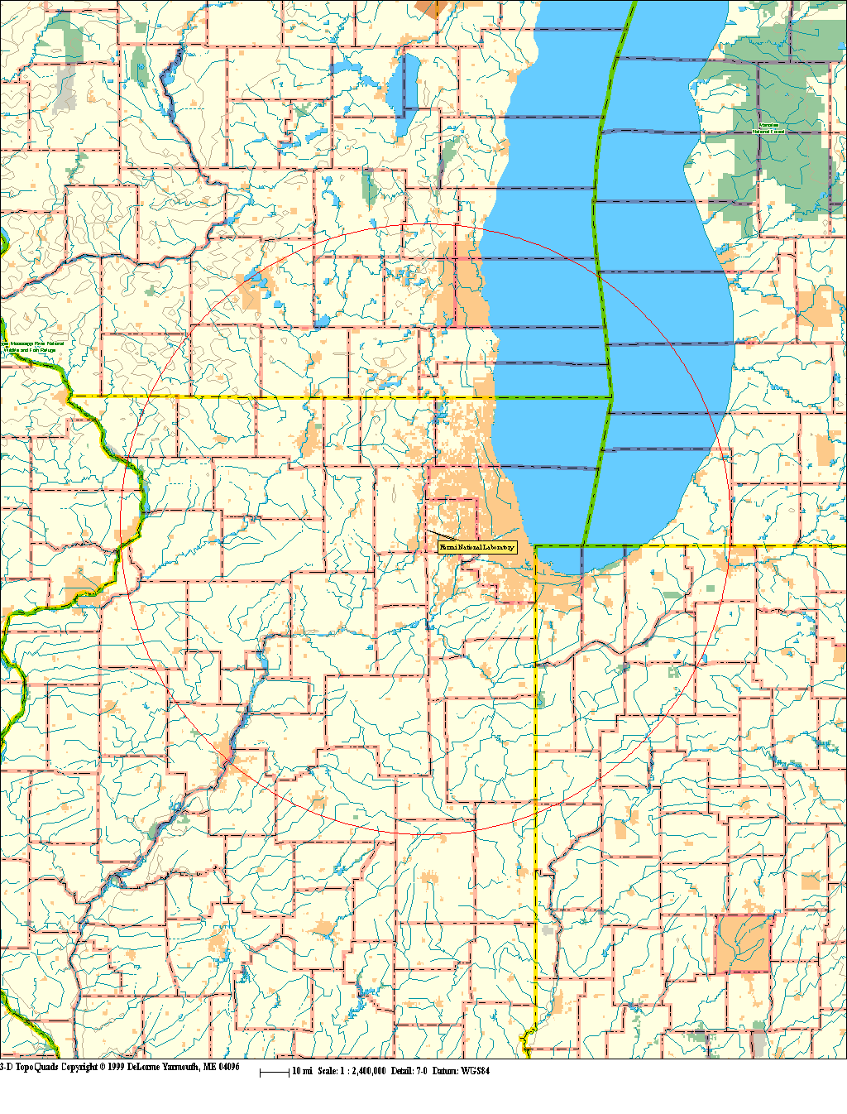
Figure 1: VLHC Maximum Study Region
Fermi
Study Region
Fermi

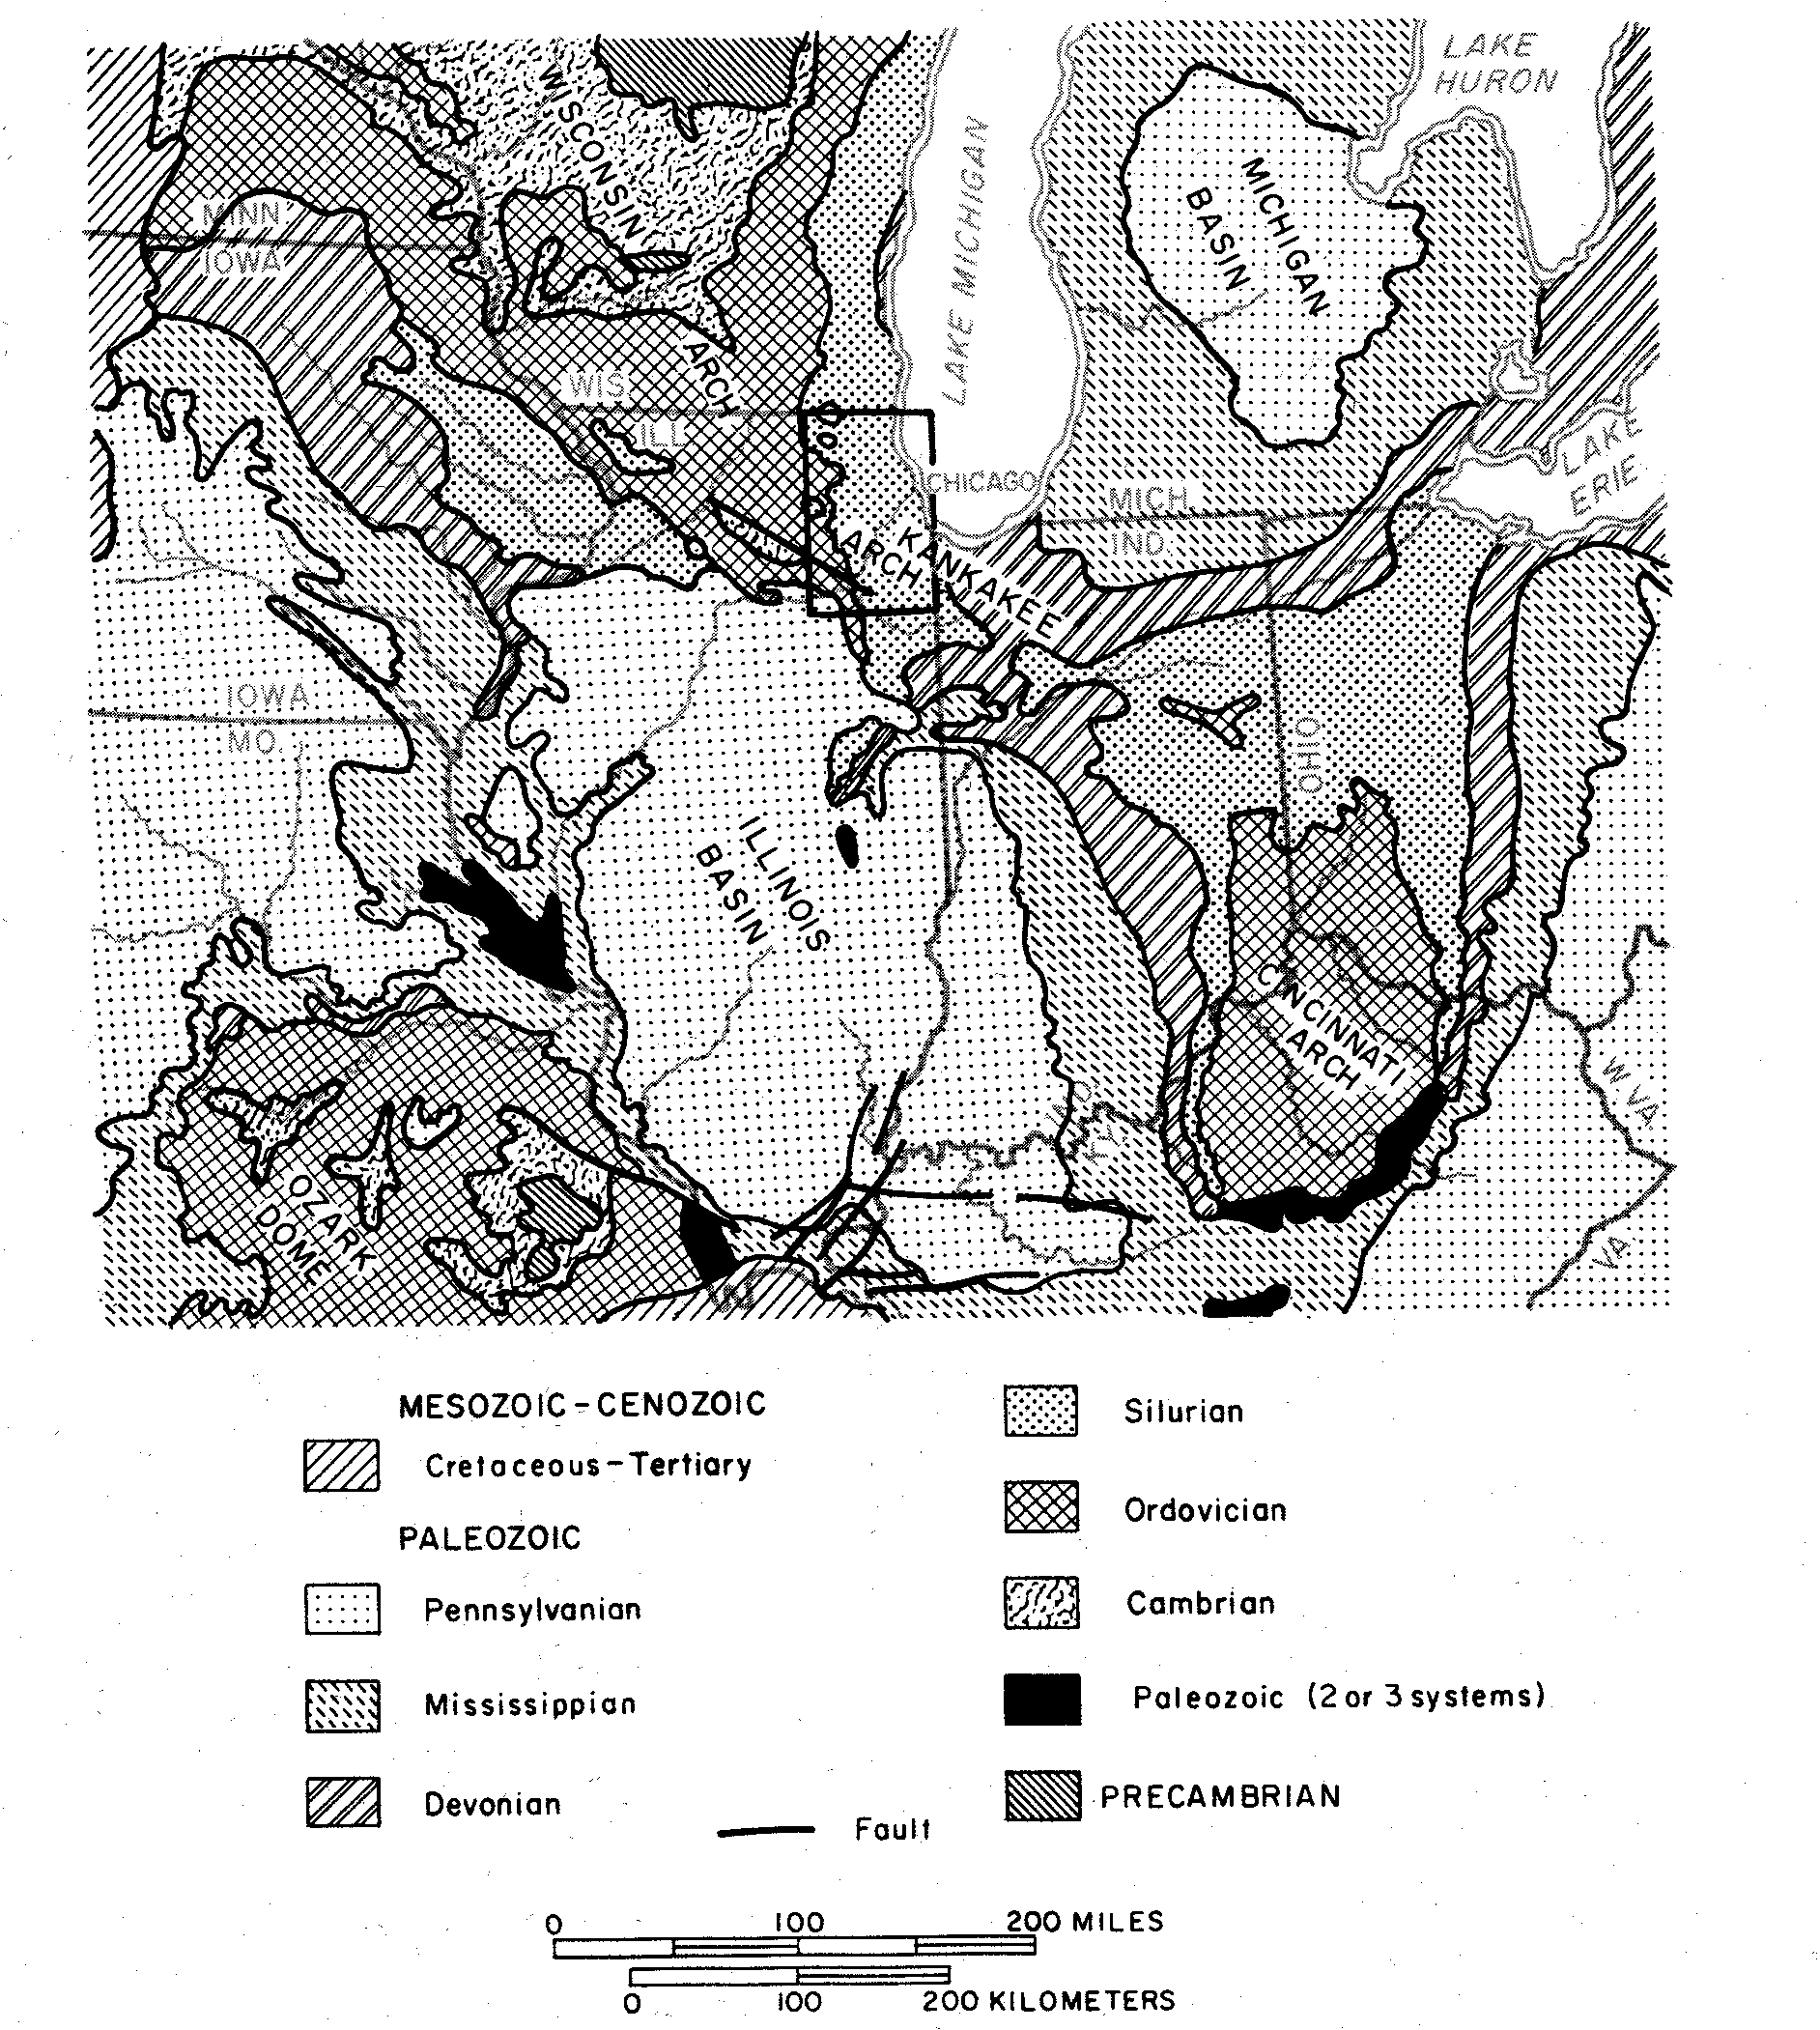
.
Figure 2: Bedrock Geology Map
Of
North-Central States

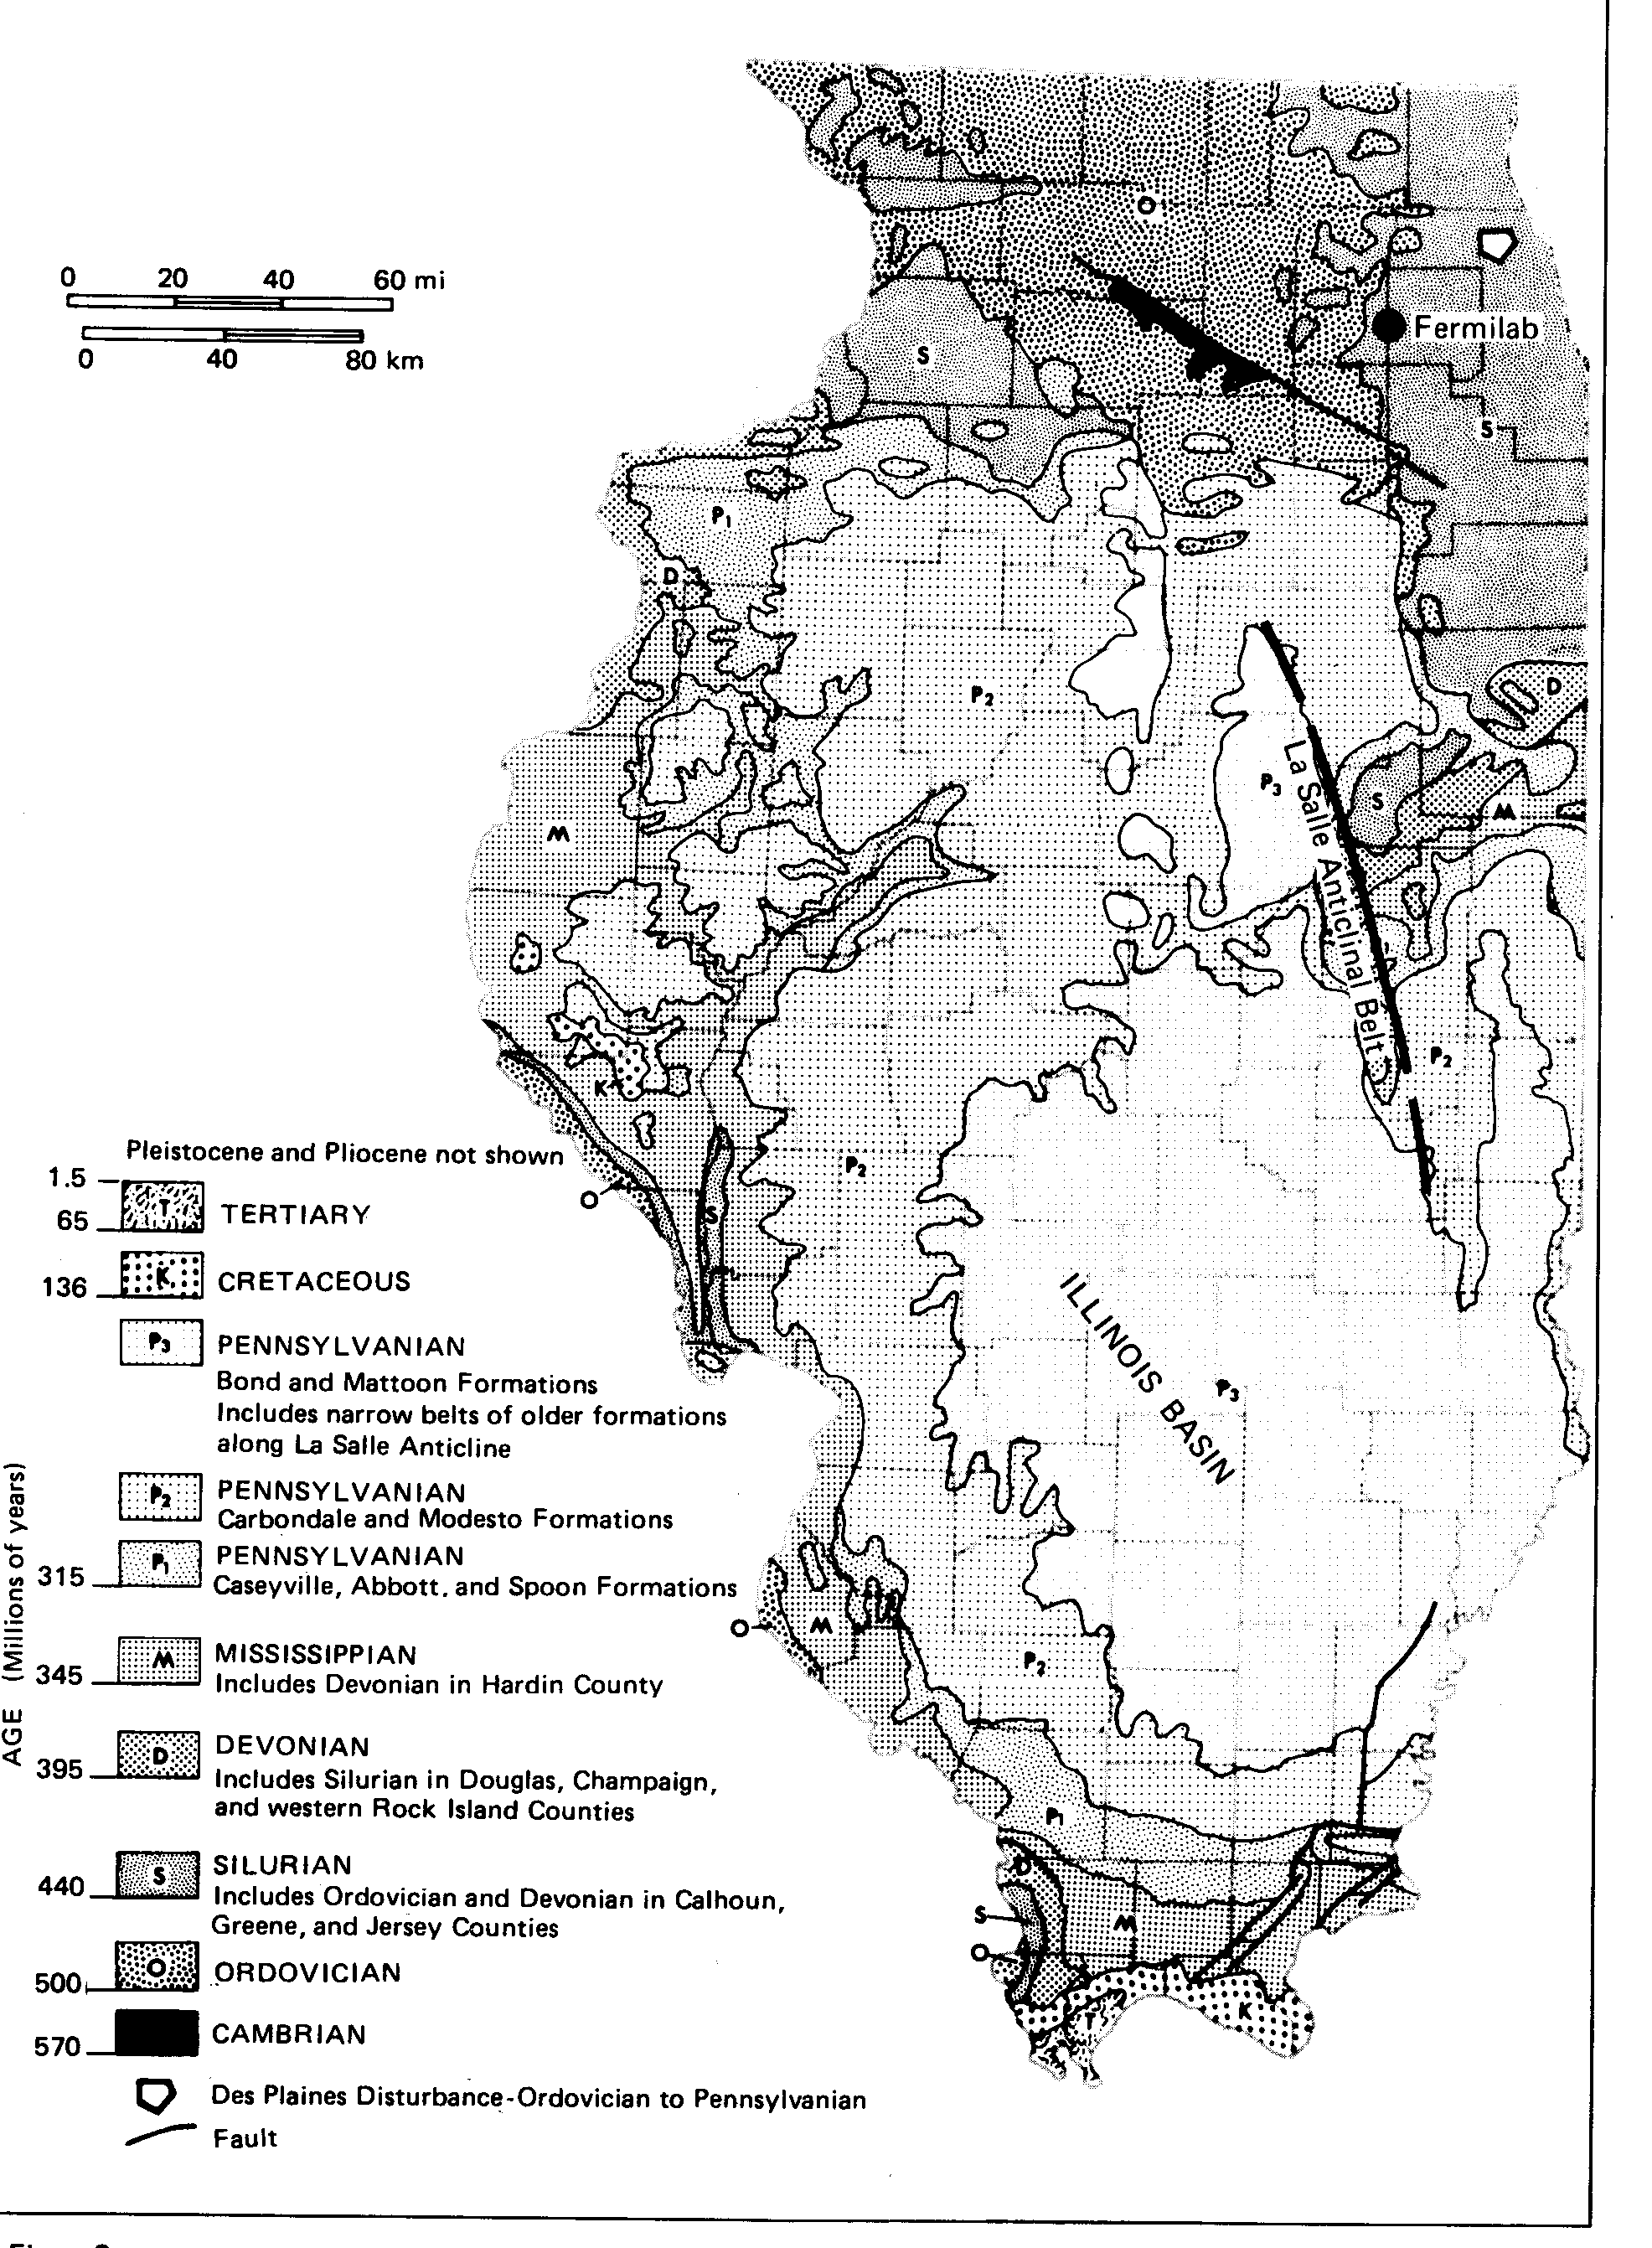
.

A
C
B
D

B
A
C
D

Figure 3: Geology of the Bedrock Surface of Illinois

Fermi
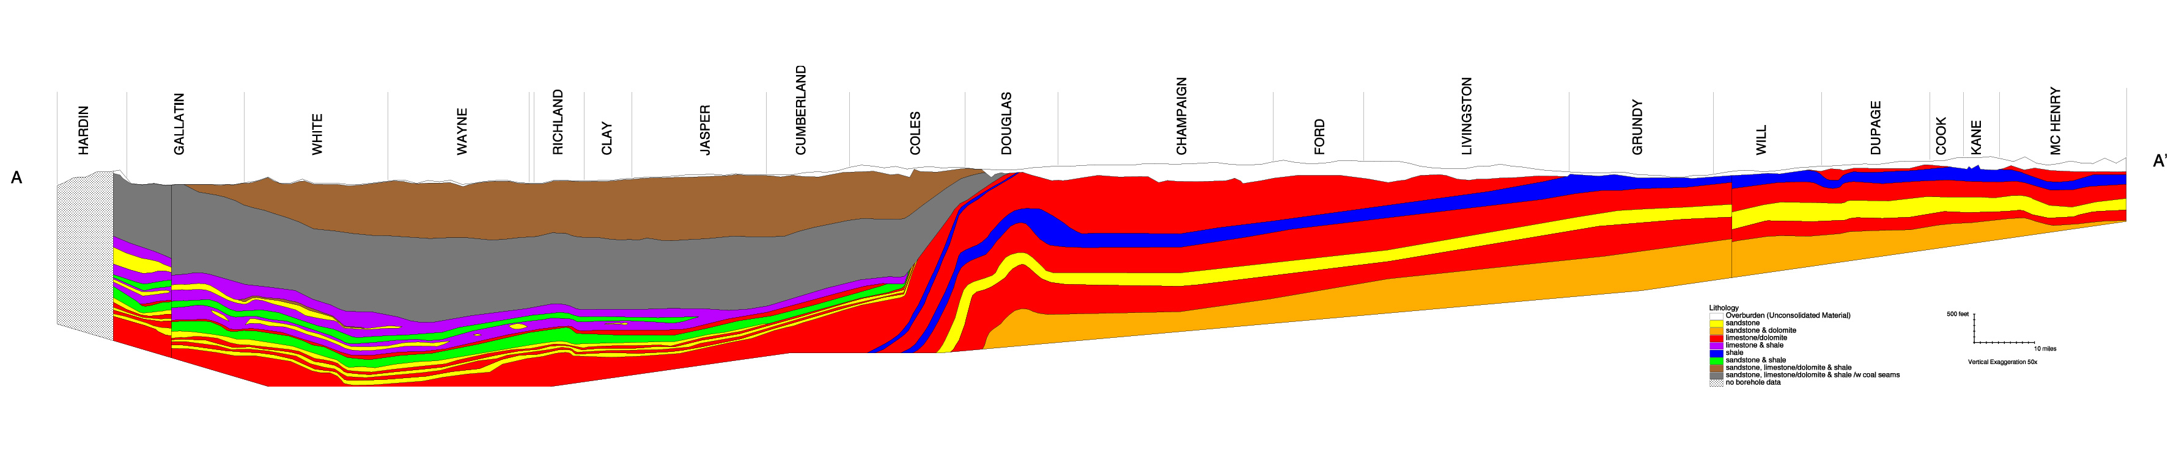
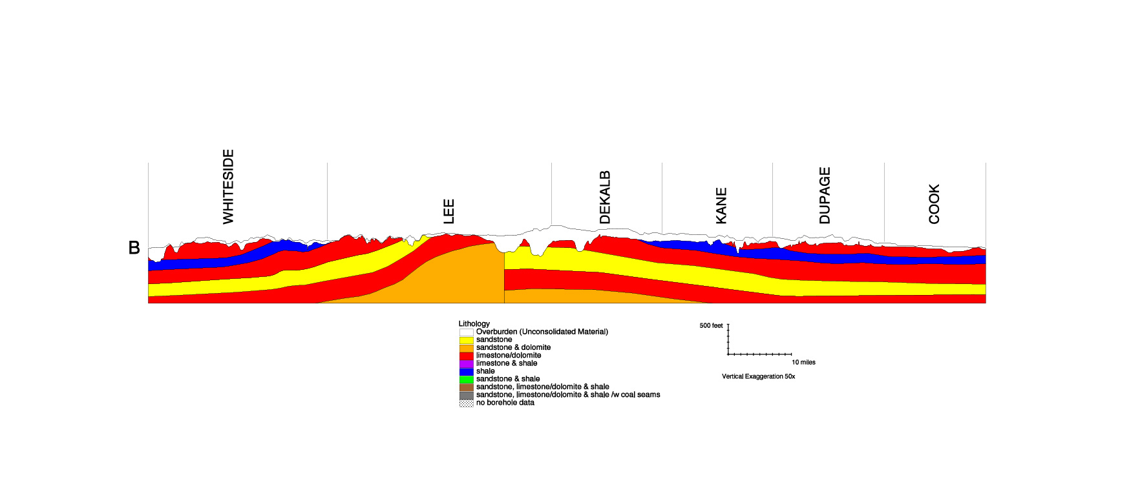
.
Illinois Basin
LaSalle Anticlinal Belt
Sandwich Fault Zone
Sandwich Fault Zone
Kankakee Arch
Michigan Basin

Section A-A
North

South
East
West

Fermi

Fermi
.
Kankakee Arch

Section B-B

Southeast
Northwest

Fermi
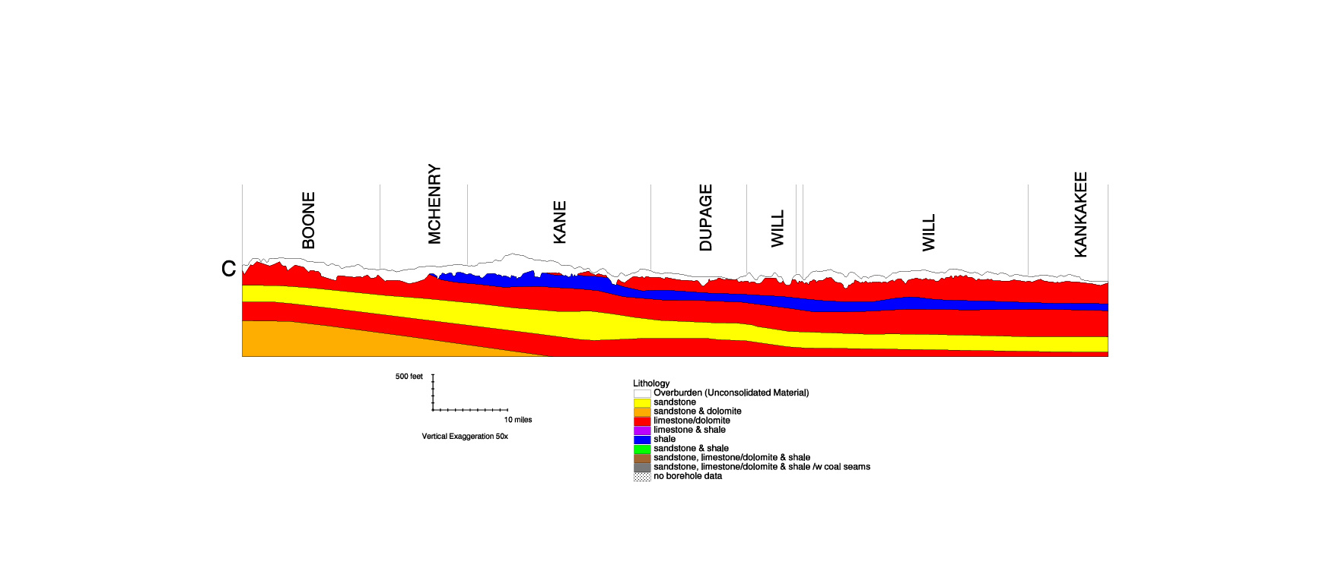
.
Illinois Basin
LaSalle Anticlinal Belt
Sandwich Fault Zone

Srction C-C
Northeast
Southwest

Fermi
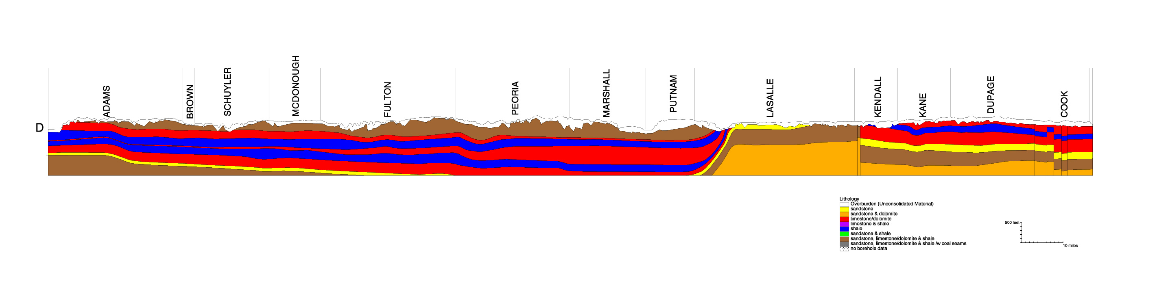
.
Figure 4: Geologic Sections, Illinois State Geological Survey

Section D-D
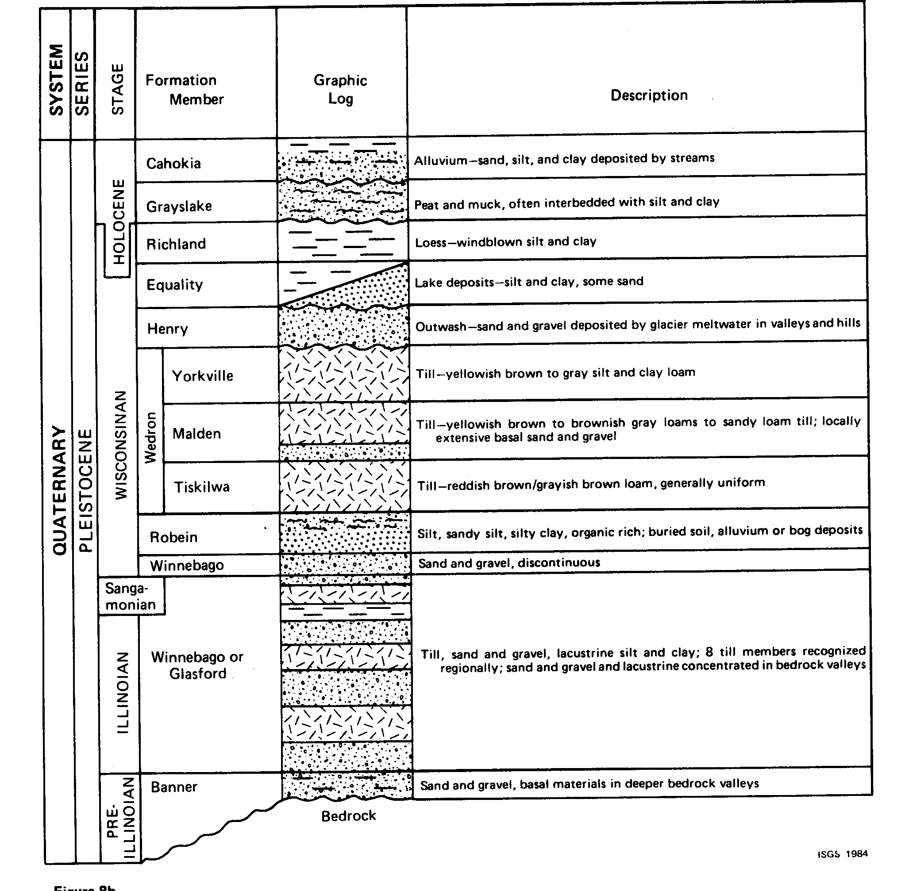
.

Figure 5: Quaternary Geologic Column

EGN 111

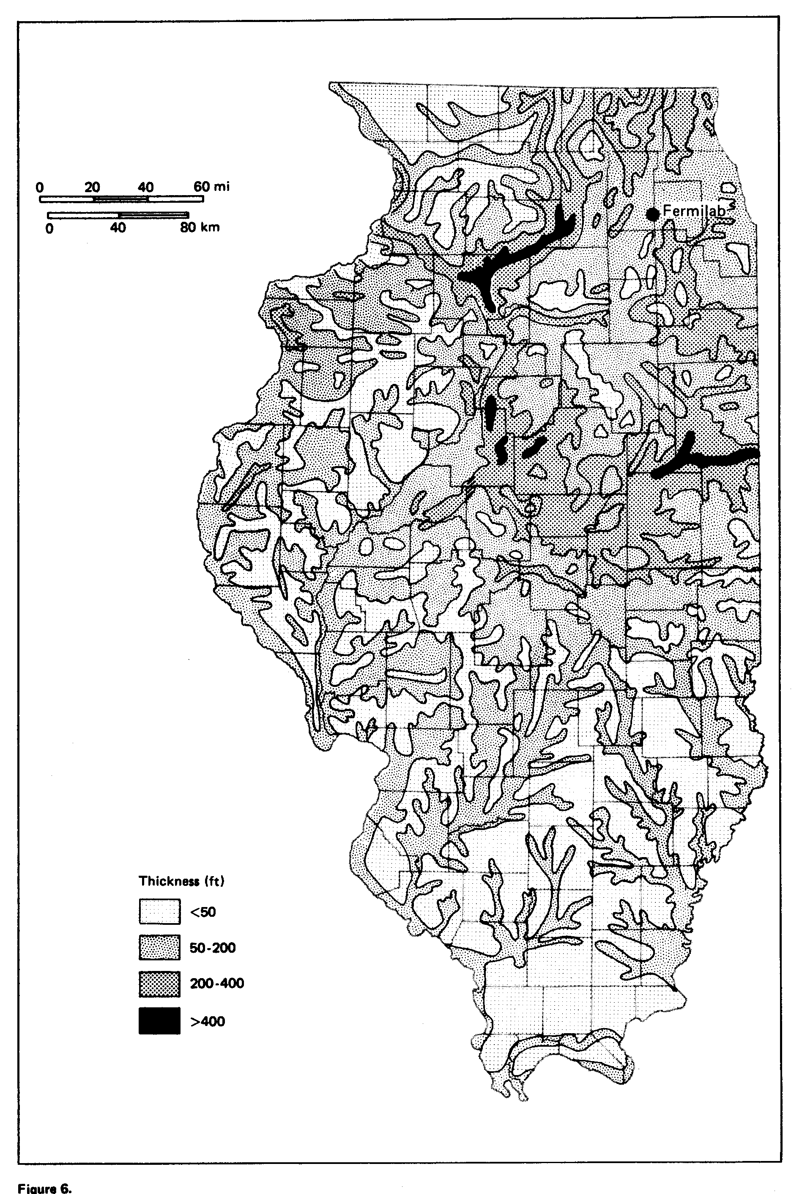

Figure 6: Thickness of Glacial Drift

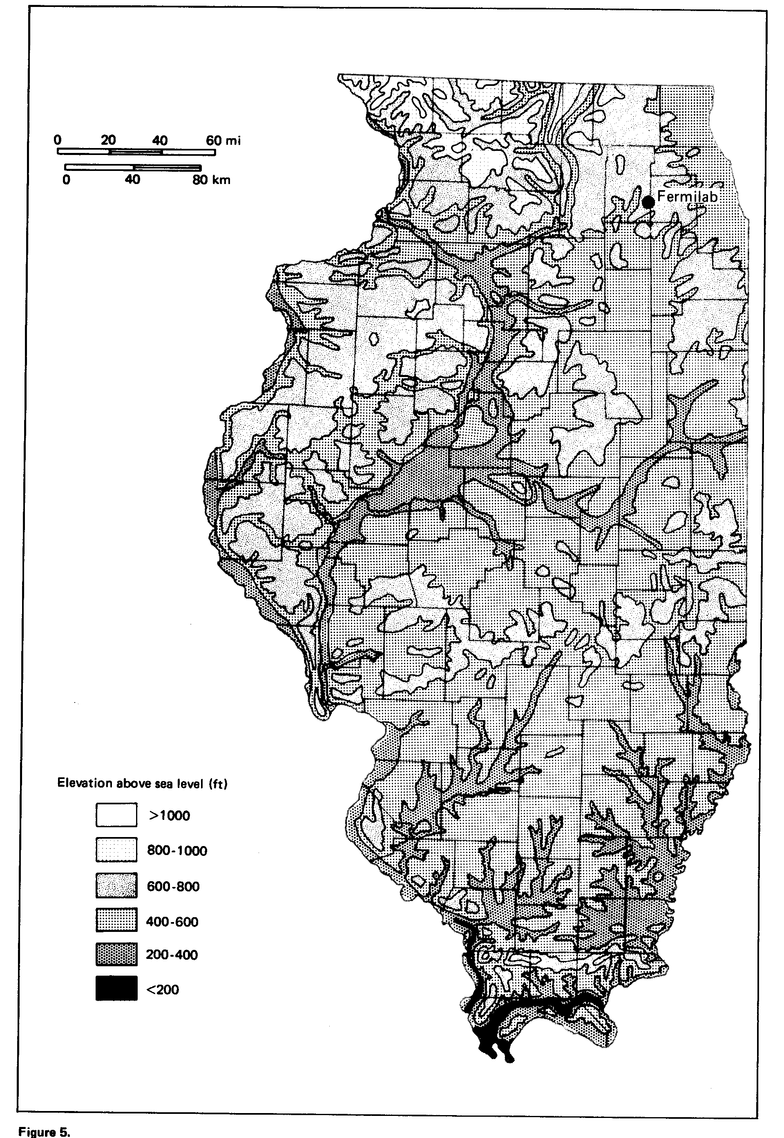
Figure 7: Top of Bedrock

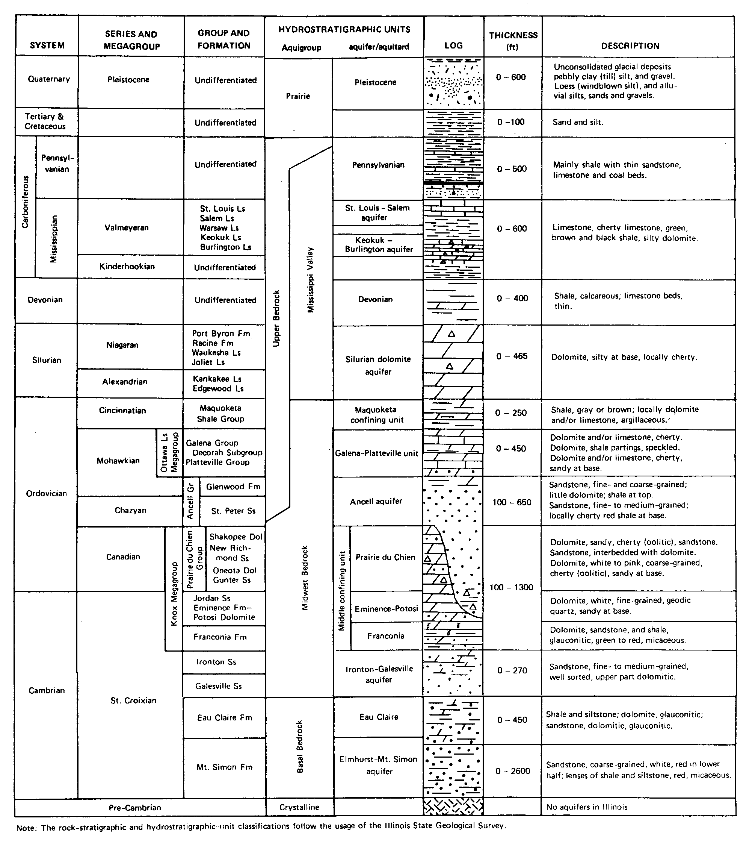
Figure 8: Bedrock Stratigraphic Column

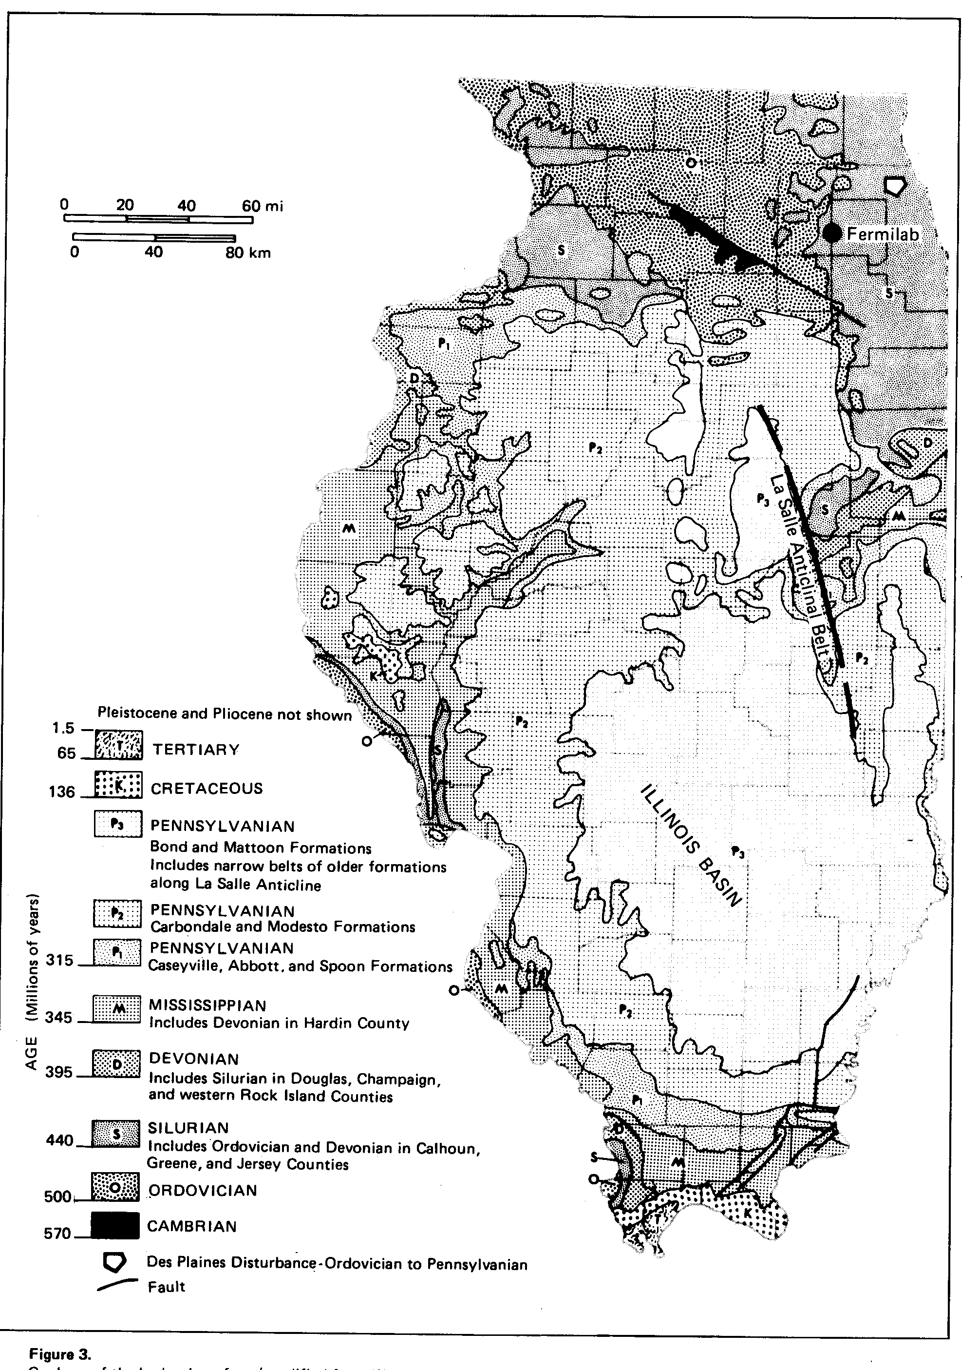
Figure 9: Illinois Bedrock Geology

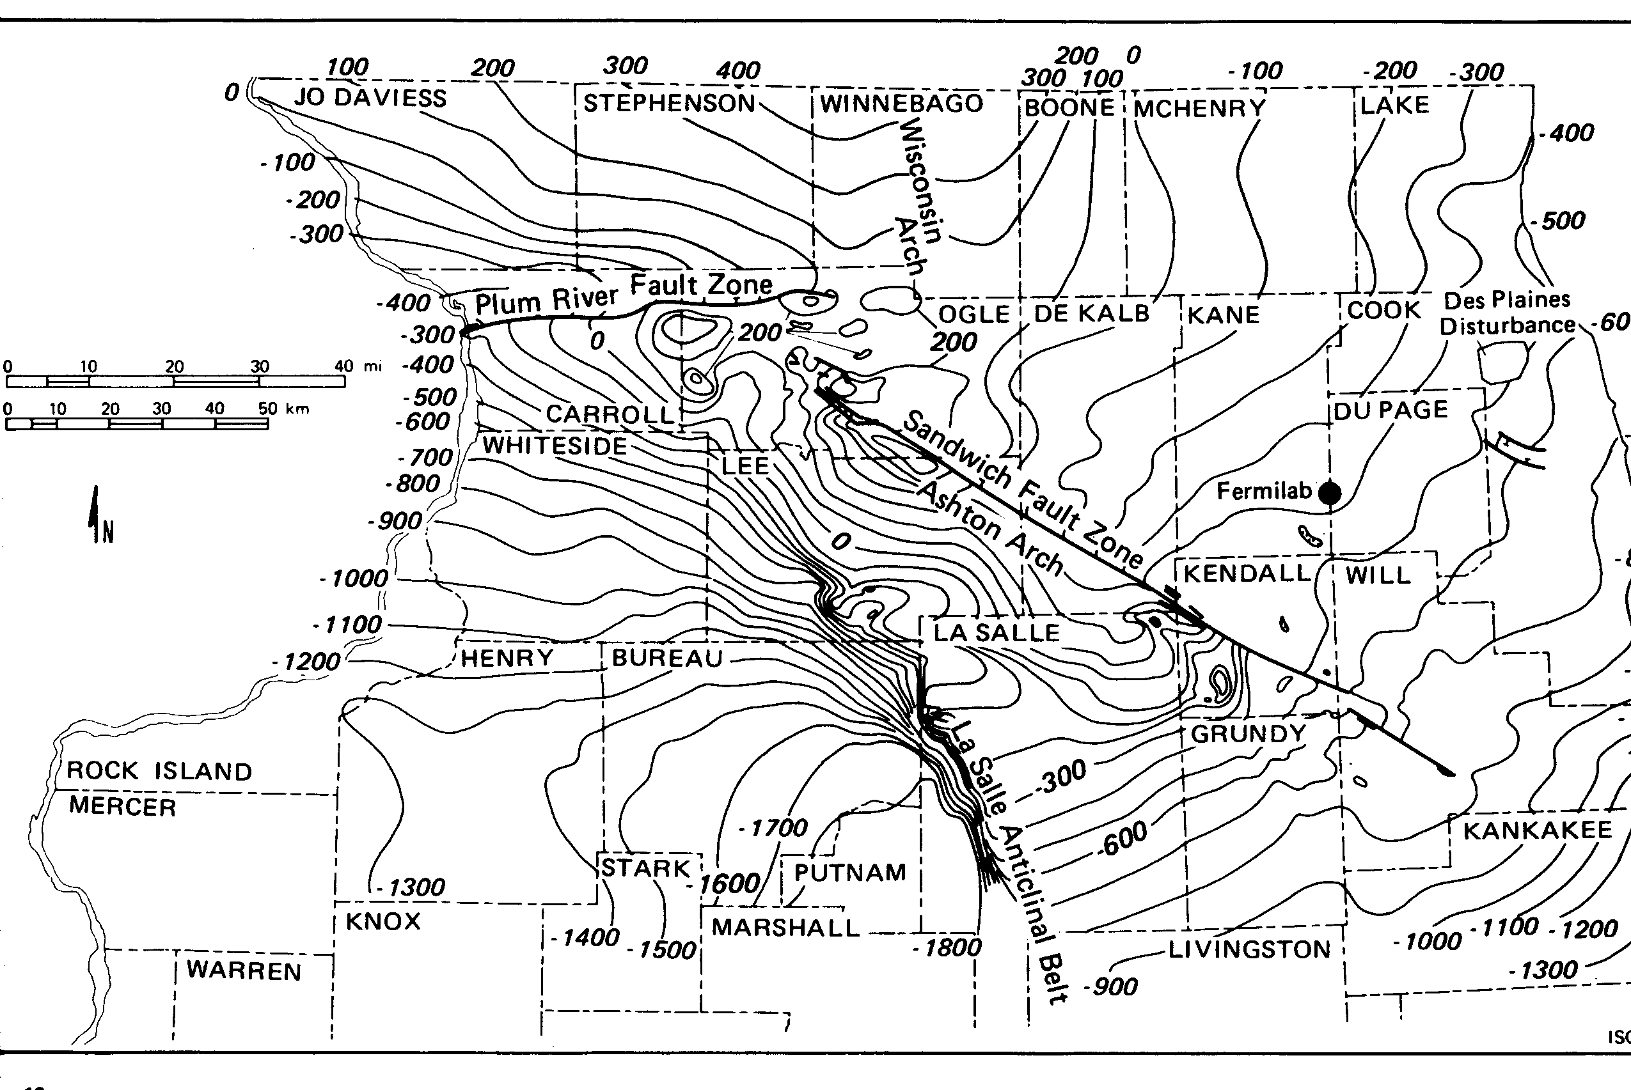
.

Figure 10: Structural Features
Contours top of Franconia Formation

.
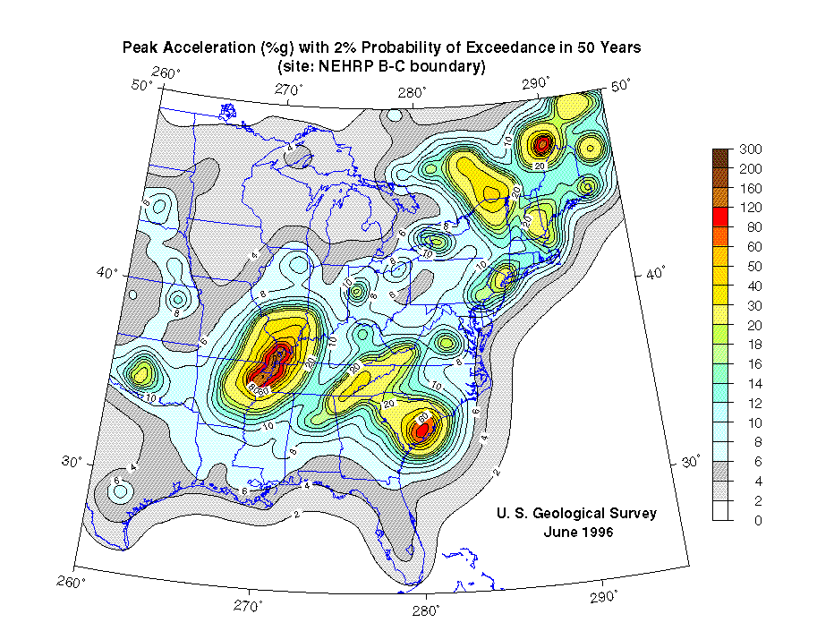

Figure 11: Seismic Hazard Map
.
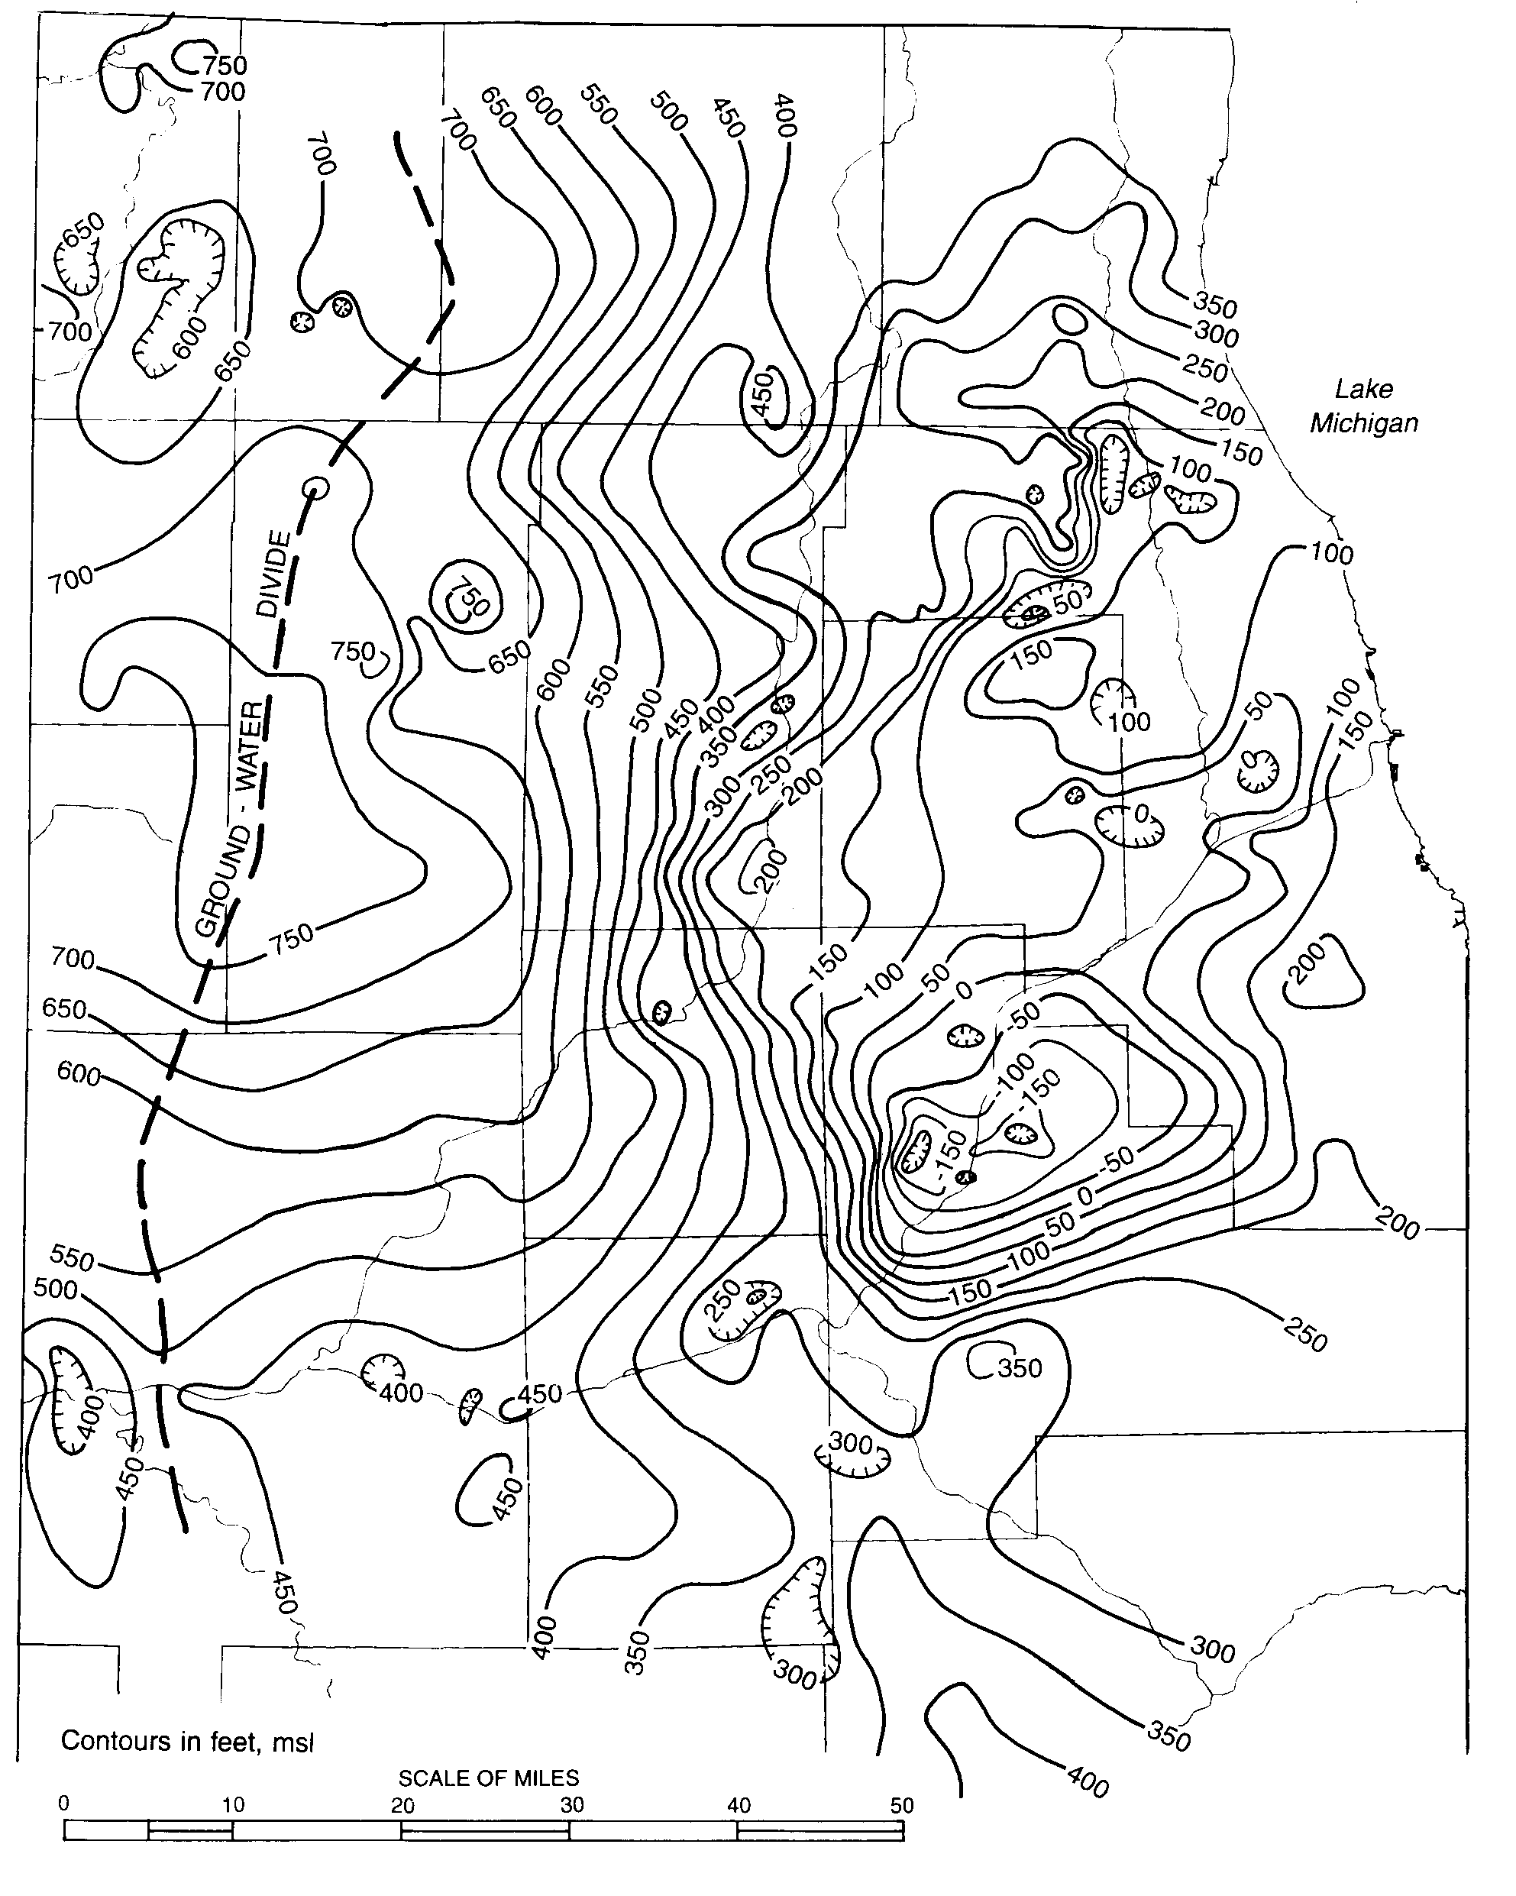
Fermi

Figure 12: Peizometric Surface
Deep Bedrock Aquifer, 1995

531kmSW
228km NW
228km N
120km W
228km NNW

Figure 13: Possible VLHC Alignments

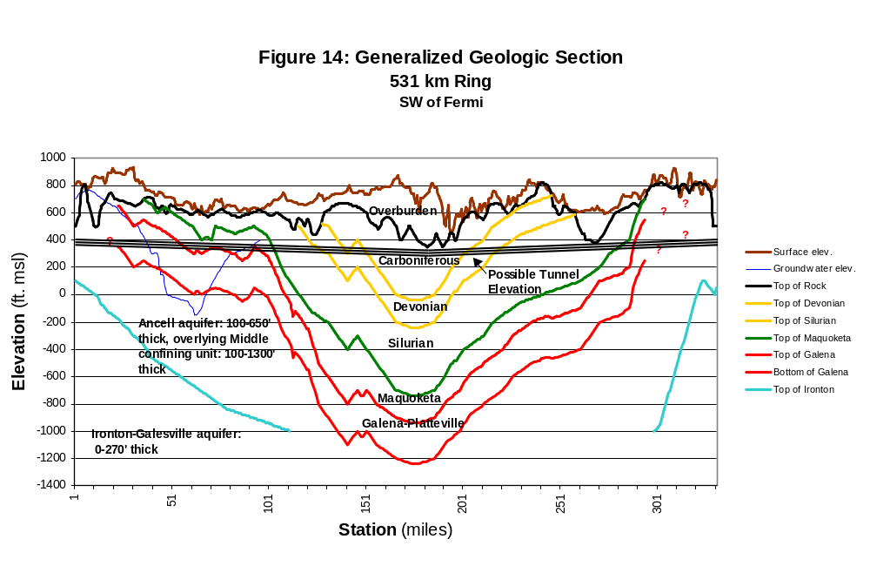

North

South

East
Fermi
West
North
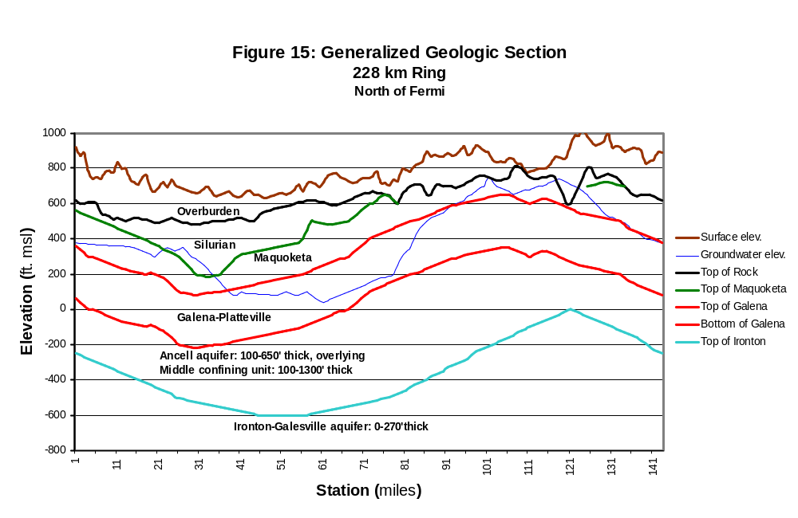

Fermi

North
North
East
South

West
Possible Tunnel Elevation
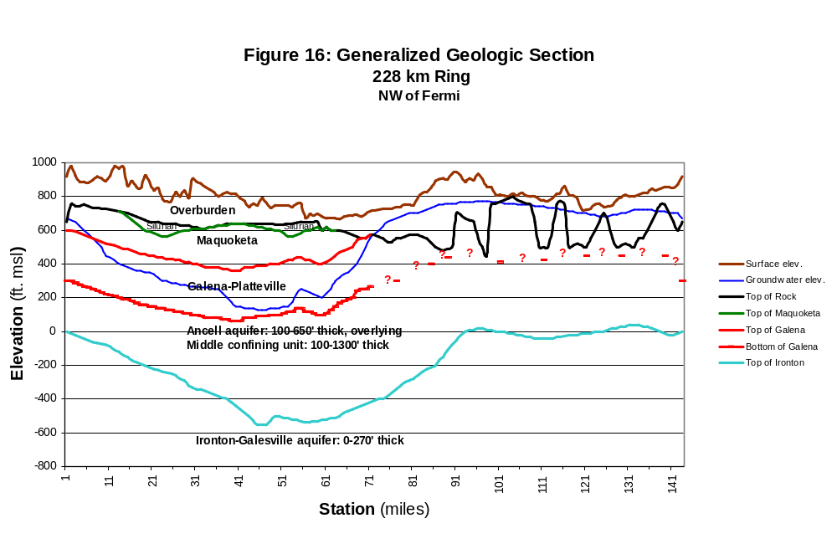
Fermi

North

North
South
East

West
Possible Tunnel Elevation
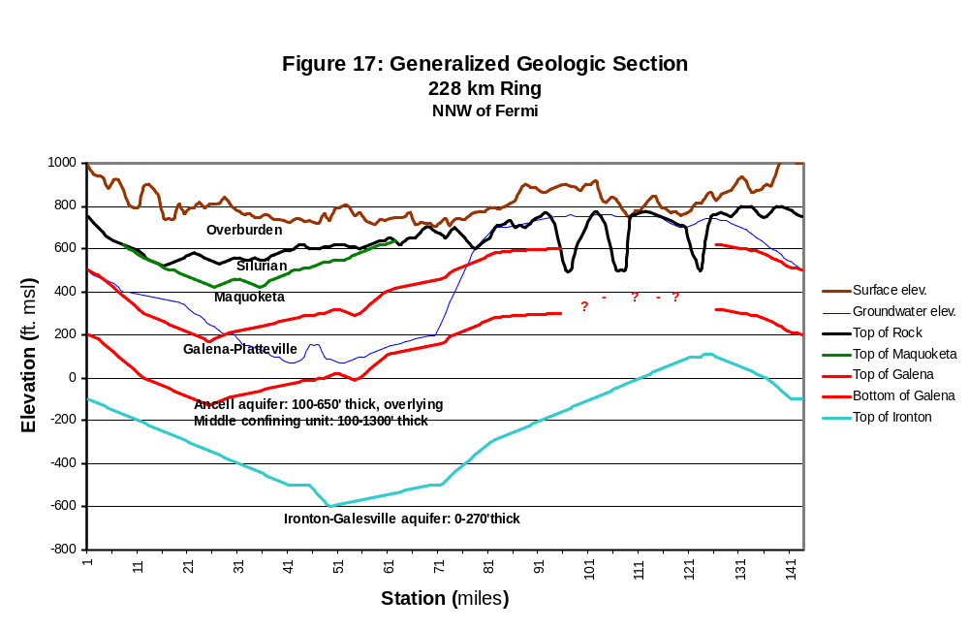
North
East

South
West
North
Fermi
Possible Tunnel Elevation
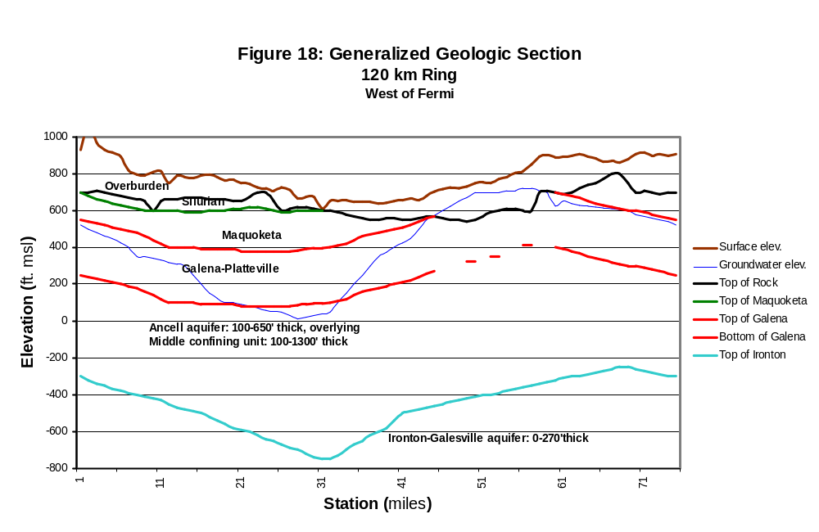
228km N

North

East

South

West

North

Fermi
Possible Tunnel Elevation

