DRAFT
07/15/01
Letter of Intent for the
LINX Test Facility at SLAC

NLC Collaboration

Stanford Linear Accelerator Center
Lawrence Livermore National Laboratory
Lawrence Berkeley National Laboratory
Fermi National Laboratory

Martin Breidenbach
Franz-Josef Decker

Stanford Linear Accelerator Center

Philip Burrows
Simon Jolly
Glen White

Oxford University, Oxford, England

Thomas Mattison

University of British Columbia, Vancouver, Canada

EXECUTIVE SUMMARY
The interaction region in any future linear collider has unique engineering challenges. The beam line components, which focus the beams at the interaction point, must be effectively stabilized at the nanometer level. Masking and instrumentation around these focusing components must be integrated with the detector while minimizing the solid angle occupied and the additional material which can generate sources of background. LINX is a proposed new facility at SLAC to support engineering studies of many of these critical issues. It would be located in the SLD collider hall and reuse much of the existing hardware of the SLC and SLD. The primary goals of this facility are:

      - Test stabilization techniques proposed for future linear colliders and demonstrate nanometer stability of colliding beams.
      - Investigate new optical techniques for control of beam backgrounds.
      - Provide a facility where ultra-small and ultra-short beams can be used for a variety of other experiments.

The beam-beam interaction is an unsurpassed tool for measuring the stability of the beam-beam collision at the nanometer level and validating any vibration suppression scheme proposed for colliding 1-10 nm size beams. It is for this reason that the LINX test facility would be located in the SLD collider hall and use SLC-like electron and positron beams, rather in the FFTB where only a single beam is available. To achieve the required resolution in the beam-beam deflection, the beams must be focused to a size of less than 100 nm. By implementing the recently proposed final focus design with local chromatic correction in the final doublet, vertical beam sizes of roughly 50 nm may be achieved. To reach this value, the incoming beam emittance must also be reduced through minor upgrades to the damping rings. With the short focal length at the upgraded interaction point, it will also be desireable to have beams with a very short bunch length which can be achieved by compressing the beams in the SLC Arcs.
This document summarizes the motivation, design, program, and impact of the LINX experimental facility. The hardware modifications required to change the SLC final focus and improve the incoming emittance are modest in cost and scope. The beam parameters and running modes have been chosen to be “gentle” on the hardware, completely parasitic to PEP-II running, and relatively easy to establish and maintain. Low bunch charge, a beam energy of 30 GeV, and low repetition frequency are ideal for the accelerator engineering goals of LINX. The facility would be developed in a phased approach where the first step would be simply to reestablish the integrity of the existing hardware, before committing resources to the upgrades. Once the basic hardware upgrades were complete, LINX would be operated for 2-3 week blocks as new hardware became available and new experiments were proposed. A list of initial experiments and the time estimated to complete them is included in the main body of this document. An Experimental Impact Report is in preparation.

Introduction
The international high energy physics community has developed a growing consensus that the next major accelerator project will be an electron-positron linear collider with an energy in the range of 0.5 to 1.0 TeV. Collaborations in Europe, Japan and the US have well-defined conceptual designs for such a facility based on a variety of rf technologies. These designs build on the experience with the SLC and on years of R&D and studies. Test facilities have been constructed to verify the major components of the collider, including the Final Focus Test Beam (FFTB) [1] [2] and Next Linear Collider Test Accelerator (NLCTA) [3] at SLAC, the Tesla Test Facility (TTF) [4] at DESY, the Accelerator Test Facility (ATF) [5] at KEK, and the CLIC Test Facility (CTF) [6] at CERN. These facilities have demonstrated the viability of critical technologies and the designs are now sufficiently mature to be proposed as the next project. Effort has now shifted to engineering test facilities which can further optimize the cost, manufacturability, reliability and operability of the collider.
LINX is a proposed test facility for the Interaction Region (IR) of a linear collider which is a critical area with tight constraints on the stability of the final quadrupoles. In all of the current designs, the beam must be stabilized at the sub-nanometer level – far below the 40 nm jitter that was measured at the FFTB IP at SLAC. LINX is a “low energy version” of the IR which will allow tests of engineering prototypes of the stabilization systems required, using collisions between beams similar to those in future linear colliders. Beam collimation and background control are also critical issues for the performance of a linear collider. LINX will directly verify the effectiveness of new optical techniques developed to reduce the beam tails in the final magnets. If successful, these techniques could ease the requirements on the collimation systems and substantially reduce their cost or complexity.
LINX will use 30 GeV electron and positron beams colliding in the SLD IR with about 6*10⁹ particles per bunch and a repetition rate ≤ 30 Hz. The vertical beam size will be about 55 nm with a bunch length between 1 mm and 100 μm. The Final Focus optics would be modified to emulate the new NLC Design [7] in order to achieve IP beta functions of 8 mm and 100 μm without excessive high-order aberrations. The SLC Final Focus triplets would be replaced by a quadrupole doublet with characteristics very close to those required for NLC. The transverse beam sizes are comparable to those produced in the FFTB at SLAC but LINX has two major advantages: a shorter bunch length (up to a factor of five) and colliding beams. The beam-beam deflection from the colliding beams provides an exceedingly high resolution diagnostic of the beam offset and the beam sizes at the IP that would be virtually impossible to duplicate by other methods.
SLAC is the only laboratory where high-energy beams have been brought into collision at the sub-micron level. The geometric emittances of the beam at the end of the SLAC linac are some of the smallest emittances in the world—the horizontal emittance is the smallest in the world and only the ATF damping ring at KEK produces a smaller geometric vertical emittance. More importantly, the combination of the SLAC linac and SLD detector provides a unique opportunity to create a world class test facility for high energy collider development with little additional effort or cost. A side benefit of operating such a test facility at SLAC is that it will augment the knowledge and experience acquired during the operation of the SLC, providing some continuity toward the operation of a future linear collider. In addition, we foresee it as an open experimental facility to test new ideas that might arise during the next few years of operation and studies.
To reach the very small beam size required at the IP, very high quality beams must be produced and maintained. This in itself is an important demonstration of the feasibility of reliably operating a linear collider. These high quality beams will also open the experimental facility to a wide range of possible novel experiments on short bunches for short wavelength Free Electron Lasers like the Linac Coherent Light Source (LCLS) [8], next generation plasma wakefields, new diagnostics for ultra-small and ultra-short beams, etc.. A successful facility will provide the world's only test bench for a variety of physics topics that require such unique beams with the combination of low emittance, small beam size at the IP and short bunch length.
In the next sections, we describe the experimental program including the primary goals as well as some of the additional experiments that might be considered. Next we describe the facility and the hardware modifications needed. Finally we outline a commissioning procedure that might be followed.

LINX experimental program
The two primary goals of LINX are to demonstrate sub-nanometer level stability of the Interaction Point (IP) and to test new methods of background control, but we anticipate that further experiments to test new ideas and hardware will be proposed. We believe that a staged approach is a proper strategy for achieving the LINX goals – both in terms of gradual improvement of the performance and in terms of implementing the hardware. Table 1 lists the LINX parameters and beam requirements. The staging of the facility is outlined later in the text.

TABLE
LINX Parameters
 | Beam energy | 30 GeV
 | IP emittances | γε _{x,y}=1.6/0.16E-5 m
 | IP betas | β_{x}=8 mm, β_{y}=0.1 mm
 | Bunch length | σ_{z}= 0.1-1.0 mm
 | IP spot sizes | σ _{x,y}=1500/55 nm
 | Bunch population | N = 6E9

a) Nanometer Stabilization at the IP
A major challenge for future linear colliders is the stabilization of the nanometer-sized colliding beams at the IP. The relative offset between the beams can be affected by motion of upstream quadrupoles, but in most cases the effect is suppressed by long wavelength correlations or controlled by feedback. The most significant concern is high frequency motion of the final quadrupoles where differential motion of the two sides of the IP will cause the beams to miss. A number of collision stabilization approaches are being developed which use inertial or optical sensors on the position of the magnets either to stabilize the position with feedback or to feed-forward a correction to the beam trajectory. The NLC-like final quadrupoles for LINX would have appropriate dimensions, supports and active stabilization as shown in Figure 1. This would provide an ideal test bed for developing these techniques.
It is extremely difficult to demonstrate sub-nanometer stability of the collisions by indirectly measuring the vibration and the correlations that are important to the beam with seismometers or other measurement devices. LINX has the advantage that the main diagnostic for beam jitter at the IP will be the beam-beam deflection of the colliding electron and positron beams which provides a greatly amplified signal of the IP beam separation. The deflection measures directly the quantity of interest without the need for interpretation or dependence on particular models. The sensitivity of this diagnostic scales with the beam size, charge, and bunch length. Assuming a charge of 6x10⁹, a spot size of 100 nm, and a bunch length of 100 μm, the deflection angle would be roughly 1.7 μrad per nanometer of separation between the beams. This is a very strong signal and the BPM resolution is actually adequate for a signal a factor of 10 smaller which might arise from a longer bunch length or larger spot size as illustrated in Figure 2.
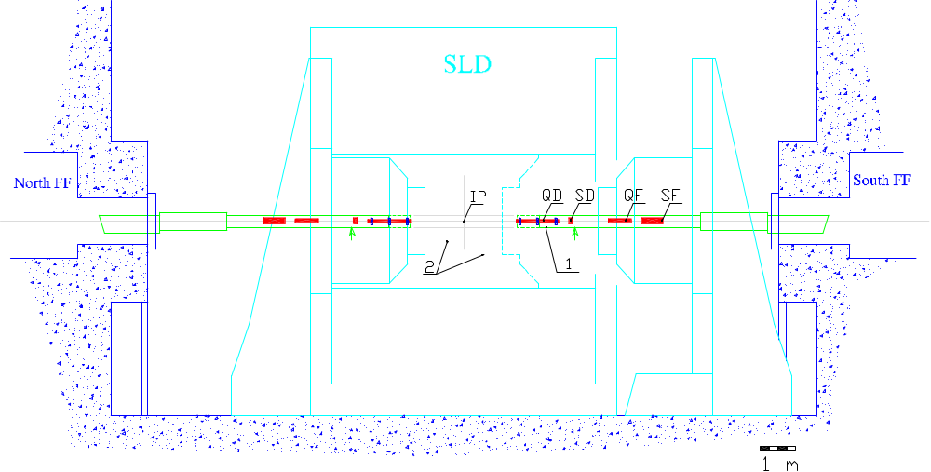
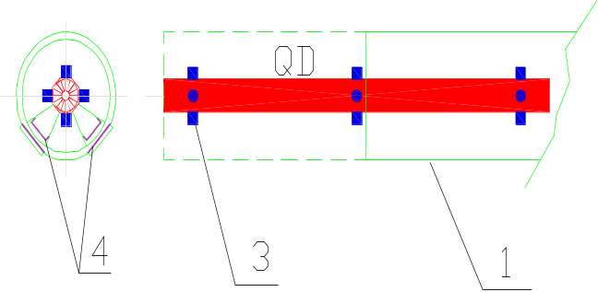
Figure 1. Schematic of the interaction region of the LINX test facility. The upper figure shows the SLD detector (right door opened). 1 indicates the girder for the final doublet with embedded sextupoles (QD-SD-QF-SF) with the small arrows showing the point of sliding support in the closed door position. The central area of the detector (2) can be opened up by removing the drift chamber to make room for additional equipment (such as an optical anchor prototype) or for other experiments. The lower figure shows a strawman concept of the final quadrupole installed in the girder. QD is the fixed strength Halbach type permanent quadrupole with dipole coils for feedforward correction of magnetic center position. 1 indicates the girder where the solid line shows the dimensions of the SLD triplet cryostat (to be removed) and the dashed line shows the enlarged dimensions of the new girder. 3 indicates the seismometers for inertial motion sensing.
A major contribution to the beam-beam separation at the IP can be the natural beam jitter originating in the linac. At the low currents planned for LINX, such jitter is expected to be less than 5% of the beam sigma. However, this is still a few nanometers and, if not removed, it will contribute significantly to the achievable collision stability. We expect that most of this incoming jitter can be subtracted from the measurements of IP stability by using the correction techniques developed during SLC operation. In addition, an active feed-forward trajectory correction system will be developed using beam position information at the end of the linac to send a fast correction signal straight ahead to the IP as schematically illustrated in Figure 3. Similar feed-forward systems have been proposed in future linear collider designs which use the position of the leading bunches in the train to correct the position of the later bunches.
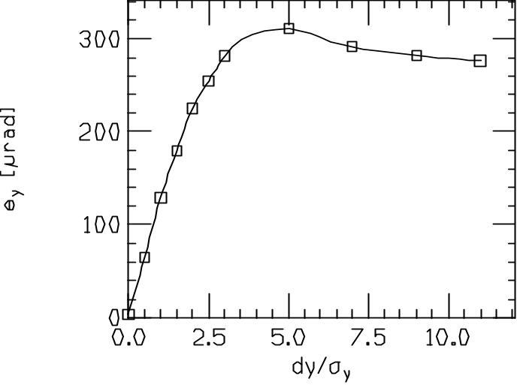
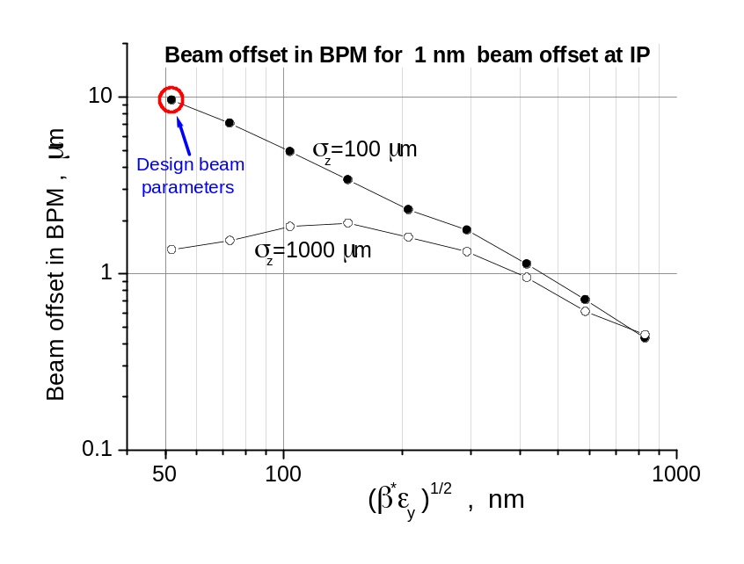
Figure 2. Simulation of a vertical beam-beam scan for the nominal beam parameters with σ_{z} = 0.1 mm (top) and of the beam offset measured by the BPM for a 1 nm beam offset at the IP as a function of the vertical β* at the IP (bottom) for different bunch lengths [9]. The matrix element from the IP to the BPM was assumed to be Ryy’ = 3 m. Calculated with Guinea-Pig program [10].

b) Background Studies
The control of detector backgrounds is another critical challenge for future colliders. At the SLC and at circular colliders, the achievable luminosity has often been limited by the need to maintain an acceptable background level rather than by intrinsic limitations of the optics or hardware. In general, beam scrapers are used to reduce backgrounds, but unfortunately these systems do not scale well to higher energy or higher beam power. To avoid damage from the very high density beams or beam blowup from strong collimator wakefields, the transport lines needed for such systems become extremely long and expensive.
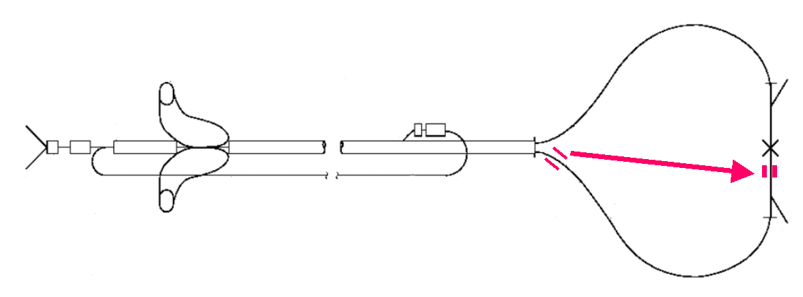
Figure 3. Schematic of the fast feedforward from the linac exit to the IP for beam jitter reduction.
Simulations indicate that the new NLC Final Focus optics should significantly reduce sources of detector background. Figure 4 shows the beam halo at the entrance to the final doublet for the new final focus design and the traditional design⎯one can see that the new final focus generates far fewer large amplitude halo particles. By modifying the SLC Final Focus to use this new optics, it should be possible to demonstrate the predicted background performance. In addition, it will be possible to test new concepts for control of beam tails by using non-linear magnetic elements to provide active collimation. The use of octupoles for non-linear control of beam tails has long history [11,12]; it has been investigated for the linac [14] and for the Final Focus [13,14,15,16]. A practical solution recently found uses octupole doublets located in the beta-match region to fold in the tails in both planes as shown in Figure 5 [17]. The octupoles wrap the large amplitude beam tails back into the beam core, effectively increasing the aperture of the final doublet by a factor of four—pairs of doublets are used to provide strong non-linear focusing in both the horizontal and vertical planes. This is a potentially very powerful technique that should be verified.
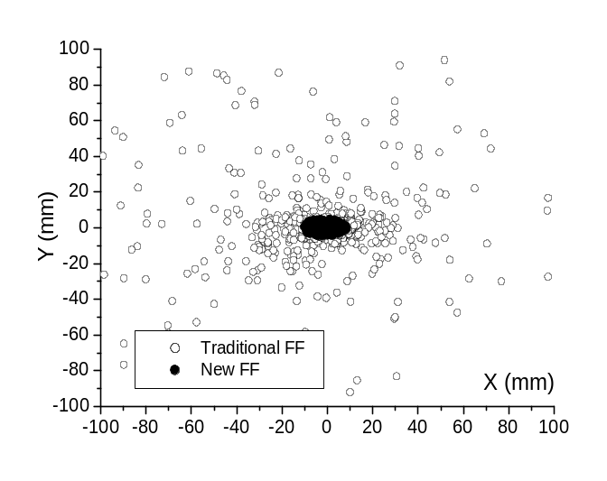
Figure 4. Simulation of beam halo particles at the face of the Final Doublet for the traditional FF and for the new design. The incoming beam is 100 times larger in the IP phase than in FD phase. Particles of incoming beam are placed on a surface of an ellipsoid with dimensions N_{σ}(x,x',y,y',E) = (800,8,4000,40,20) times larger than the nominal beam. One can see that the new FF design does not mix particles between the IP and FD betatron phases which reduces a source of background.
Details of the experiments have not yet been worked through but the SLC IR is an ideal location for such experiments since the SLD calorimeter and luminosity monitor along with the adjacent wire-scanners can be used to measure the magnitude and spatial distribution of halo particles. In particular, the SLD calorimeter can measure the muon yield per incident electron from individual adjustable collimator jaws. The rate can be calibrated by steering a known intensity beam onto the collimator and provide a cross-check of the muon Monte Carlo model. Experiments can also be performed with a combination of different beam parameters (higher current, larger emittances, tails etc.) to more thoroughly characterize and understand the background issues. This understanding could potentially lead to a collimator region design for linear colliders which is shorter and less expensive or which has relaxed tolerances.
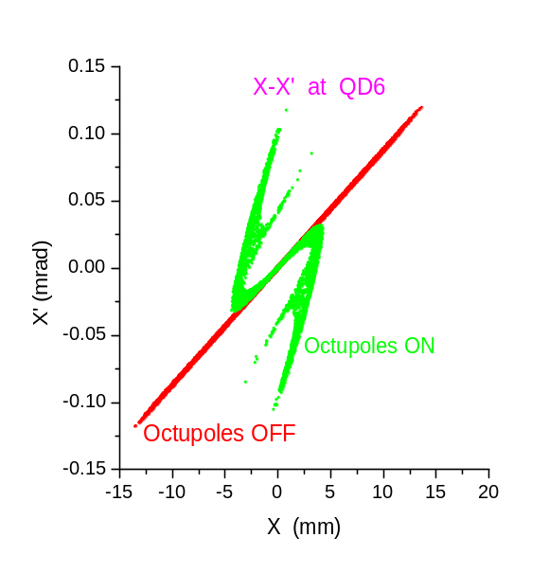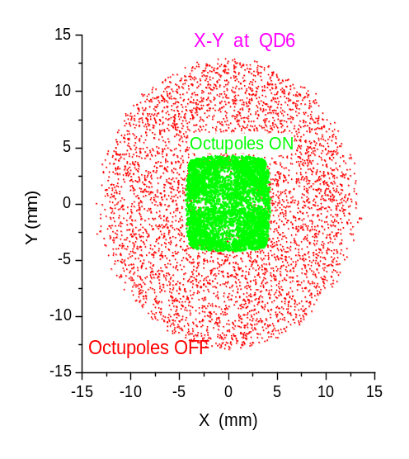
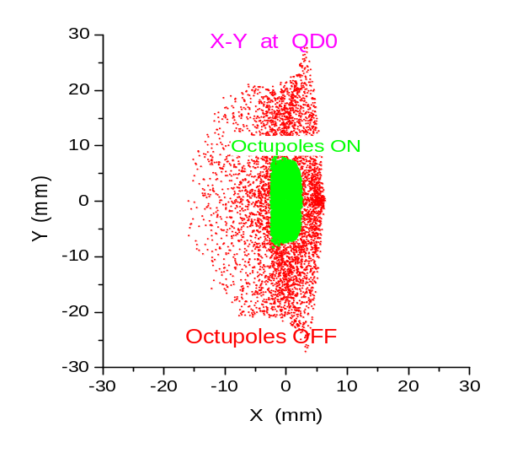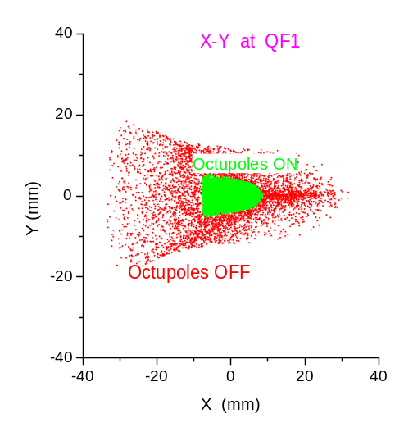
Figure 5. Simulation of tail folding by means of two octupole doublets in the new NLC final focus. The top figures show the phase space after a drift following the octupole doublets. The bottom figures show the beam distribution in the final doublet. The input beam has a flat distribution with half width (X,X’,Y,Y’) = (14μm,1.2mrad,0.63μm,5.2mrad) in IP units and ±2% energy spread. This corresponds to approximately (65,65,230,230) sigma with respect to the nominal NLC beam.

c) High Quality Beams
An important feature of LINX is very high quality beams with very small transverse emittances (see Table 1). This is a critical requirement for the planned experiments. In addition, the final steps of the experiment would use a very short bunch length but this can be achieved gradually. The process of generating the beams will improve our understanding of beam quality issues for a future collider and will open the facility to a range of other new beam physics experiments.
To achieve the required beam quality, the beam energy should be limited to 30 GeV to prevent emittance dilution due to synchrotron radiation in the SLC Arcs. In addition, minor modifications are needed to the damping rings to decrease the transverse beam emittance. The techniques developed for the SLC to control and optimize the orbits and emittances in the Linac will be utilized. Finally, the bunch length will be shortened using the SLC Arcs as a bunch compressor as was demonstrated in a previous experiment [18]. Details of the upgrade to the damping rings will be discussed in Section 3. It should be noted that the technique suggested may have application to other storage rings, including the PEP-II ring or the linear collider damping rings and is an interesting experiment in itself.
A significant issue in the preservation of beam quality throughout the SLAC accelerator complex is the tolerances on magnet strength and position stability which must be achieved. Previous experience with the FFTB suggests that the linac tolerances will be achievable (see Section 4). An initial survey of the tolerances of the LINX facility itself has been performed, and the results indicate that adequate performance should be possible for an acceptable cost, although a more detailed study is required.

d) Additional Experiments
In addition to the primary goals of LINX described above, there are numerous other experiments for which the facility could be invaluable, once it is commissioned. These include topics that are relevant to future linear colliders as well as more general beam physics studies.

Collimator design: A very important issue for future linear colliders is collimator design. The optics required to ensure that the beams are large enough that they cannot damage the collimators causes the system to be long and expensive and to have excessively tight stability tolerances. An option under study is to allow the collimators to be damaged infrequently and to provide a mechanism to rotate them to a new position after damage. For such a novel design, there are questions of monitoring the collimator surface and assuring accurate positioning of the collimators. In addition, the collimators must have long shallow tapers to minimize emittance dilution due to wakefields. Measurements of wakefields from different collimator materials and taper angles are currently underway at a wakefield measurement facility located in sector 2 of the SLAC linac. LINX would allow a test of prototype NLC or TESLA style collimators during real operation.

Ultra-short bunch experiments: As part of the LCLS [8] R&D program, there was a proposal to use the north Arc as a bunch compressor to generate ultra-short bunches for experiments on coherent synchrotron radiation. The original SNAFU (SLAC North Arc Femtosecond Undulator) [19] proposal used the first third of the Arc up to the reverse bend; similar bunch lengths can be produced using the full Arc although the longitudinal tails become larger. The measurement equipment could be installed in the final focus, instead of at the reverse bend, which would likely simplify the installation and subsequent access. A simulation of the compressed bunch shows the core has a FWHM of roughly 150 μm. A more recent calculation has found that similar bunches could be generated in the FFTB for a particular bunch charge, however an additional magnetic chicane must be added to the SLAC linac.

Traveling Focus: Balakin proposed the concept of a traveling focus to avoid the luminosity loss due to the hourglass effect when the bunches are longer than the beta functions [20]. Very high-energy linear colliders may have a vertical β* which is shorter than the bunch length and requires such a technique to maximize luminosity. This is a promising idea, which could potentially be tested at LINX. Figure 6 shows a simulation of the beam-beam interaction with a traveling focus.
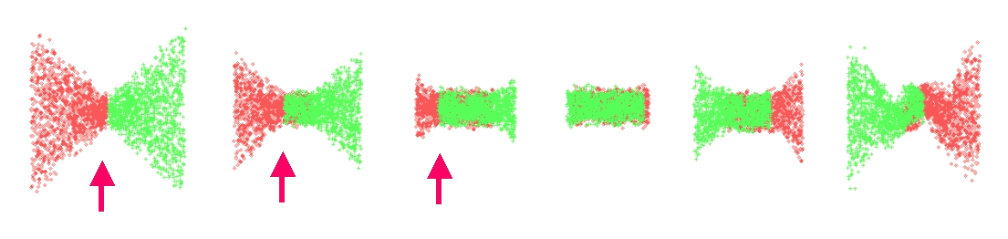
Figure 6. Simulation of traveling focus. The arrows show the position of the focus point during collision. The beam parameters are optimized for the traveling focus collision in this example. For LINX such conditions would require higher beam current than currently planned.

Plasma Wakefield Experiments: The next generation of plasma wakefield experiments could take advantage of the higher accelerating gradients from the ultra-short bunches produced for LINX as well as the smaller emittances. Although the Final Focus Test Beam at SLAC can produce single beams with similar emittances and spot sizes, LINX will have up to a factor of 5 shorter bunch length which would greatly enhance the plasma accelerator studies.

Photon Collider Test Beam: Future linear collider proposals contain the option for producing γ-γ collisions by Compton backscattering of laser photons from the high-energy electron beams. The LINX facility provides the opportunity to prototype all the required technology for producing photon collisions. A detailed experimental γ-γ program for the LINX facility is described in Appendix A.

Instrumentation: The LINX beams will provide an opportunity to test different instrumentation designs for future linear colliders including methods to measure the very short bunches and small beam sizes.

HARDWARE and OPERATION
LINX will reuse much of the existing SLC hardware. In particular, it will use the SLC electron and positron sources, the damping rings and bunch compressors, and the first 30 GeV of the main linac. All of these components are currently being operated and maintained for PEP-II. In addition, it will use the SLC Arcs and the SLC final focus modified to emulate the newly developed NLC optics. The modifications to the final focus are small, but both the Arcs and the Final Focus will require refurbishment because they have not been operational for more than two years.
The operation of LINX will have to be transparent to PEP-II and thus beam would be delivered to LINX only while PEP-II is not filling. In steady operation, PEP-II needs beam only about 10% of the available time. The main linac pulse rate could remain 30 Hz downstream of Sector 3 as for current PEP-II operation. This could provide 27 Hz electrons and positrons to LINX without increasing the cost of linac operation. The damping rings could be operated in a long store mode with a store time of 33 ms rather than the 8 ms or 16 ms store time that was used during SLC operation to produce smaller extracted beam emittances.
It is possible to further reduce the emittance from the damping rings by a factor of 2 to 3 by a minor modification of the optics to allow the quadrupoles to be used as combined function magnets. In addition, operation at low current and low energy should greatly reduce the emittance dilution due to wakefields in the linac and synchrotron radiation in the Arcs. It should also be pointed out that running at lower beam energy and bunch charge in the Arcs and the Final Focus will decrease the cost of operations and the stress on aged components.
In summary, modifications will be required in the damping rings, the main linac operation, the SLC Arcs, the Final Focus, and the SLD. These will be described in more detail below. The total investment required for these modifications is estimated to be 1-3 M$ which is relatively modest given the potential benefit.

Damping Rings: It is possible to decrease the emittance from the damping rings if the quadrupoles in the FODO lattice are used as combined function magnets instead of normal quadrupoles. In this manner, the total radiation and the horizontal partition numbers J_{x} can be increased, decreasing both the horizontal and vertical damping times. This simple scheme could be tested by modifying the power and water feeds to the existing quadrupoles to shift their magnetic centers in an adjustable manner. With very small resulting orbit distortions, we expect to reduce both horizontal and vertical emittances by a factor of 2 to 3 and the damping time should decrease by about 30%. Figure 7 shows the orbit distortion for a shift of the magnetic center of the QF's of about 5 mm. For this to work optimally, it is also necessary to “unstretch” the North damping ring. Indeed, the stretching made in 1993 [21] increased J_{x} by about 10% with orbit distortion of about 2 mm⎯our proposal gives a much larger emittance reduction for a similar orbit distortion. Figure 8 shows the necessary rearrangement of power connections for the quadrupoles—an additional booster supply is used in each ring to increase the current in two of the four poles of the QF magnets generating a net dipole field and the electrical and water feed connections for the focusing quads must be modified accordingly.
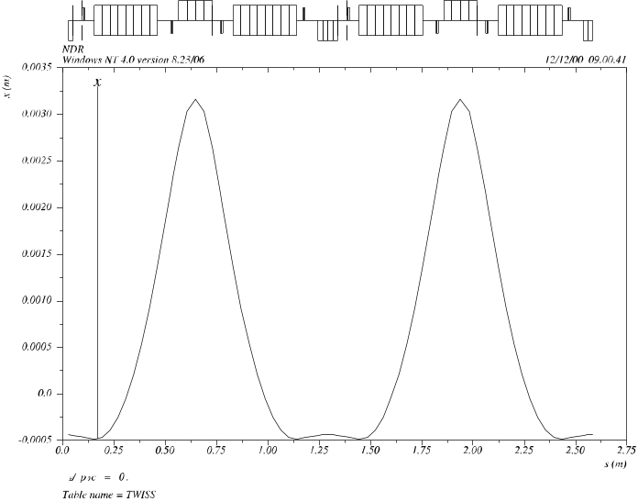
Figure 7. Orbit distortion in the damping rings arcs for a shift of the magnetic center of the QF's of about 5 mm.

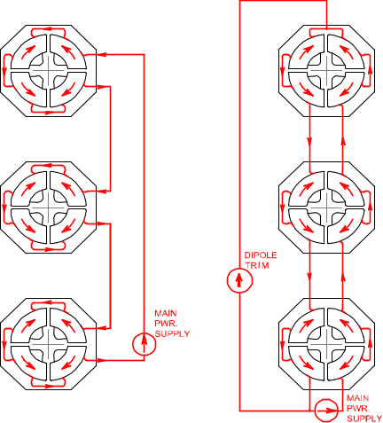
Original
Modified

Figure 8. Diagram of the rearrangement of power feeds for the damping ring focusing quadrupoles. On the left is the original configuration. The boost power supply in the modified configuration (right) will shift the magnetic centers
Table 2 shows the present and the expected performance of the rings. With the proposed modification, the bend field would need to be increased in order to keep the energy constant, but this is not possible with the present power supply. A simpler solution is to lower the energy of the rings, since LINX would run at low repetition rate (“long store” mode) and does not require a shorter damping time. This would further reduce the equilibrium emittance, and would have no impact on PEP-II injection as the linac can make up the small extra energy needed.

TABLE .
Damping Ring Parameters

 | Existing DR | Modified DR | Modified DR, lower energy
Energy, GeV | 1.19 | 1.19 | 1.07
Damping time, ms | τ_{x,y,E} = 2.3/2.2/1.1 | τ_{x,y,E} = 1.1/1.8/1.4 | τ_{x,y,E} = 1.5/2.5/1.9
Partition numbers | 0.95/1.0/2.05 | 1.7/1.0/1.3 | 1.7/1.0/1.3
Emittance, γε_{x} mm mrad | 31 | 15 | 11
Loss per turn, keV | 90 | 112 | 74

Linac Orbit Control: During the 1994 and 1997 FFTB runs, it was demonstrated that the present linac orbit control system was capable of transporting LINX-like normalized emittances and bunch charges from the north damping ring to the FFTB without measurable dilution. It is therefore anticipated that adequate linac performance will be achievable without hardware or software upgrades. Some modest improvements to the linac wire scanner system may be required to take full advantage of the reduced vertical emittances from the damping ring upgrades.

ARC Bunch Compression: The SLC Arcs can be used as a bunch compressor by introducing a correlated energy spread along the bunch in the Linac and combining this with the natural R₅₆ of the Arc transport matrix. Such compression is necessary in order to collide beams with vertical beta functions as small as 100 μm without being limited by the hourglass effect. A simulation of the compressed bunch is shown in Figure 9 where the core of the bunch has a FWMH of roughly 150 μm

Arcs and Beam Switch Yard: The Arc vacuum system needs maintenance and any leaks must be repaired. At the present time, part of the South Arc is under vacuum while the North Arc is not. A recent walk-through suggests that there may be 3 or 4 locations in the North Arc where the chambers would have to be replaced. There are also two known leaks in the Beam Switch Yard vacuum that will need to be repaired.

Final Focus: The SLC superconducting final triplets need to be replaced by permanent magnets doublets to achieve the very small IP beta functions required. Superconducting magnets are also a possible option although likely more expensive and some provision would be needed to restore cryogenics. With the new Final Focus optics, shown in Figure 10, a pair of sextupole magnets must also be added interleaved with the quadrupoles of the doublet. At least the innermost sextupole would need to be a permanent magnet. A doublet of permanent magnet octupoles would be added per side for background reduction. The remaining FF magnets can be used in their present locations but they will have different field strengths which will require some re-cabling and possibly two additional power supplies. There were a number of unused power supplies during SLC operation which can probably be reassigned.
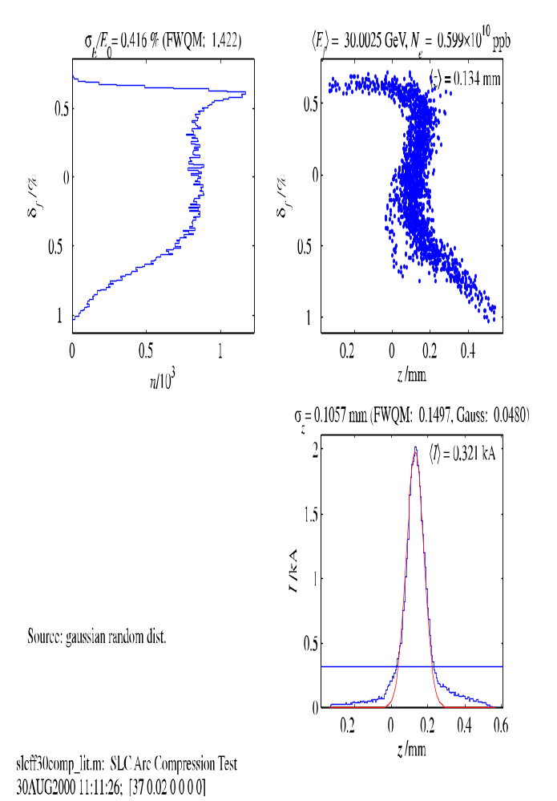
Figure 9. Simulation of longitudinal phase space in SLC FF after bunch compression in the Arcs. FWHM is approximately 150 μm.
Of course, as after any extended shutdown, the vacuum system needs maintenance and any leaks must be repaired. The North Final Focus is under vacuum while only a portion of the South has been vented. However, the chambers look intact and reestablishing good vacuum is not expected to be a problem. A more significant expense is that the AC power transformer for the North FF has been moved to another area and would need to be replaced.

SLD: Necessary subsystems of SLD need to be recommissioned, in particular the calorimeter and luminosity monitors. In order to enhance the experimental flexibility of LINX, the SLD vertex detector and drift chamber may be removed which would provide much easier access to the interaction region.

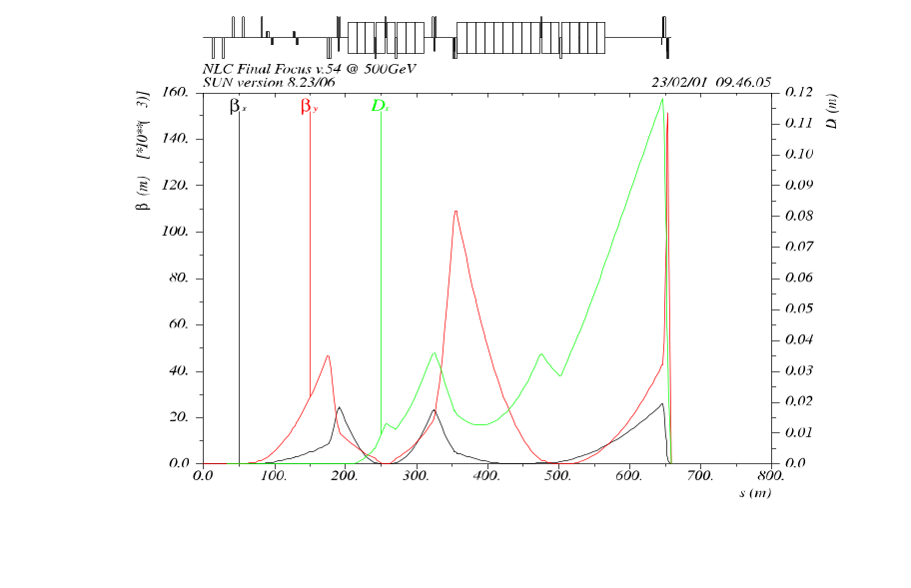
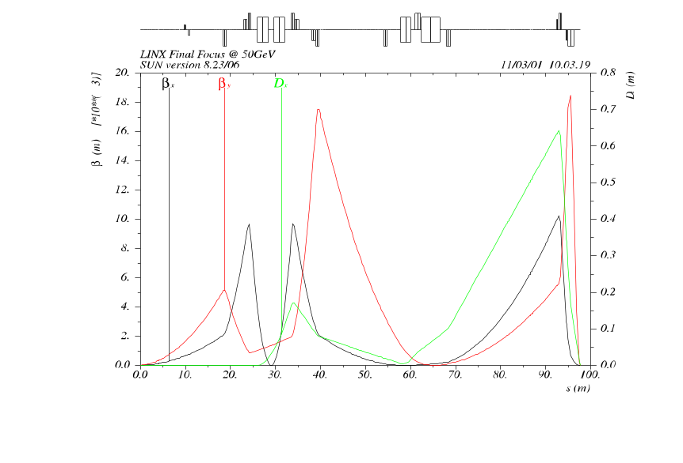
Figure 10. Optics of the NLC FF (top picture) and the SLC FF modified according to the new NLC FF design. The final triplets will be replaced by doublets with additional sextupoles interleaved. All the other elements of the SLC FF are left unchanged. One octupole doublet is added for active background control.
General: Any existing hardware that has not been recently used must be checked out and refurbished as necessary. This includes power supplies, magnets, electronics etc.

COMMISsIONING and scheduling plans
In order to derive the maximum benefit from this test facility and minimize the project risk, the LINX program would have a phased sequence of experiments. The first steps would be to restore the SLC Arcs and Final Focus to operational condition and reestablish high quality colliding beams. The most expensive and longest lead time item is fabrication and installation of the new permanent magnet doublets and sextupoles. The decision to proceed with these magnets would be deferred until after the first phases of the program were successful. An interim series of experiments could take place while the doublets were being constructed. These would include background experiments with the new Final Focus optics, production of very small emittance beams from the upgraded damping rings, fast feedback tests with beam, ultra-short bunch length experiments such as SNAFU, and preliminary tests of stabilization hardware. The final phase would require installation of an upgraded IR with the new doublets and with stabilization systems which would evolve in complexity to include more realistic hardware.
Since operation of the facility will be parasitic to PEP-II operation, there should not be stringent constraints on the time used for experiments. We forsee shift periods of limited duration to be devised and executed on a semi ad-hoc basis, as new hardware is ready. The model supposes ~two week blocks of continuous running, so that after collisions are achieved they may be maintained. Accelerator physicists from SLAC or collaborators would lead the effort on a 8-12 hour per day basis and operations personnel would perform prescribed experiments for the remainder of each 24 hour period, if required, or simply maintain the beams. There would be ample opportunity for iterating and refining each of the upgrades as well as for scheduling instrumentation tests and other beam physics experiments as they are proposed.

Step 1: The goal is to successfully transport e+ and e- beams to the north and south beam dumps respectively.
This requires that the BSY, Arcs, FF and SLD be restored to beam ready condition. The vacuum integrity must be reestablished although the vacuum quality need not be optimal at this stage. All magnets should be restored to operation except the superconducting triplets and detector solenoid, which are not needed to send beams to the dumps. The Arc movers, Beam Position Monitors and other diagnostics should be operational. The Arc and Final Focus controls and Machine Protection sufficient for low rate (10 hz) must be recommissioned. The SLD doors and Pacman must be closed and ready for beam.
We propose that refurbishing of the hardware take place on a best efforts basis using existing lab staff as much as possible. Some investment is required to replace components scavenged for other uses and some repairs will need to be scheduled for a time when PEP-II is off. Once the beamlines are restored to service, the program would require beam for 1-2 weeks of shifts to tune up the system for 30 Gev beam.

Step 2: The goal is to demonstrate that the SLC beamlines can still deliver high quality colliding beams.
This requires that all systems from the damping rings through the linac to the final focus be optimized to deliver low emittance beams. In particular, a more careful correction of the Arc optics will be needed as well as beam based alignment and spot size optimization in the Final Focus. This can be expected to take somewhat longer to achieve than Step 1. The superconducting triplets need to be cooled down and operational for the final tuneup of the beamline but this period can be rather short so a local helium supply would be adequate. This step is highly desireable but not absolutely required.

Decision point: The decision to proceed with the rest of the program would be contingent on the success of these first steps. Engineering design of the new final doublets could begin during this period but construction would not be authorized until the viability of the SLC systems had been demonstrated. Throughout the early steps of the program, there may be opportunities to test detectors and hardware to be used for stabilization of the final quadrupoles, to test instrumentation, or to perform other beam physics experiments. The next parts of the program (Step 3-6) are not sequential and could proceed in parallel or in whatever order was appropriate for the resources available. In particular, the production of ultra-short beams and the first round of background tests use existing hardware and could be scheduled whenever convenient.

Step 3: The goal is to produce ultra-short beams.
This would not require any further hardware modifications. One would demonstrate the required bunch compression in the arc combined with establishing the proper energy correlation in the linac. This step could be combined with one of the previous steps and would require a minimal number of shifts. Once the ultra-short beams were established, they could be used for experiments such as the SNAFU proposal of LCLS.

Step 4: The goal is to evaluate the effectiveness of background suppression with the new Final Focus optics.
This would require that the new optics be implemented on at least one side of the Final Focus and, eventually, that permanent magnet octupoles be constructed. Since one is interested in the backgrounds in the Final Doublet phase, the existing triplets could remain for this phase but beam transport through the IP must be maintained to use the wire scanners effectively. It would also be desireable to revive some parts of the SLD detector as a diagnostic, specifically the calorimeter and luminosity monitors. The backgrounds would be measured first with the new optics and later with the octupole doublet installed. This step would involve several blocks of shifts to explore the performance of the system under a variety of incoming beam conditions. If the octupole construction is delayed, that portion of the tests could be conducted much later after some of the other interim steps are complete.

Step 5: The goal is to produce ultra-low emittance beams.
This would require that the damping ring magnets be modified to allow them to act as combined function magnets. Since these modifications would interfere with PEP-II operation, they would need to be scheduled for an extended shutdown. Once the modifications were complete, several blocks of shifts would be required to fully commission the new ring optics and to reoptimize the linac orbits to preserve the very small emittance.

Step 6: The goal is to develop fast intra-pulse feedback hardware.
Hardware capable of correcting the trajectory within the NLC bunch train would be developed and tested, first without beam and later possibly in the ASSET area of the linac. These tests would lead to a final design of a fast feedforward system from the end of the linac to the IP, with hardware similar to that needed for the NLC intra-pulse feedback. Development and testing can proceed in parallel with the earlier steps but the final system should be installed and tested prior to the nanometer stabilization experiments. Tests would take a few shifts at a time as the hardware was developed.

Step 7: The goal is to produce < 100 nanometer vertical beam size at the IP.
This would require that the new final doublets are installed along with prototype stabilization hardware. This is a major installation where the existing triplets, IR beam pipe and SLD vertex detector would be removed and replaced with the new magnets and diagnostics. The installation itself would take months, but is entirely compatible with continued PEP-II operation. Once complete, there would be several blocks of shifts over an extended period to fully optimize the beam tuning, study the performance of the stabilization system and install successive refinements. There may also be further background studies to perform with the complete new Final Focus optics installed and a variety of other beam physics experiments may be proposed to utilize the unique ultra-short and ultra-small beams.

Step 8: The goal is to demonstrate nanometer stabilization at the IP.
Nanometer stabilization is the primary goal of the LINX facility and the culmination of all the previous steps. It would require a system with nearly the performance of the final stabilization required for a linear collider IR. This demonstration would undoubtedly require an extended period of shifts to tune up the beams and stabilization control, and to study the long term performance of the integrated system.

Conclusions
LINX is an engineering test facility to model the Interaction Region of a future Linear Collider. The initial goals of the facility would be to study the IR stabilization needed to collide nanometer sized beams and to study background issues with different collimation techniques. The facility will collide electron and positron beams so that the beam-beam deflection can be used as a very high-resolution diagnostic that cannot be duplicated in other ways. In addition, the facility will use the SLAC linac and the SLC Arcs to deliver very high quality beams that are unique in the world and are likely of interest for other beam physics experiments.
The LINX proposal makes use of existing SLAC facilities so that the cost of the project is modest. The operational costs would be minimal, as most of the hardware would already be operated for PEP-II. We believe that through the operation of such a facility, we could greatly improve the designs of several components of a future collider. Moreover such a facility will attract physicists from all over the world to experiment with new ideas and hardware to the benefit of SLAC and the broader physics community.

Frequently Asked Questions
What is the impact on the NLC project? Doesn’t a new test facility mean that the NLC project is less ready than we thought? Can it delay the decision to start NLC construction?
LINX is an engineering facility where important components of the NLC will be prototyped and tested as part of optimizing the final design. The knowledge gained would ensure the most cost effective solution to IR stabilization and enhance our confidence in the cost estimate. Such engineering facilities are appropriate for a project entering the construction phase. We believe that results from LINX are not required before a construction decision for the linear collider but that they will refine and strengthen the final design.

Is there significant risk of failure that could negatively impact the NLC project?
We have suggested a phased approach for LINX in order to minimize the risk, starting with a simple demonstration that the SLC Arcs and Final Focus can be restored to beam ready condition. Each phase of the project should achieve a gradual increase in the performance as new hardware is developed. Problems encountered can lead to a redesign of the hardware but do not reflect on the NLC project as a whole. LINX will provide an opportunity to refine and optimize the engineering solutions for an important section of the collider, the IR.

Is there negative impact on SLAC and on other experimental programs?
The LINX proposal has been structured so as to have minimal impact on other experimental programs. In particular, it should be completely parasitic to PEP-II operation. The hardware modifications required are modest in cost and scope. The beam parameters and running modes are “gentle” on the hardware and relatively easy to establish and maintain. Such a facility, once constructed, will attract many users from other laboratories, benefiting science in general and SLAC in particular.

Will the diversion of NLC staff into LINX activities result in less effort on other critical path issues of the project?
While we hope to attract outside collaborators to share the responsibility for running experiments and analyzing results, LINX will require SLAC resources, both from the technical support groups and from NLC. Nonetheless, we believe that LINX can provide an exciting hands-on opportunity to work with a real accelerator which can strengthen and augment the design and simulation studies. We believe that the benefits from running LINX are incomparably greater than resources required to construct and operate it.

Can the SLC really be used for LINX?
In a word, yes. The two main issues are reliability and tolerances. Reliability is hard to predict but the phased turnon will allow natural decision points where the feasibility of the program can be reevaluated. Emittance dilution in the linac will be negligible at the bunch charge and beam energy proposed, as evidenced during previous FFTB runs. The correction of the Arcs will be much simpler than for the SLC because the synchrotron radiation emittance dilution will be minimal at the lower beam energy and there is no need to preserve polarization. The damping ring emittance will benefit from a long store time and from a modest upgrade to the lattice to further reduce the equilibrium emittance. Initial estimates of the tolerances on magnet strength and position stability indicate that the current system will perform adequately, although more study is required.

Is it possible to perform the suggested tests at the FFTB?
In principle, the FFTB could be used to perform some initial background experiments with the new Final Focus optics. Unfortunately, the FFTB tunnel constrains the upgrade possibilities and no solution for the new optics has been found that does not require changing the geometry of the beamline. The FFTB has several other shortcomings as an experimental location for LINX. Most importantly, with only a single beam there is no beam-beam deflection, which is the only diagnostic with the precision to verify sub-nanometer stabilization. In addition to its high precision, the beam-beam deflection has the unique advantage that it demonstrates directly the stability of interest without the need for interpretation or reliance on models. In the FFTB, it is also not practical to produce the short bunch length needed for some experiments. Lastly, the FFTB in the near term is committed to a variety of accelerator experiments as part of the ORION program and longer term will be part of the LCLS project. There is no such conflict for the SLC and SLD.

Is a beam test of the new FF optics required?
The FFTB not only demonstrated that a particular optical design could deliver the demagnification required for the small spot sizes of future linear colliders, but also that the third order simulation programs could accurately predict performance. The same tools have been used to design and study the new FF optics, so an explicit verification is not required. Nonetheless, it is always preferable to experimentally test important features of a new project and thus, while not a requirement, a beam test of the new optics will be an extra benefit.

Is there a real user base for such a test facility? Is this of interest to other linear collider projects?
We have spoken to colleagues from the accelerator laboratories developing linear collider technology at CERN, DESY, FNAL, KEK and LLNL. Many of them are interested in participating in this facility, as are university researchers, for example at Oxford, England and University of British Columbia. In addition, we believe there are other areas of research where such a facility could play an important role. Construction of LINX will further strengthen SLAC as a center for advanced accelerator research.

REFERENCES
- Final Focus Test Beam (FFTB) at SLAC, K. Oide, “Design of Optics for the Final Focus Test Beam at SLAC”, in Proceedings of the 1989 Particle Accelerator Conference, 1319 (1989).
- V. Balakin et al, “Focusing of Submicron Beams for TeV-Scale e+e- Linear Colliders”, PRL 74:2479 (1995).
- NLC Test Accelerator (NLCTA) at SLAC, http://www-project.slac.stanford.edu/lc/nlc.html
- TESLA Test Facility (TTF) at DESY, http://tesla.desy.de/
- Accelerator Test Facility (ATF) at KEK, http://www-jlc.kek.jp/atf-intro-e.html.
- CLIC Test Facility (CTF) at CERN, http://ctf3.home.cern.ch/ctf3/CTFindex.htm
- P.Raimondi, A.Seryi, “New Developments In Linear Colliders Final Focus Systems”, SLAC-PUB-8460, 2000; Phys. Rev. Lett 86, 3779 (2001).
- “Linac Coherent Light Source (LCLS) Design Study Report”, By LCLS Design Study Group (J. Arthur et al.). SLAC-R-0521, 1998, http://www-ssrl.slac.stanford.edu/lcls/design_report/e-toc.html
- K.Thompson, private communication.
- D.Schulte, Guinea-pig beam-beam simulation program.
- P.F.Meads, “A Nonlinear Lens system to Smooth the Intensity Distribution of a Gaussian Beam”, IEEE Transaction on Nuclear Science, NS30, 1983, p.2838.
- N.Tsoupas, R.Lankshear, C.L.Snead,Jr., T.E.Ward, M.Zucker, H.A.Enge, “Uniform Beam Distribution Using Octupole”, Proceedings of IEEE Particle Accelerator Conference, San Francisco (1991), p.1695.
- F. Zimmermann, “Octupoles in Front of the Final Doublet”, NLC Accelerator Physics Note, July 14, 1998, http://www-project.slac.stanford.edu/lc/local/AccelPhysics/Collimation/OctFD_FZ.pdf and http://www-project.slac.stanford.edu/lc/local/AccelPhysics/Collimation/OctQ1AH_FZ.pdf also 9 Meeting notes of NLC collimation working group May to August 1998 from http://www-project.slac.stanford.edu/lc/local/AccelPhysics/Collimation/note1.pdf to http://www-project.slac.stanford.edu/lc/local/AccelPhysics/Collimation/note9.pdf
- R. Pitthan, “Using Octupoles for Background Control in Linear Colliders - an Exploratory Conceptual Study”, SLAC-PUB-8402, Presented at LC 99, Frascati, Italy, 1999.
- http://www-project.slac.stanford.edu/lc/local/AccelPhysics/Collimation/OctupolesforBckgr.pdf
- R.Helm, SLAC, unpublished, 1999-2000.
- R.Brinkmann, “An Effective Acceptance Expander for the FFS”, presented at the Beam Delivery and Interaction Region Workshop BDIR2000, Daresbury Laboratory, UK, July 2000,
http://www.astec.ac.uk/ap/bdir2000/
- P. Raimondi, A. Seryi, “Halo Reduction by Means of Non-linear Optical Elements in the NLC Final Focus System”, presented at PAC 2001.
- K.L.F.Bane, P.Emma, M.G. Minty, F. Zimmermann , “Measurements of Longitudinal Wakefields in the SLC Collider Arcs”, SLAC-PUB-7781, 1998.
- P.Emma, J. Frisch, “A Proposal for Femtosecond X-ray Generation in the SLC Arcs”, SLAC-Pub-8308, 1999.
- V.Balakin, "Traveling Focus Regime for Linear Collider VLEPP", in Proc. of the LC91 Workshop on Linear Colliders, Protvino 1991, Vol. 1, p.330.
- M. Minty et al., “Using A Fast Gated Camera for Measurements of Transverse Beam Distributions and Damping Times”, SLAC-PUB-5993, 1992.

Appendix: Photon Collider Test Beam

Future Linear Collider proposals contain the option for producing gamma-gamma collisions by Compton backscattering of laser photons from the high-energy electron beams. The LINX facility could provide the opportunity for engineering development and key measurements in support of the γγ option. It could be a testbed to prototype all the required technology for producing photon collisions. At this point, a working detector would provide the opportunity to make some interesting engineering and physics measurements. The facility could be used to measure the γγ cross sections and greatly expand the existing experimental data. Methods could be developed and tested for an absolute measurement of the luminosity. Finally, there is the potential for a physics program in heavy quark spectroscopy.
For γγ collisions, the interaction region beam pipe would need to be replaced with one containing appropriate optics to transport and focus the laser pulses. The required optics would be essentially identical to that proposed for a future linear collider and would allow the stabilization, alignment and focusing to be fully tested. The reduced duty cycle at LINX would allow a short pulse laser with orders of magnitude less average power than that required at a full scale LC. Initial operation would be with a single laser. The energy spectrum of the post Compton backscattered electrons would be used to measure the conversion efficiency and spectrum of the produced high-energy photons. The addition of a second laser, providing pulses for the opposite beam, would allow actual γγ luminosity to be produced.
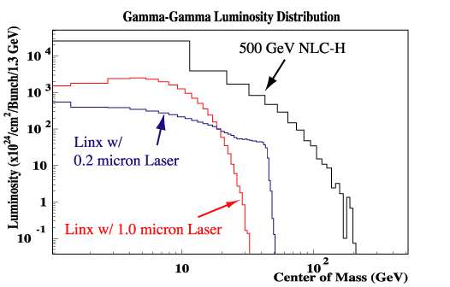
Figure A1. Luminosity spectrum for γγ collisions at LINX.
At an e⁺e⁻ LC there is a γγ luminosity spectrum from the collision of beamstrahlung photons. The direct γγ cross sections are well known. However, the photon can fluctuate into qq pairs which can then interact. These resolved photon processes are difficult to model and there is a dearth of experimental data on event rates and angular distributions at high center of mass energies. This facility would probe these events at energies of up to 50 GeV, greatly extending the range of experimental data on which the models are based. The γγ luminosity at the LINX facility would be comparable to that from beamstrahlung photons at a 500 GeV c.m. e⁺e⁻ collider on a per bunch basis, as shown in Figure A1. To achieve maximum center of mass energy a laser operating in the UV range (0.2 microns) would be required.
The benchmark measurement of the partial width of Higgs to two photons requires an absolute measurement of γγ luminosity. The LINX facility would provide a test bench for developing data based and machine based luminosity measurements. This would reduce the uncertainty on the resolution of the luminosity measurement at a future photon collider and improve the physics case for such a facility.
A LINX photon collider facility, with a working detector, would also have the potential for a physics program in heavy quark spectroscopy. Bound states of cc and bb can exist in many spin and CP states. Typically, spin 1 J/Ψ(cc) and Υ(bb) states are produced in e⁺e⁻ collisions. The spin 0 and spin 2 states are then accessed through radiative decays of these states. Once the mass of the spin 1 state is larger than the open heavy quark threshold they predominantly decay into heavy quark meson pairs. The rate of radiative decays becomes negligible at this point. A photon collider can produce all states of spin 0 and spin 2 at arbitrarily high mass through the process γγ -> qq. Many of these states remain undiscovered. For this application a 1 micron laser would be optimal. At this wavelength a small fraction of energy is transferred from the electron to the photon in each Compton backscatter. This allows each electron to produce multiple low energy photons. Since luminosity scales as the number of photons squared this can greatly increase the available luminosity. Figure A2 [missing] shows the expected luminosity distribution for ?J / ?ps laser pulses at 1 μm wavelength.

